**How to create a M10x1.5 screw?**

1. **Create the revolve feature**

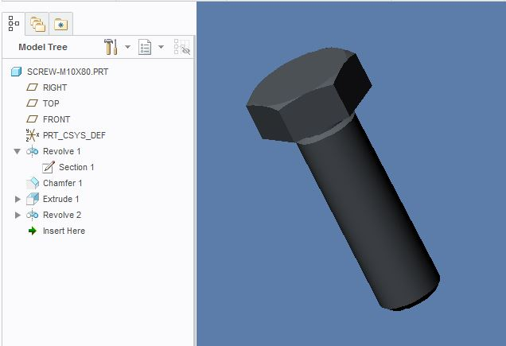

1. **Sketch the Helical Sweep profile**

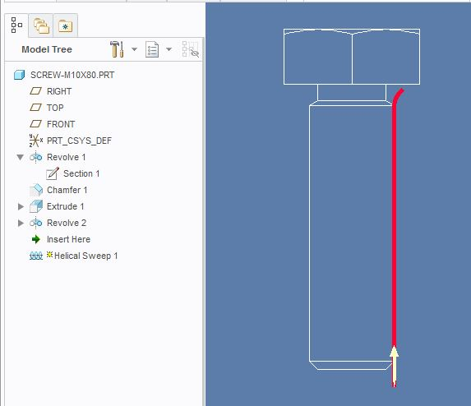

1. **Sketch the Profile Section**

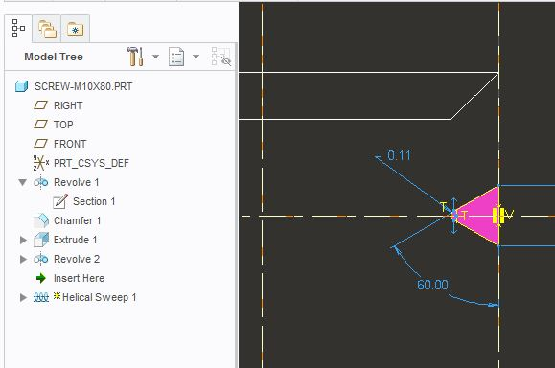

1. **Click OK and you are done.**

