Creating a simple Gif animation file for Grabcad & Web with Keyshot

1. Open your project in Keyshot

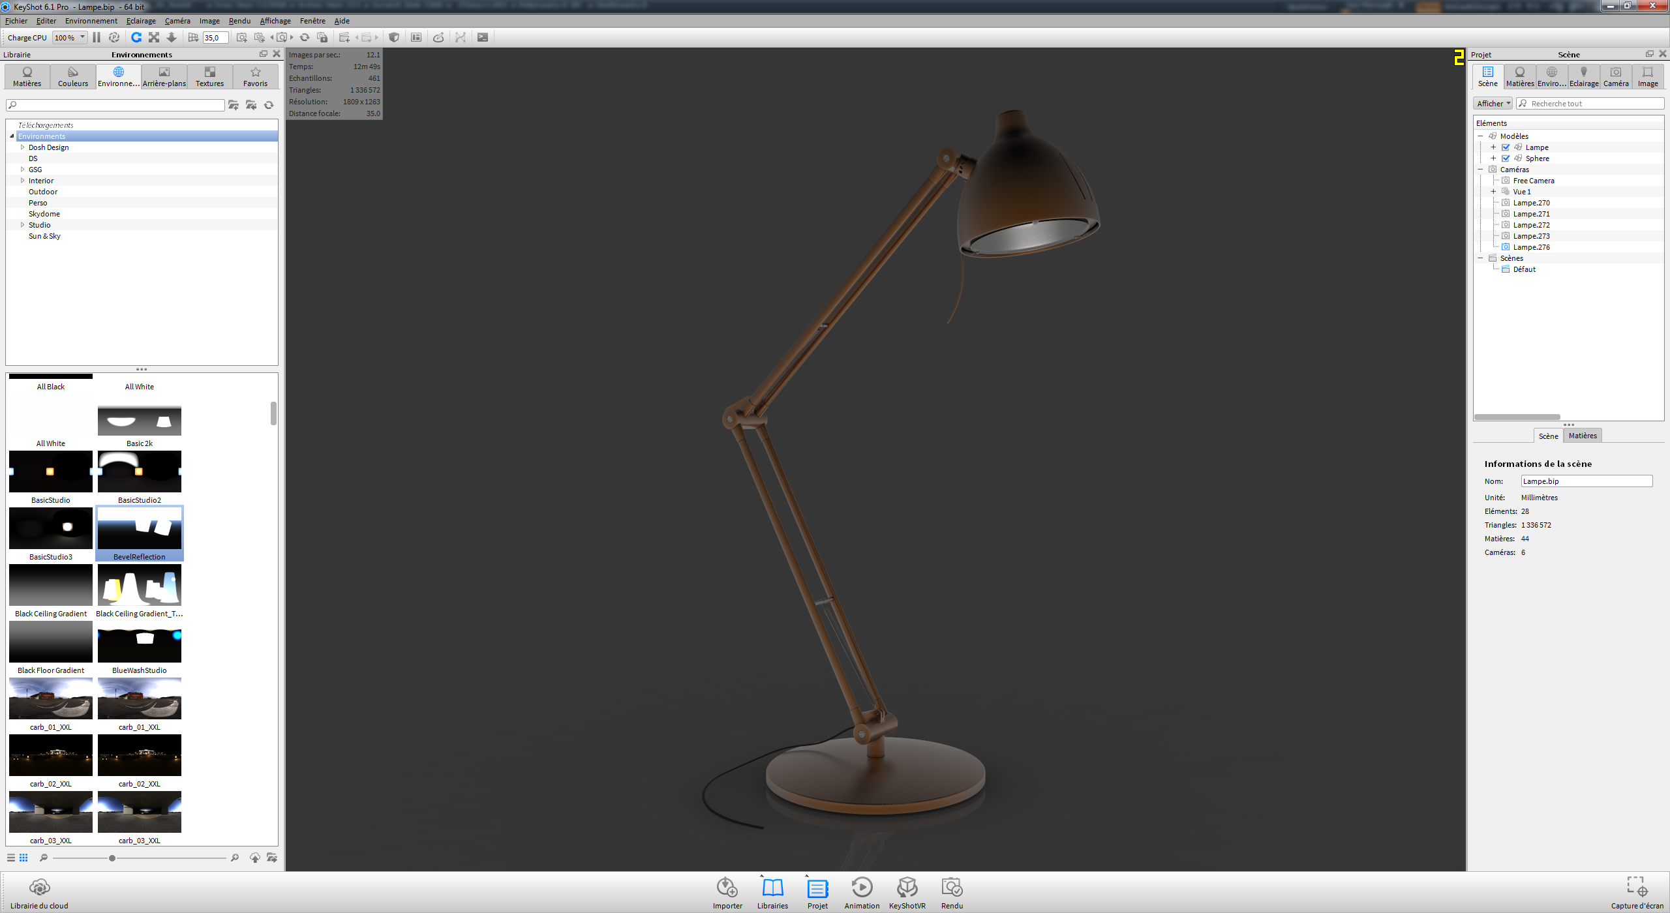

1. Create a KeyshotVR animation



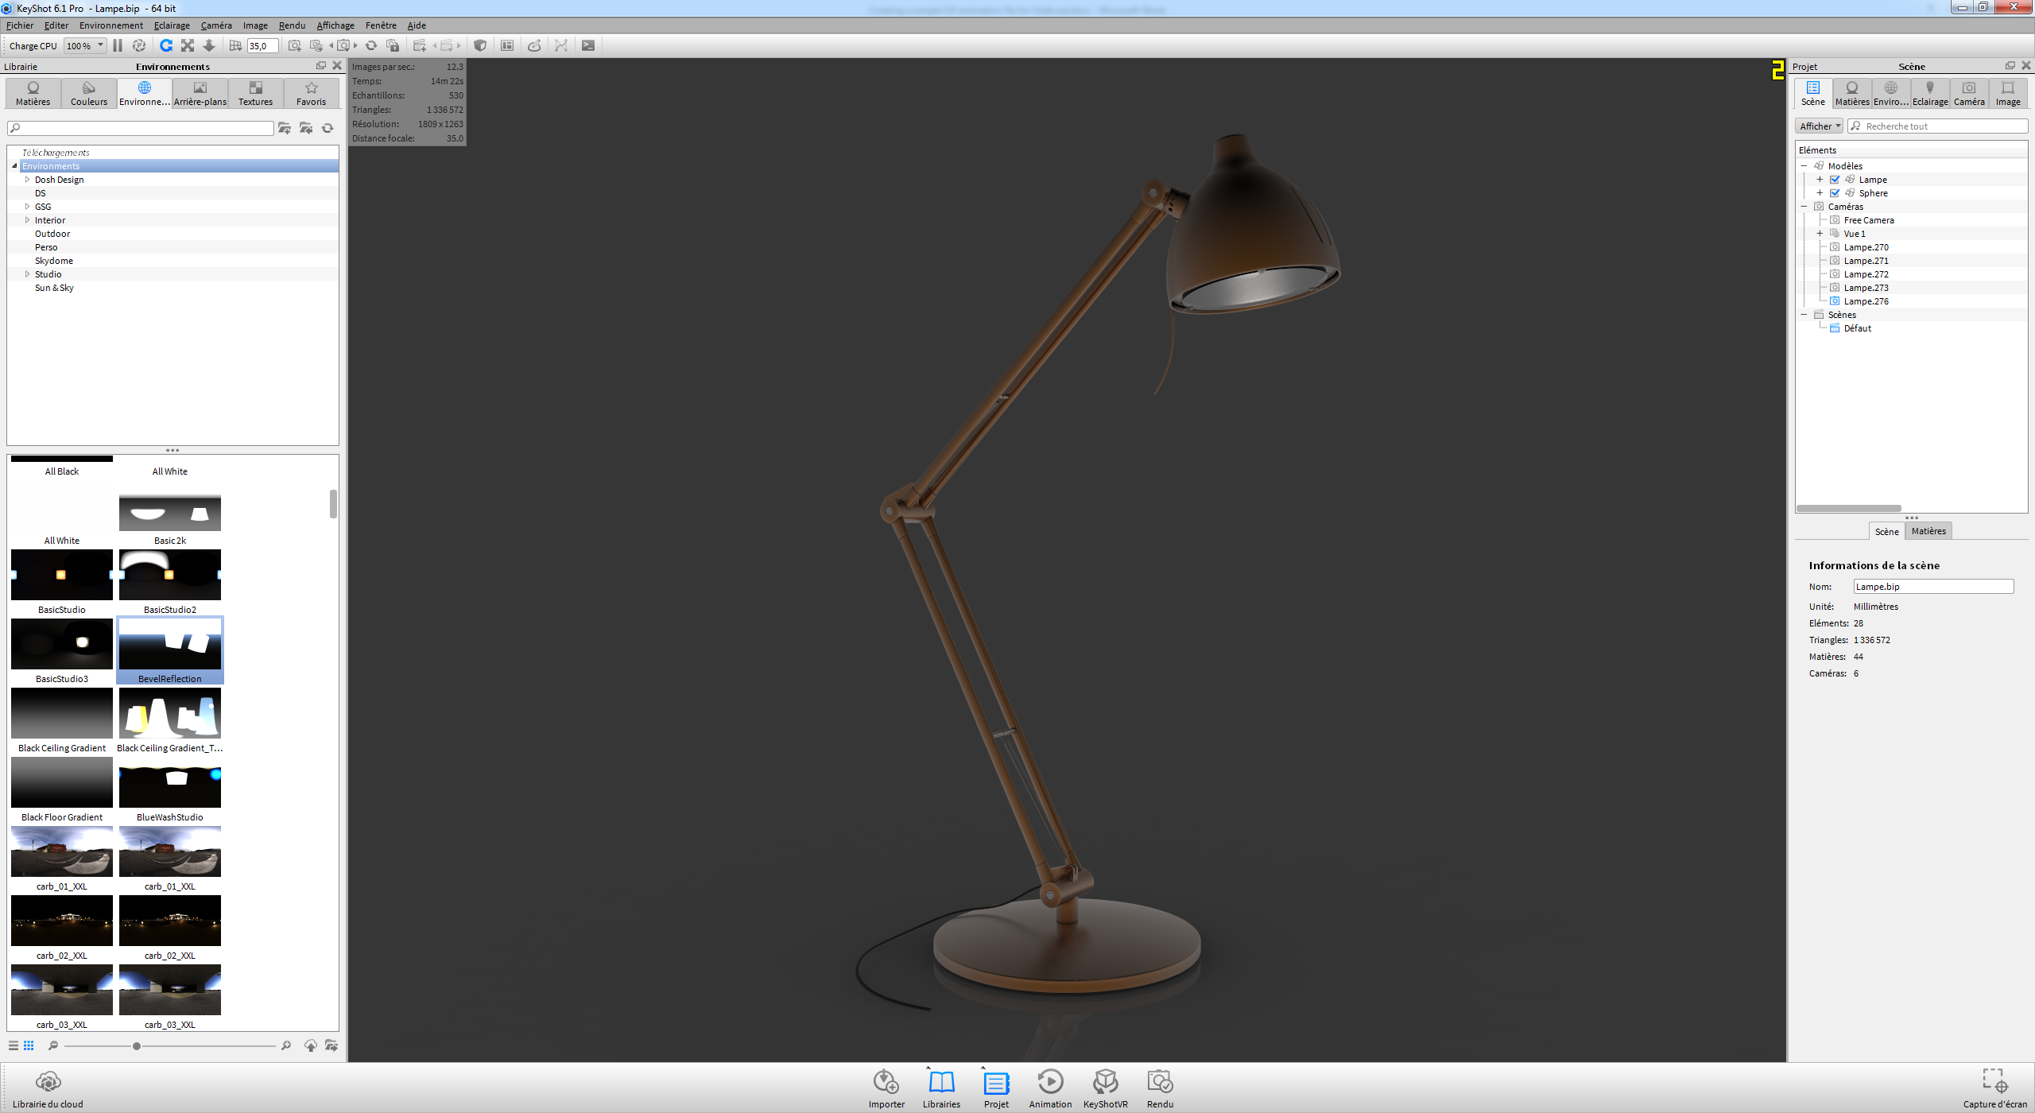

This example will use simple turn table.

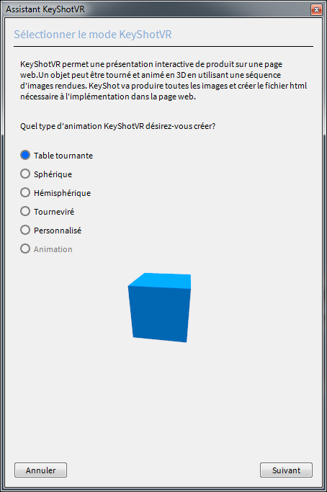

Don’t hesitate to try the others option. You can

Choose the center of rotation of your model

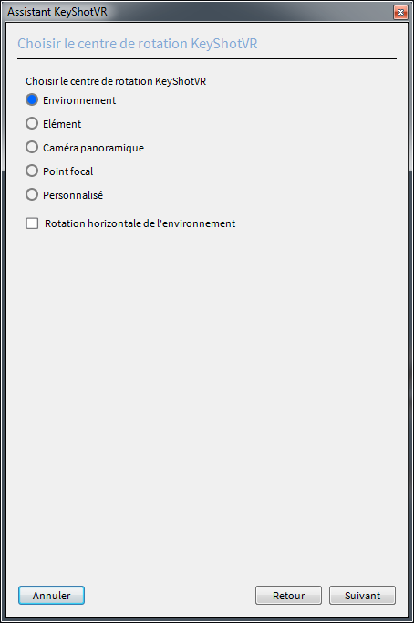

Configure camera settings

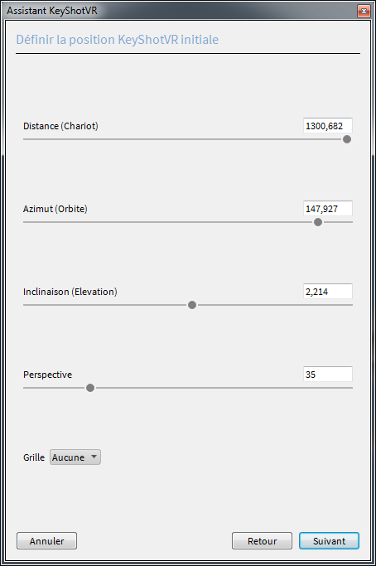

Choose the numbers of images for your KeyshotVR animation

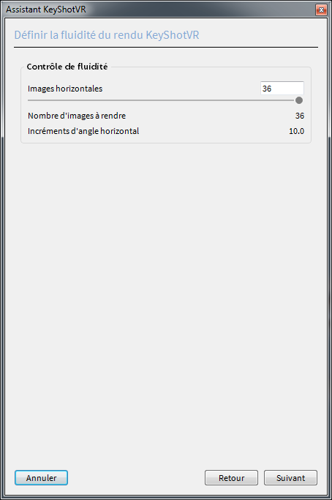

More images will produce a bigger file but a better fluidity

Less images will produce a smaller image but less fluidity

Choose the name for your KeyshotVR animation, the access folder and the resolution

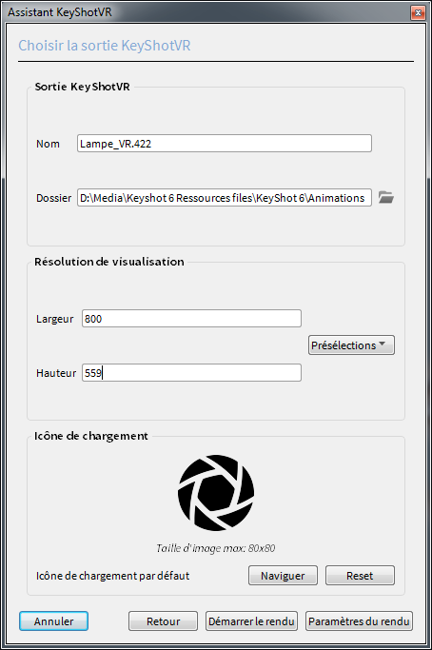

Bigger resolution will produce a bigger file with a better resolution

Smaller resolution will produce a smaller file with a lower resolution

It’s a matter of compromise

Configure all the different options for the KeyshotVR rendering

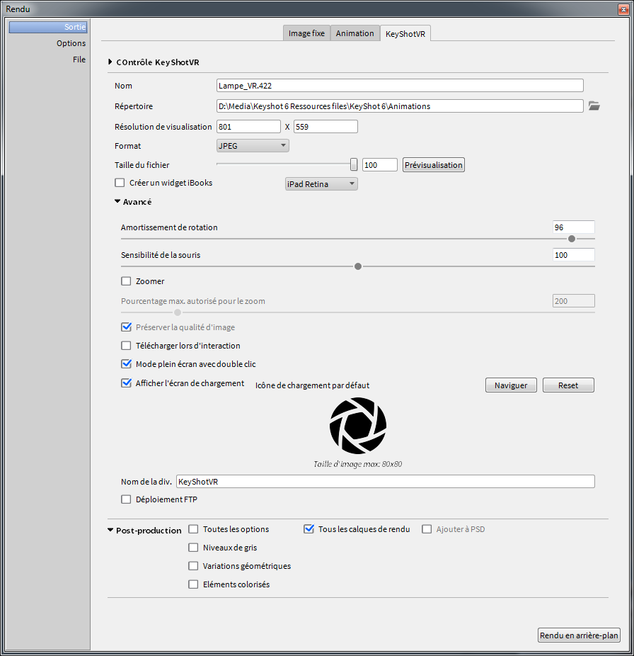

Choose time consuming for each image

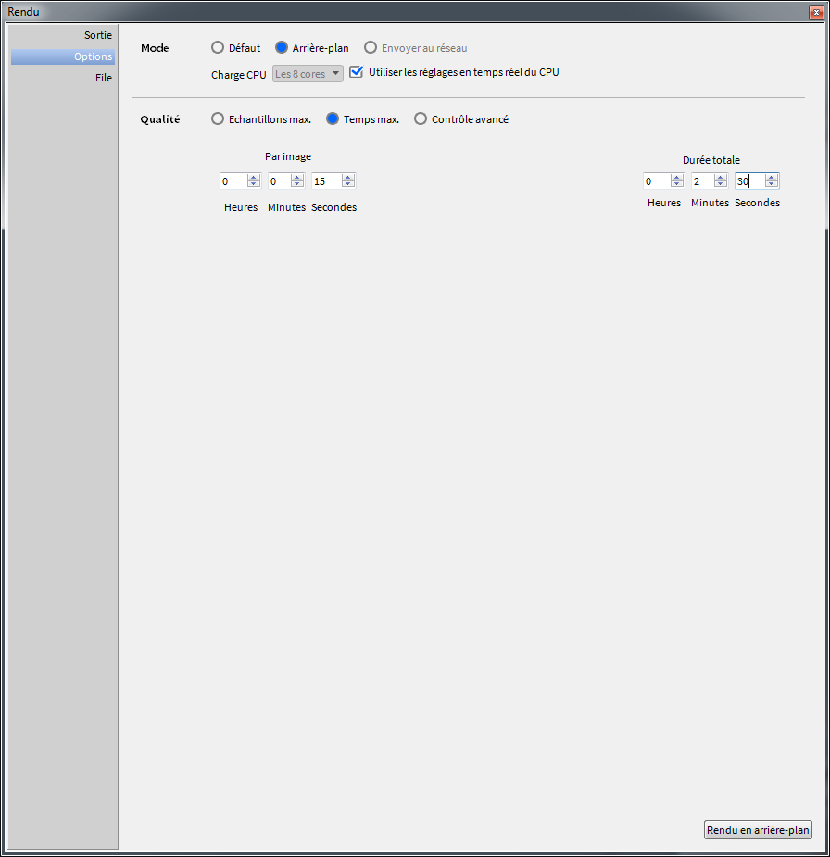

More time will produce a better definition image

KeyshotVR animation is processing

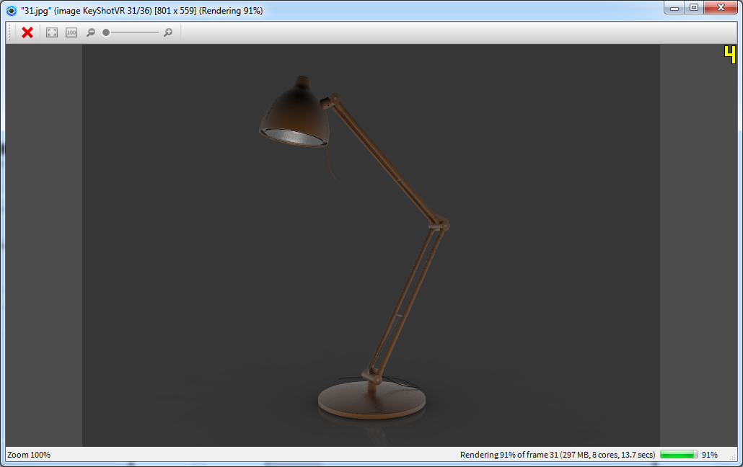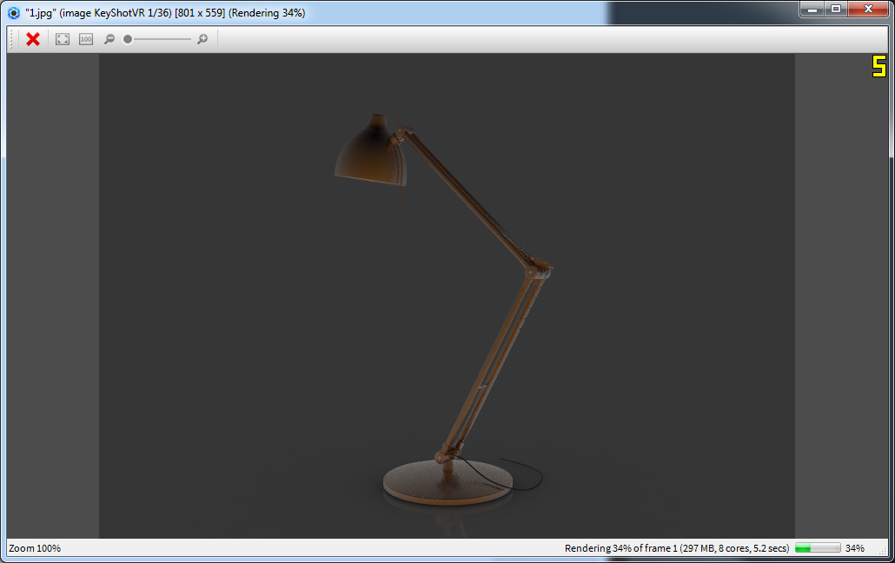

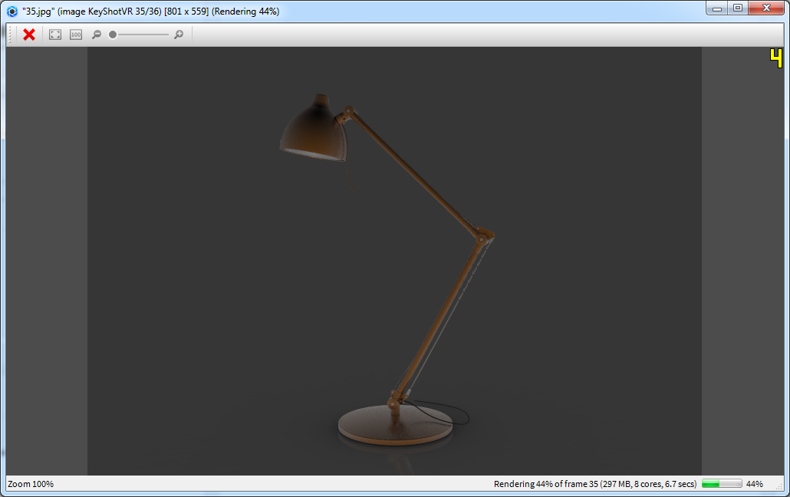

At the end of the process Keyshot VR open the result in a web explorer.

Move your mouse inside the image.

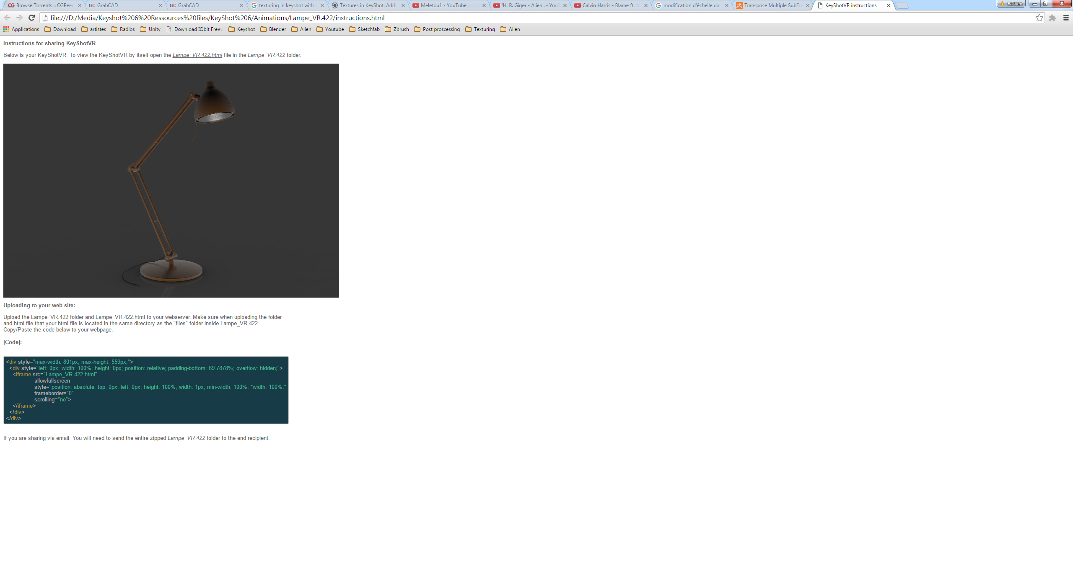

Wow it’s fantastic!!

Yes, KeyshotVR is really a good way to show your project!

You can add the KeyshotVR on Your web server if you have one.

You’ll find the instructions in the html file

Open the folder where the rendering images have been done

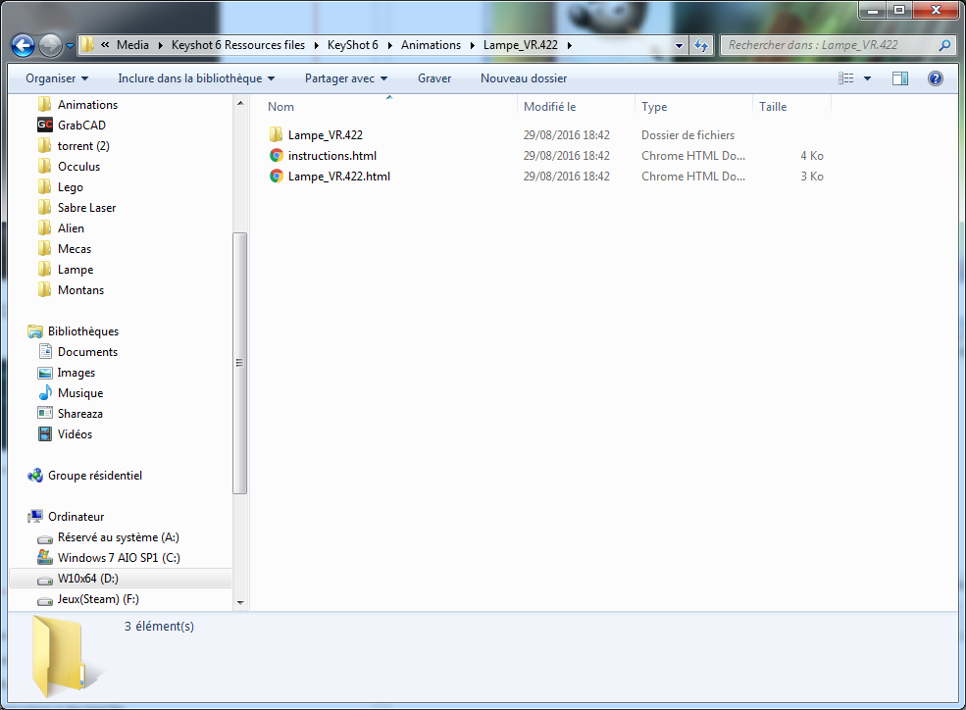

As you can see Keyshot have stored all the images of the KeyshotVR animation in the folder chosen before

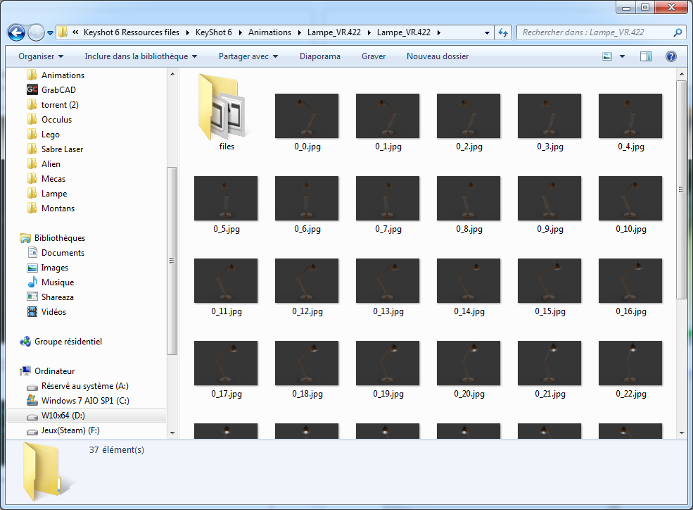

You will open them with Gimp

1. Start Gimp

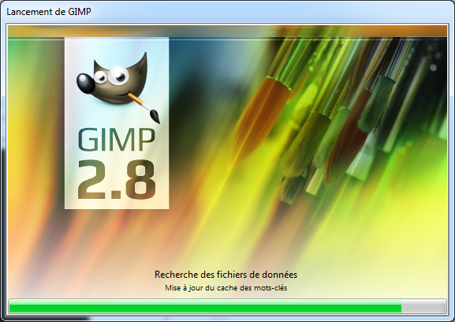

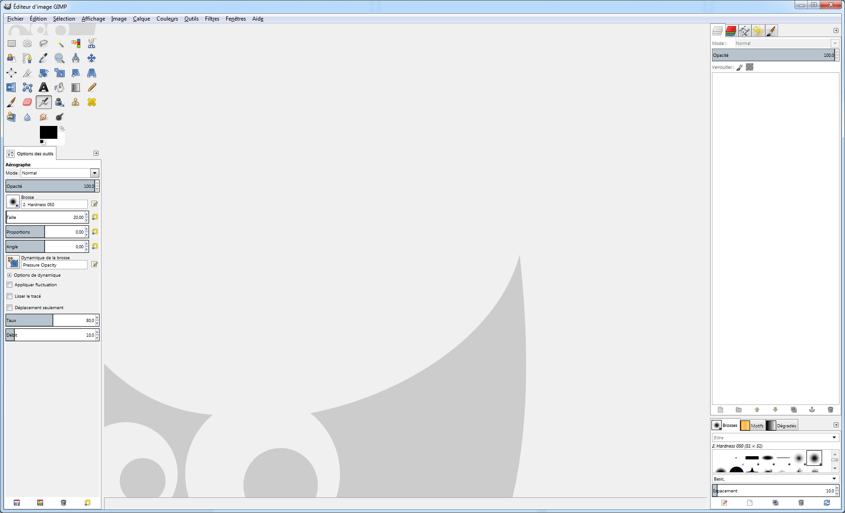

Click on “open as layers”

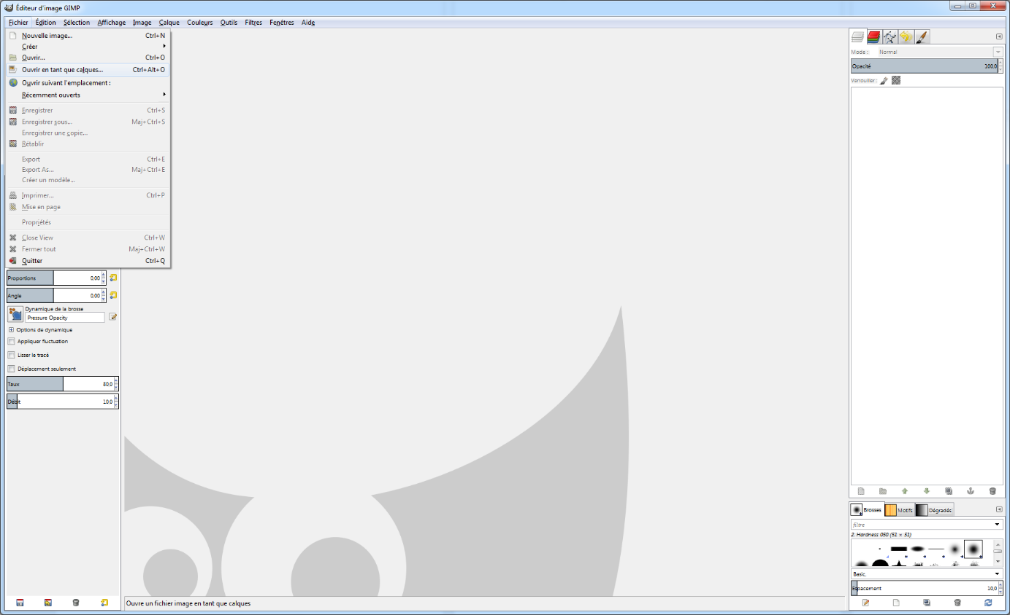

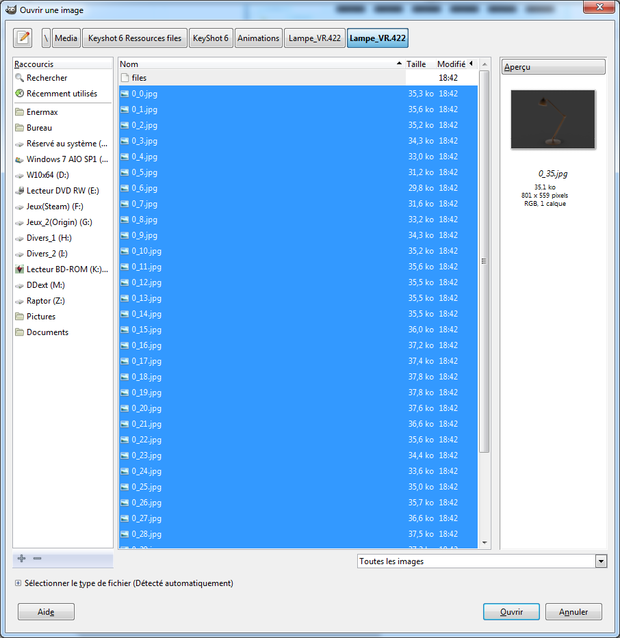Select all the images

You should see all the images as layers in Gimp

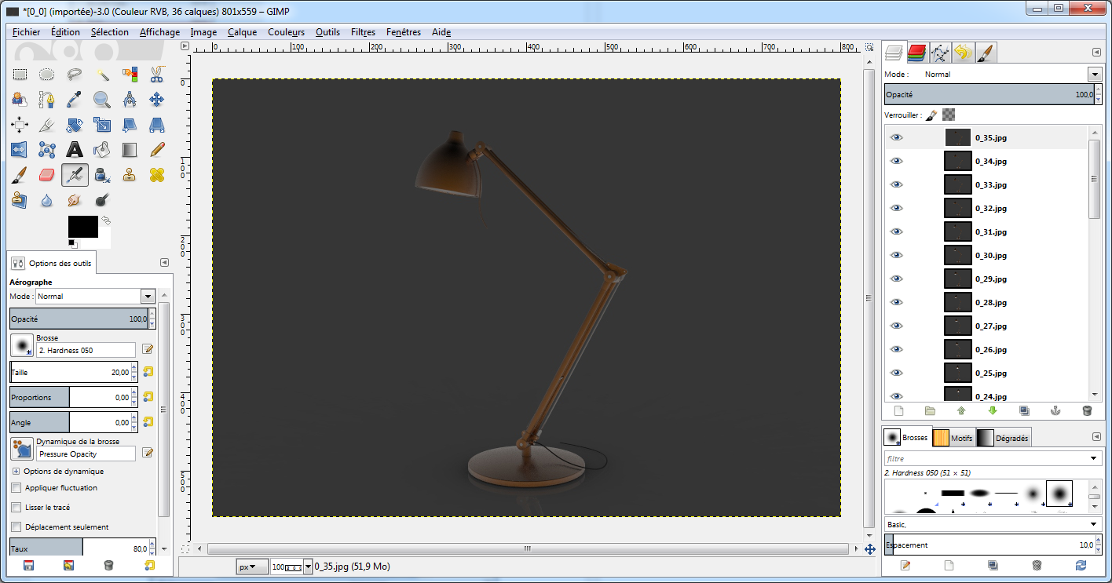

You can verify the future result clicking here

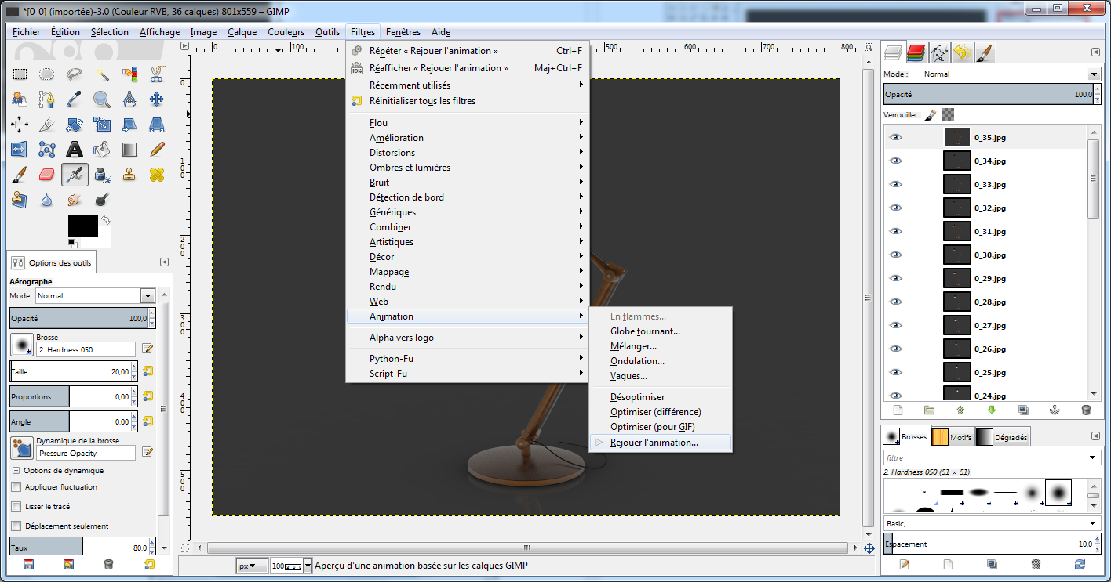

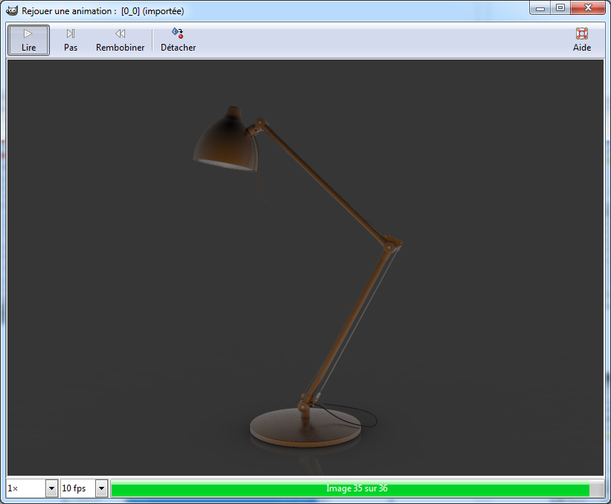

If you want to optimize the gif for a smaller file here



1. Export as Gif with gimp

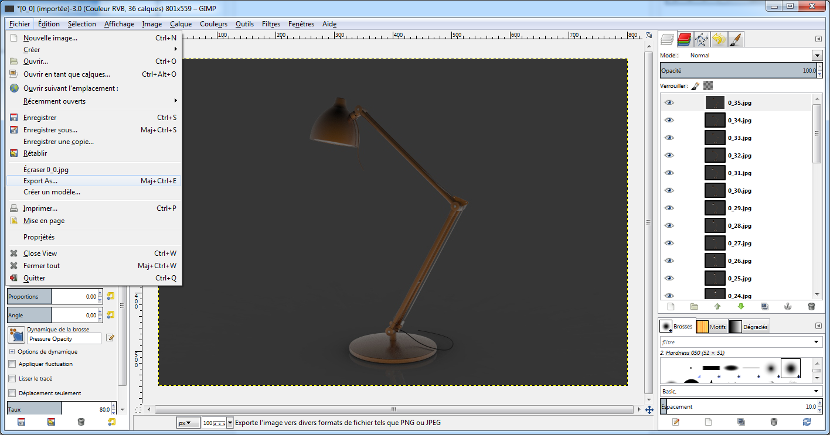

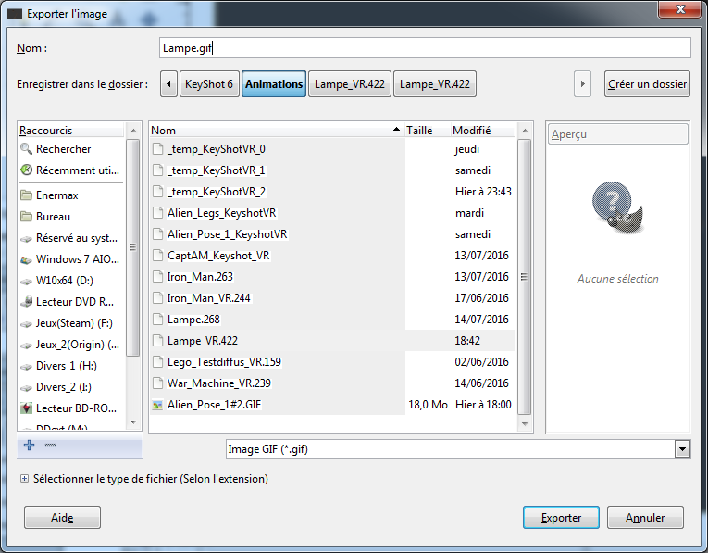

Choose the parameters for the gif animation

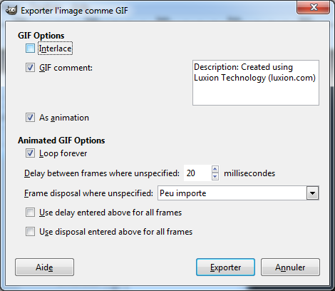

20 milliseconds is a little fast for this example, it’s depends how much images you have.

Remember, I’ve chosen 36 images for 360° of rotation so for this animation, a rotation of 360° will be done in less than 1 second (0,72 second ) ! it’s too fast.

Don’t hesitate to do test and **calculate before launching the rendering**, it’s important ;)

Then you can upload the gif animation in Grabcad or for example, for your website.

Sorry for my poor English, I’m french but I hope this tutorial will help you uploading gif!!!

Have a nice day, and if you want, you can like my model on my grabcad profile (<https://grabcad.com/marc.dupuy-1>), or send me questions about any software. If I can, I’ll respond.

BYE !!

The example project on my profile

<https://grabcad.com/library/desk-lamp-27>

