MODEL SPRING IN SOLIDWORKS OPCION HELIX/ESPIRAL Y SWEPT BOSS BASE
I know two ways to do a spring in SolidWorks, one is using Helix and Spiral with Swept Boss/Base and the other option is using only Swept Boss / Base.
I´m going to explaine Helix and Spiral with Swept Boss/Base:
1 paso_circulo
Open a new part. Create a 2D sketch. Select the Top Plane in the feature tree and create a sketch by clicking on the 2D Sketch icon. Create a circle 100 mm diameter and click OK.
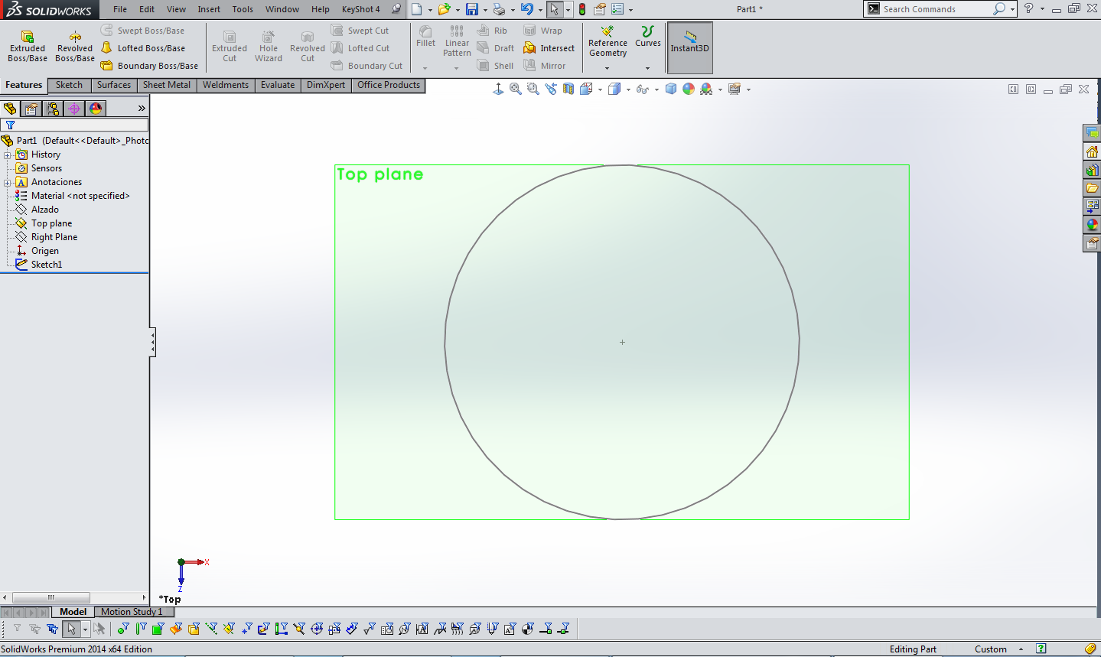
2 paso_helice:
Create a Helix / Spiral. Select the Constant Pitch option
Set the Pitch length to 25 mm. Set the number of Revolutions to 10. Set the Start angle to 0 deg. Select the Clockwise option and clic OK.
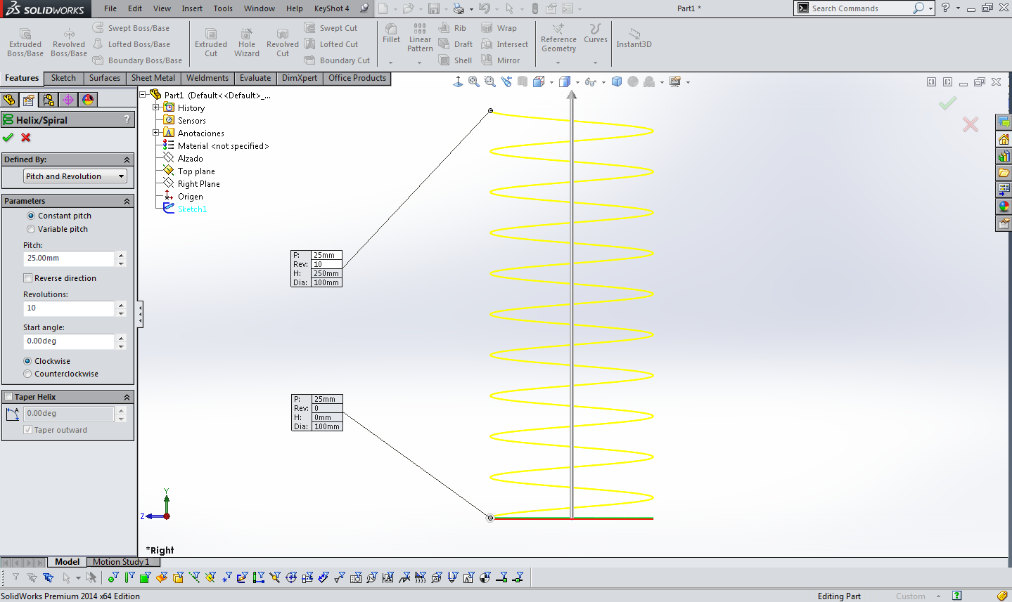
3 paso_espira:
Create a 2D sketch. Select the Right Plane and create a sketch. Create another circle. Create a circle somewhere at the Right Plane as shown in the picture. Connect the Circle sketch with the Spiral Sketch. Select the midpoint of the circle, hold down the Control key and select the Spiral sketch. Click at Pierce. The circle is now connected with the Spiral sketch. Change the diameter of the circle into Ø15 mm by clicking at the dimension button and clic OK.
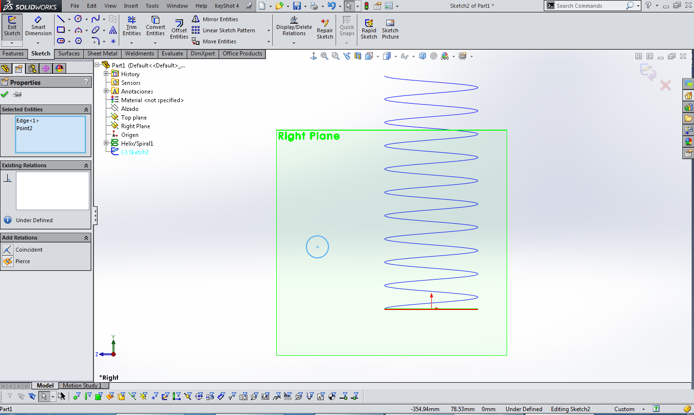
Create a Swept Boss/Base. Select profile Sketch2 and select path Helix/Spiral1 and select OK.
And ready model spring in Solidworks.
