The tolerance text color is Green here.

But, I want the tolerance text color as my Dimension Layer color.

(My Dimension is in Dimension Layer and the Color of Dimension Layer

is White)

What should I do ?

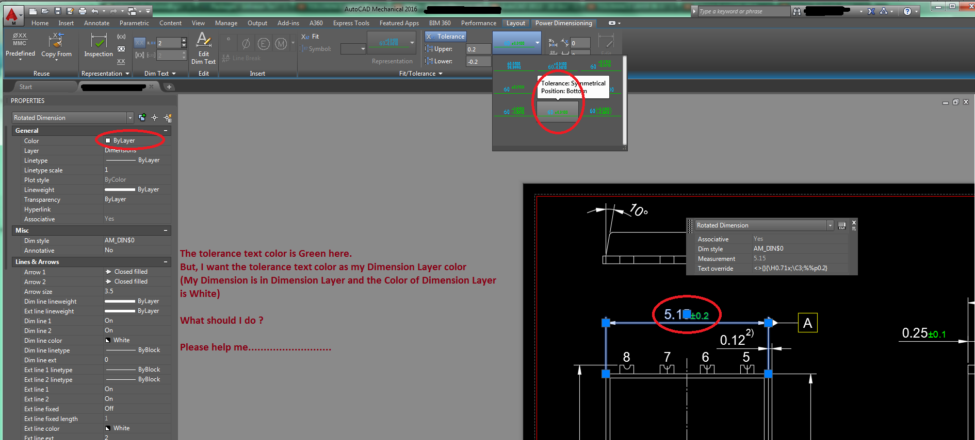Please help me...........................

The GD&T text color is White and the outline box color is Yellow here.

But, I want the text outline box color as white, what I defined before

in GD&T color setting. (My DG&T color is white)

What should I do ?

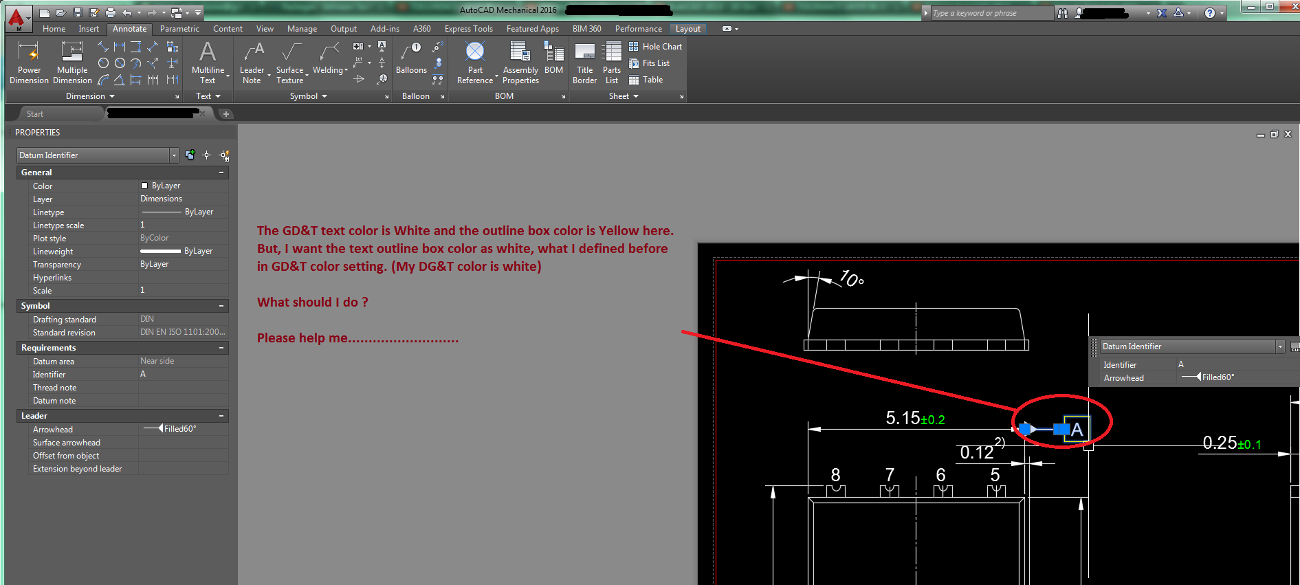Please help me...........................

