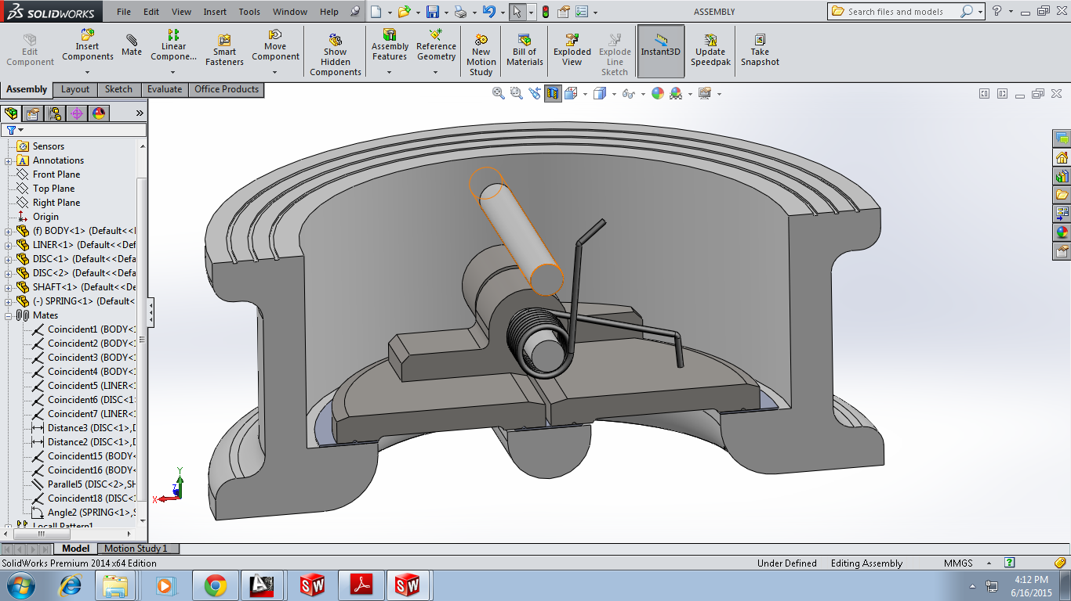

THIS END OF SPRING

HOW TO MATE THE END OF SPRING WITH THE SHAFT. CAN WE STRETCH THE SPRING TO MATE IT WITH THE SHAFT.