The numbers used in this example model are for (12) .080 sq. diamond shapes on both the flat side and the curved side. Adjust to suit quantities and sizes you needs.

(1)Start with the top view sketch of the base. I put this sketch on the top plane. Notice that the flat side is matched to the perimeter of the curved side. Note to get the perimeter dim first click the arc then each end point of the arc you would want to hold. The .015 dims used here end up being the corner radius of the final part.
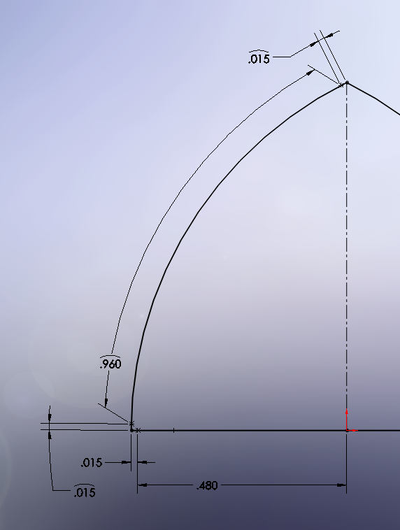

(2) add 3D sketch, this will be the base of the diamond. This base will later be extruded out at an angle.
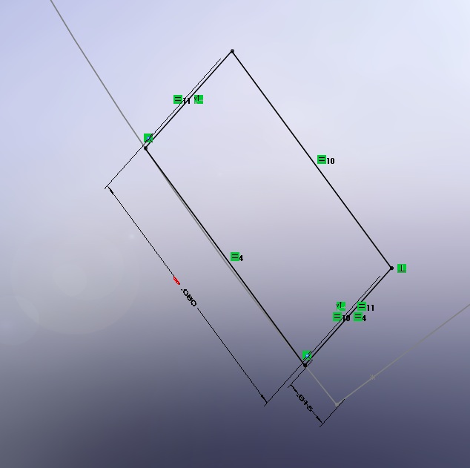

(3)Add a separate 3D sketch of the vector direction to use in the next step. This will be just a single line, coincident to any of the four corners of the square, perpendicular to both legs (to see this look at the picture in step (4) and the line is highlighted blue and named Line1@3DSketch3). You will use this for the emboss direction.

(4)Emboss the shape (Square). The distance just needs to be greater the then the height, you desire the draft angle will eliminate the extra amount. Notice in this example the angle is 70 degrees (or 20 depending on how you look at it.).

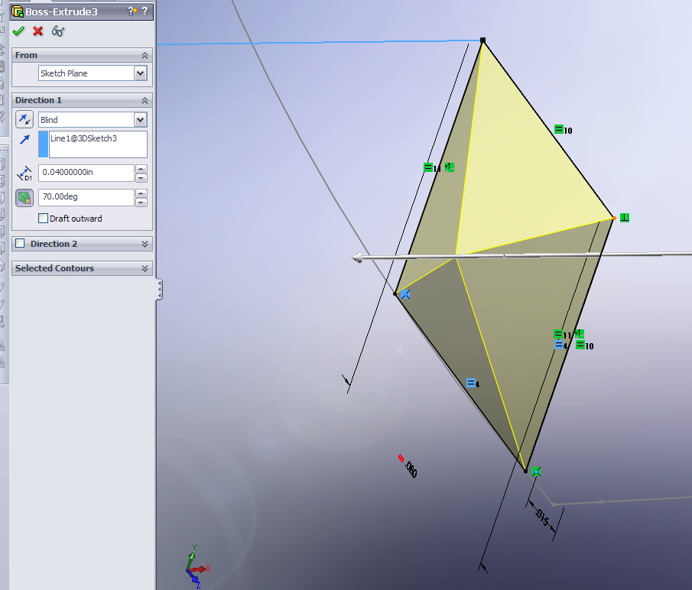

(5) Delete the inner flat face of the diamond to make it from a part to surfaces.
Be sure the change the Options from Delete and Patch to just Delete.
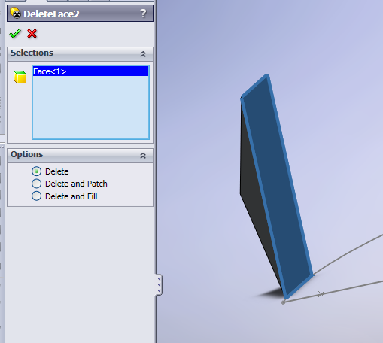

(6)Make a Pattern selecting the Body, upward for the amount of rows, in this case 3, the distance will be equal to the width of the diamond. Do not pick the feature, must be the body to work. By default bodies selection is sorta hidden but its there just hit the down arrows.
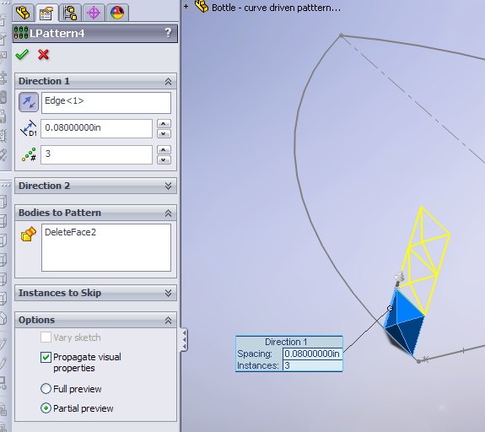

(7)Knit those three Surface Bodies together, when knitting you may need to increase the gap tolerance (I did to .001”). Select Merge entities.
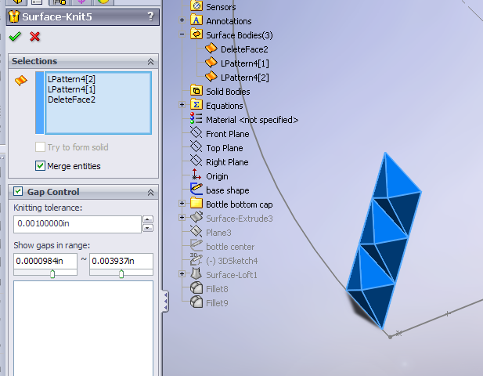

(8)Copy this body, and then move it to the flat side. Note that is two steps; step one to copy it (and just drag it anywhere), then step two is to move it, to move it I made it parallel to the flat line and coincident to the .015 point that was for the corner rad..
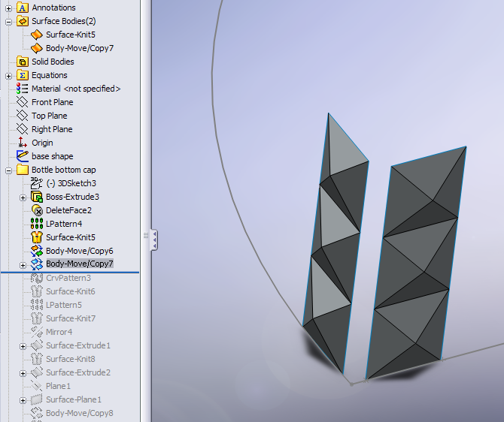

(9)Now use the Curve driven pattern, here are the options I used. Again the distance is equal to the diamond size. Also select the Surface body.
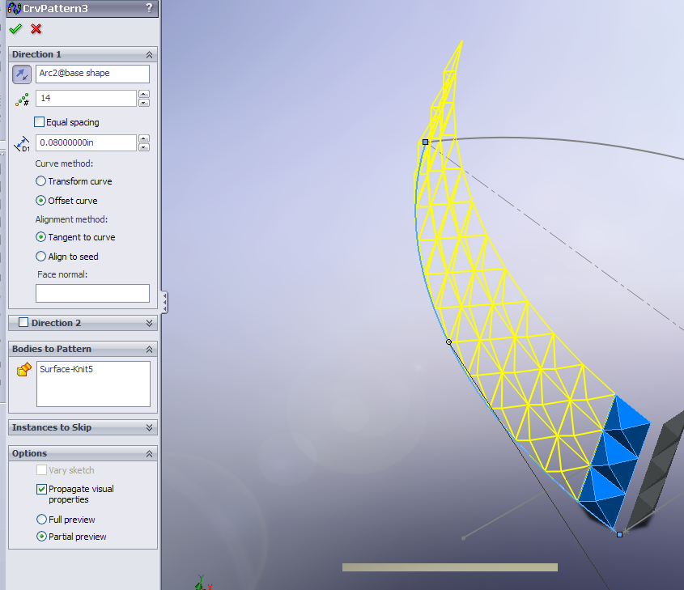

I can elaborate more on this later but for now out of time:
-After this I did the same to the flat side with a regular pattern.
-Mirrored the curved pattern to the other side.
-Created another sketch on the top plane that was just like the outer shape but offset it in the material thickness (I used .015”) then surface extruded it up to the top of the third row of diamond pattern.
-Made a top and bottom with surfaces.
-Once water tight I knitted all the surfaces to be a solid part.
-Done ☺

