Create the Through Curves surface
- Open ffm4_mc_fender.
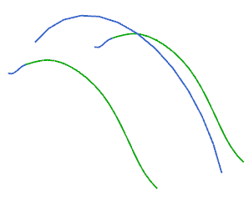
- Select all three strings, and then on the Analyze Shape toolbar, click Show End Points .
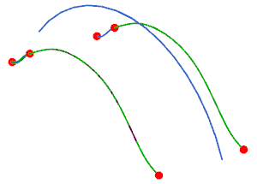
Notice there are two curves in the strings on the left and on the right, but only one curve in the middle string. Take note of where the curves in the front of both the left and right strings end.
- Press the Escape key to deselect the curves.
- On the Surface toolbar, click Through Curves .
- In the Through Curve dialog box, from the Alignment list, ensure that Parameter is selected.
- Select the Preserve Shape check box.
- In the Sections group, highlight Select Curve or Point.
- On the Selection bar, from the Curve Rule list, select Tangent Curves.
- Select the curve as shown.
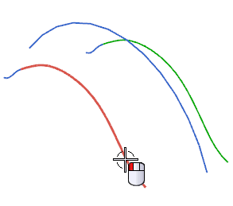
- Click the middle mouse button to advance.
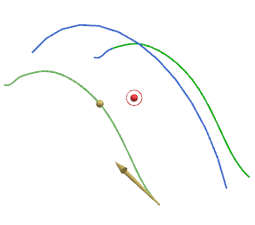
- Select the second curve as shown.
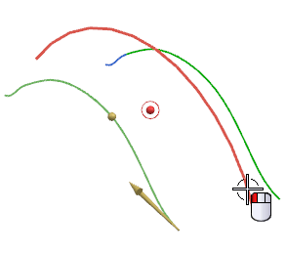
- Click the middle mouse button to advance.
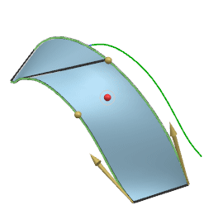
- Select the final curve as shown.
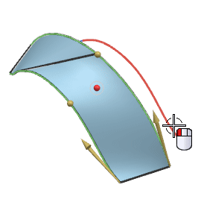
The preview of the surface is displayed
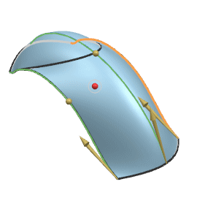
- Click OK.

Edit the surface alignment
- In the view background, right-click and choose Rendering Style→Shaded.
- Rotate the part and notice the irregularity of the shape.
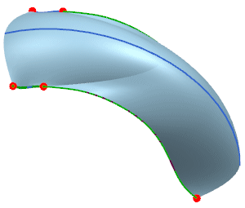
- On the Utility toolbar, click Edit Object Display .
- In the Class Selection dialog box, select the surface and click OK.
- In the Edit Object Display dialog box, expand the Wireframe Display group, and in the U and V boxes, type 10.
- Click OK.
- In the view background, right-click and choose Rendering Style→Static Wireframe.
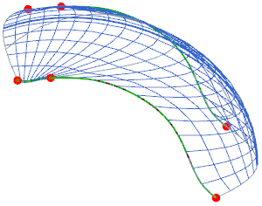
Notice how Parameter alignment and Preserve Shape affect the isoparameter lines of the surface.
- Double-click the surface as shown.
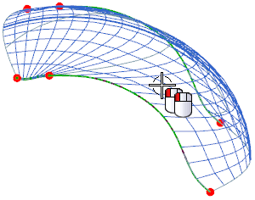
The Through Curves dialog box is displayed.
- In the Settings group, clear the Preserve Shape check box.
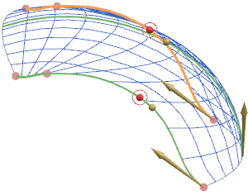
- In the Alignment group, from the Alignment list, choose Arc Length.
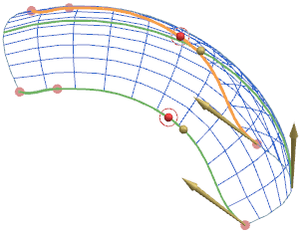
- In the view background, right-click and choose Rendering Style→Shaded with Edges.
- Click OK.
- Hide all the curves and sketches.
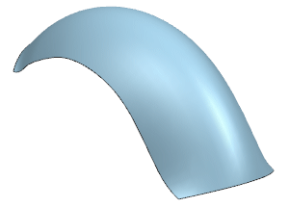
Tip | On the Utility toolbar, click Show and Hide .  - In the Hide column, click the Negative signs “–” for Sketches and Curves.  - click Close.

Trim the solid body to the surface
- In the Part Navigator, right-click Extrude (8) and choose Show.
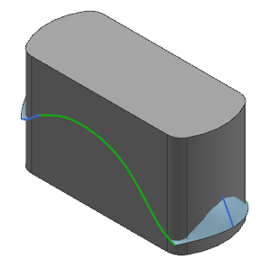
The Trim Body dialog box appears.
- On the Feature toolbar, click Trim Body .
The Trim Body dialog box is displayed.
- Select the solid body as shown.
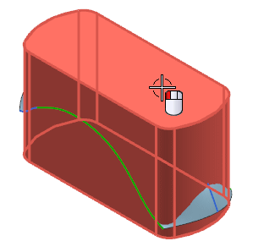
- Click the middle mouse button to advance to the Tool selection.
- Select the Tool body as shown.
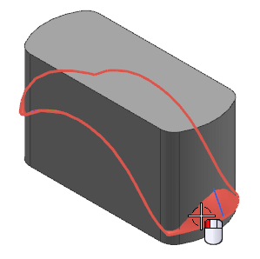
- If your part does not appear as shown, click Reverse Direction.
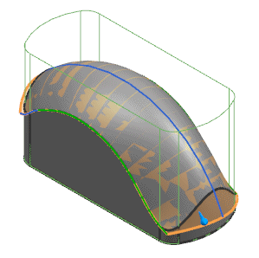
- Click OK.
- On the Utility toolbar, click Show and Hide .
  - In the Show and Hide dialog box, select the minus Hide symbol for Curves, Sketches, and Sheet Bodies.
  - Click Close.
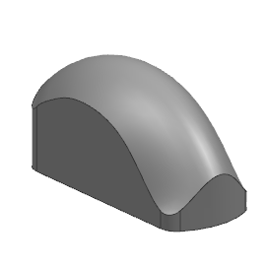

Create a shell feature
- On the Feature toolbar, click Shell .
- On the Selection toolbar, from the Face Rule list, select Tangent Faces.
- Select the face as shown.
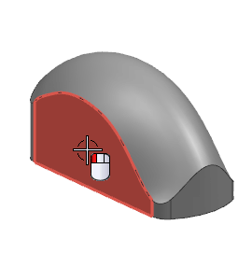
If you get an Alerts message, you can dismiss it.
- Select the bottom face of the part.
The preview is displayed.
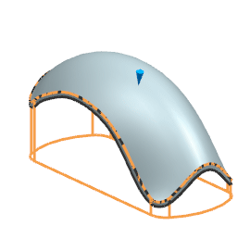
- In the Thickness group, in the Thickness box, type 5.
- Click OK.
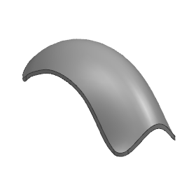
Other features would be added to complete the part.
- Close the part.
You completed the activity.

Use parameter alignment
- Open ffm4_thru_curves_2.
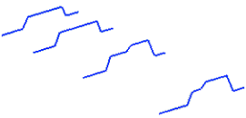
You will use the four sets of sketch curves to define the shape of the surface.
- On the Surface toolbar, click Through Curves .
- At the top of the Through Curves dialog box, click Reset .
- Make sure the following settings are selected:
  - In the Continuity group, First Section and Last Section = G0 (Position).
  - In the Alignment group, Alignment = Parameter.
  - In the Output Surface Options group, Patch Type = Multiple.
  - Construction = Normal.
  - Normal to End Sections = cleared .
  - In the Alignment group, Preserve Shape = cleared..
  - Lofting Degree = 3.

✓ 2 of 3 ▼ ✓
Create a surface using By Points alignment

Select the section curves
- In the Sections group of the dialog box, make sure Select Curve or Point is active.
- Expand the List so you can follow the selection of sections.
- From the Curve Rule list select Feature Curves.
- Select the first section at the left end, and click the middle mouse button or click Add New Set to complete the selection of the first section.
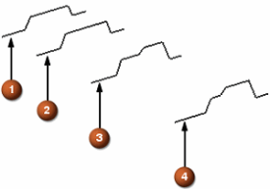
- Select the second section at the left end and click the middle mouse button.
- Select the third and then the fourth setions at their left ends and click the middle mouse button after each selection.
Your vectors should display like this.
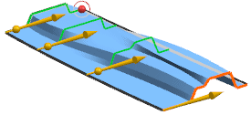
✓ ✓

1 - Use parameter alignment
2 - Select the section curves
3 - Change to By Points alignment

Change to By Points alignment
- In the Alignment group, from the Alignment list, select By Points.
The alignment points for each section are calculated and they are connected with lines.
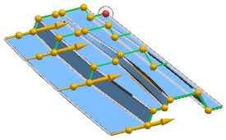
The alignment is now better than with parameter alignment, but you want to change the location of the points on sections 1 and 2 to provide a better transition shape for the upper angled face, and how it washes out.
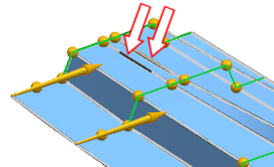
- In the Alignment group, make sure Specify Point is active, drag the four alignment points for the sections indicated above so it looks something like the following, and then click OK.
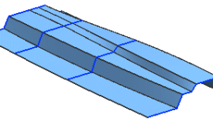
Separate faces are formed between the sharp corners in this part.
- In the graphics window, double-click the surface you just created.
In the Setting group, the Lofting Degree value is 3.
- In the Lofting Degree box, type 1 and click OK.
- Rotate the view so you are looking at the part as shown below.
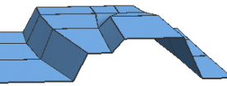
Notice that the shape of the surface between section curves is now linear (degree 1), and that there are new faces and edges at the sections.
This would be more clear if the sketches were hidden.
- Double-click the surface again and change the Lofting Degree to 2.
The shape of the surface is now better, and there are no separate faces at the section curves.
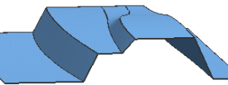
- Close all parts.
You completed the activity.

Create a solid body using Spline Points alignment

Open the part and start the feature
- Open ffm2_thru_curves_4 and start the Modeling application if it is not already active.
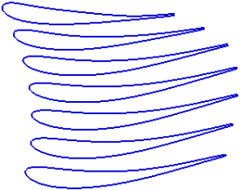
- On the Surface toolbar, click Through Curves .
- At the top of the Through Curves dialog box header, click Reset .
When you use the Spline Points construction method, the section curves must be single B-curves each with the same number of defining points. In this part, the section curves meet these conditions.
- In the Alignment group, select the Preserve Shape check box.
- On the Selection bar, from the Curve Rule list, select Single Curve.
- In the Sections group of the dialog box, make sure Select Curve or Point is active, select each of the sections (at the locations indicated by the arrowheads) as shown in the graphic below
Note: Make sure to click the middle mouse button or click Add New Set after each selection.
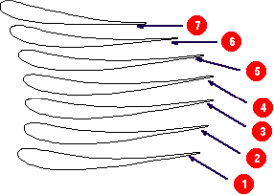
Tip | You can expand the list in the dialog box to better follow your selection process.
- Make sure the direction vectors point in the same direction, otherwise your part will be twisted.
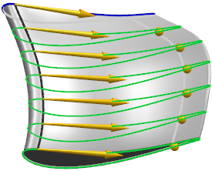

Specify the alignment
- In the Output Surface Options group, from the Construction list, select Spline Points.
- In the Alignment group, clear the Preserve Shape check box.
Notice that the edge (face division) disappeared.
- Click OK to create the body.
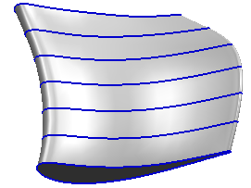
If you were to create this feature using the Normal Construction, you would have a higher number of faces and patches, making the faces more complex. Using spline points simplifies the faces while maintaining zero tolerance at the spline points.
- Close all parts.

