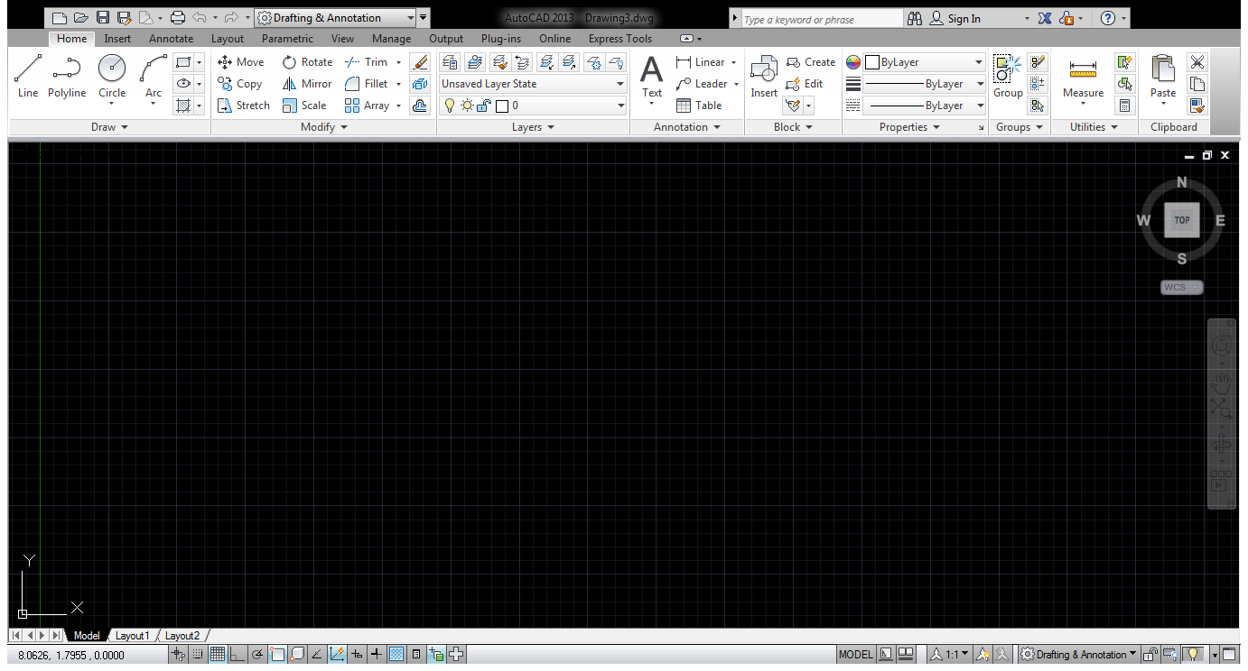
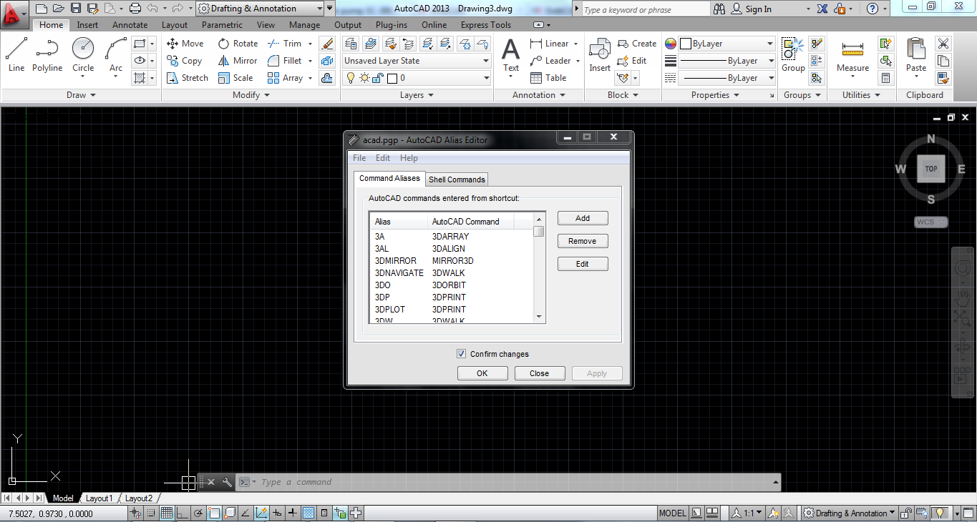
3A, *3DARRAY
3DMIRROR, *MIRROR3D
3DNavigate,*3DWALK
3DO, *3DORBIT
3DP, *3DPRINT
3DPLOT, *3DPRINT
3DW, *3DWALK
3F, *3DFACE
3M, *3DMOVE
3P, *3DPOLY
3R, *3DROTATE
3S, *3DSCALE
A, *ARC
AC, *BACTION
ADC, *ADCENTER
AECTOACAD, *-ExportToAutoCAD
AA, *AREA
AL, *ALIGN
3AL, *3DALIGN
AP, *APPLOAD
APLAY, *ALLPLAY
AR, *ARRAY
-AR, *-ARRAY
ARR, *ACTRECORD
ARM, *ACTUSERMESSAGE
-ARM, *-ACTUSERMESSAGE
ARU, *ACTUSERINPUT
ARS, *ACTSTOP
-ARS, *-ACTSTOP
ATI, *ATTIPEDIT
ATT, *ATTDEF
-ATT, *-ATTDEF
ATE, *ATTEDIT
-ATE, *-ATTEDIT
ATTE, *-ATTEDIT
B, *BLOCK
-B, *-BLOCK
BC, *BCLOSE
BE, *BEDIT
BH, *HATCH
BLENDSRF, *SURFBLEND
BO, *BOUNDARY
-BO, *-BOUNDARY
BR, *BREAK
BS, *BSAVE
BVS, *BVSTATE
C, *CIRCLE
CAM, *CAMERA
CBAR, *CONSTRAINTBAR
CH, *PROPERTIES
-CH, *CHANGE
CHA, *CHAMFER
CHK, *CHECKSTANDARDS
CLI, *COMMANDLINE
COL, *COLOR
COLOUR, *COLOR
CO, *COPY
CONVTOMESH, *MESHSMOOTH
CP, *COPY
CPARAM, *BCPARAMETER
CREASE, *MESHCREASE
CREATESOLID, *SURFSCULPT
CSETTINGS, *CONSTRAINTSETTINGS
CT, *CTABLESTYLE
CUBE, *NAVVCUBE
CURVATUREANALYSIS, *ANALYSISCURVATURE
CYL, *CYLINDER
D, *DIMSTYLE
DAL, *DIMALIGNED
DAN, *DIMANGULAR
DAR, *DIMARC
DELETE, *ERASE
JOG, *DIMJOGGED
DBA, *DIMBASELINE
DBC, *DBCONNECT
DC, *ADCENTER
DCE, *DIMCENTER
DCENTER, *ADCENTER
DCO, *DIMCONTINUE
DCON, *DIMCONSTRAINT
DDA, *DIMDISASSOCIATE
DDI, *DIMDIAMETER
DED, *DIMEDIT
DELCON, *DELCONSTRAINT
DI, *DIST
DIV, *DIVIDE
DJL, *DIMJOGLINE
DJO, *DIMJOGGED
DL, *DATALINK
DLI, *DIMLINEAR
DLU, *DATALINKUPDATE
DO, *DONUT
DOR, *DIMORDINATE
DOV, *DIMOVERRIDE
DR, *DRAWORDER
DRA, *DIMRADIUS
DRAFTANGLEANALYSIS, *ANALYSISDRAFTANGLE
DRE, *DIMREASSOCIATE
DRM, *DRAWINGRECOVERY
DS, *DSETTINGS
DST, *DIMSTYLE
DT, *TEXT
DV, *DVIEW
DX, *DATAEXTRACTION
E, *ERASE
ED, *DDEDIT
EL, *ELLIPSE
ER, *EXTERNALREFERENCES
ESHOT, *EDITSHOT
EX, *EXTEND
EXIT, *QUIT
EXP, *EXPORT
EXT, *EXTRUDE
EXTENDSRF, *SURFEXTEND
F, *FILLET
FI, *FILTER
FILLETSRF, *SURFFILLET
FREEPOINT, *POINTLIGHT
FSHOT, *FLATSHOT
G, *GROUP
-G, *-GROUP
GCON, *GEOMCONSTRAINT
GD, *GRADIENT
GENERATESECTION, *SECTIONPLANETOBLOCK
GEO, *GEOGRAPHICLOCATION
GR, *DDGRIPS
H, *HATCH
-H, *-HATCH
HE, *HATCHEDIT
HB, *HATCHTOBACK
HI, *HIDE
I, *INSERT
-I, *-INSERT
IAD, *IMAGEADJUST
IAT, *IMAGEATTACH
ICL, *IMAGECLIP
IM, *IMAGE
-IM, *-IMAGE
IMP, *IMPORT
IN, *INTERSECT
INSERTCONTROLPOINT, *CVADD
INF, *INTERFERE
IO, *INSERTOBJ
ISOLATE, *ISOLATEOBJECTS
QVD, *QVDRAWING
QVDC, *QVDRAWINGCLOSE
QVL, *QVLAYOUT
QVLC, *QVLAYOUTCLOSE
J, *JOIN
JOGSECTION, *SECTIONPLANEJOG
L, *LINE
LA, *LAYER
-LA, *-LAYER
LAS, *LAYERSTATE
LE, *QLEADER
LEN, *LENGTHEN
LESS, *MESHSMOOTHLESS
LI, *LIST
LINEWEIGHT, *LWEIGHT
LMAN, *LAYERSTATE
LO, *-LAYOUT
LS, *LIST
LT, *LINETYPE
-LT, *-LINETYPE
LTYPE, *LINETYPE
-LTYPE, *-LINETYPE
LTS, *LTSCALE
LW, *LWEIGHT
M, *MOVE
MA, *MATCHPROP
MAT, *MATBROWSEROPEN
ME, *MEASURE
MEA, *MEASUREGEOM
MI, *MIRROR
ML, *MLINE
MLA, *MLEADERALIGN
MLC, *MLEADERCOLLECT
MLD, *MLEADER
MLE, *MLEADEREDIT
MLS, *MLEADERSTYLE
MO, *PROPERTIES
MORE, *MESHSMOOTHMORE
MOTION, *NAVSMOTION
MOTIONCLS, *NAVSMOTIONCLOSE
MS, *MSPACE
MSM, *MARKUP
MT, *MTEXT
MV, *MVIEW
NETWORKSRF,*SURFNETWORK
NORTH, *GEOGRAPHICLOCATION
NORTHDIR, *GEOGRAPHICLOCATION
NSHOT, *NEWSHOT
NVIEW, *NEWVIEW
O, *OFFSET
OFFSETSRF, *SURFOFFSET
OP, *OPTIONS
ORBIT, *3DORBIT
OS, *OSNAP
-OS, *-OSNAP
P, *PAN
-P, *-PAN
PA, *PASTESPEC
RAPIDPROTOTYPE, *3DPRINT
PAR, *PARAMETERS
-PAR, *-PARAMETERS
PARAM, *BPARAMETER
PARTIALOPEN, *-PARTIALOPEN
PATCH, *SURFPATCH
PC, *POINTCLOUD
PCATTACH, *POINTCLOUDATTACH
PCINDEX, *POINTCLOUDINDEX
PE, *PEDIT
PL, *PLINE
PO, *POINT
POFF, *HIDEPALETTES
POINTON, *CVSHOW
POINTOFF, *CVHIDE
POL, *POLYGON
PON, *SHOWPALETTES
PR, *PROPERTIES
PRCLOSE, *PROPERTIESCLOSE
PROPS, *PROPERTIES
PRE, *PREVIEW
PRINT, *PLOT
PS, *PSPACE
PSOLID, *POLYSOLID
PTW, *PUBLISHTOWEB
PU, *PURGE
-PU, *-PURGE
PYR, *PYRAMID
QC, *QUICKCALC
QCUI, *QUICKCUI
QP, *QUICKPROPERTIES
R, *REDRAW
RA, *REDRAWALL
RC, *RENDERCROP
RE, *REGEN
REA, *REGENALL
REBUILD, *CVREBUILD
REC, *RECTANG
REFINE, *MESHREFINE
REG, *REGION
REMOVECONTROLPOINT, *CVREMOVE
REN, *RENAME
-REN, *-RENAME
REV, *REVOLVE
RO, *ROTATE
RP, *RENDERPRESETS
RPR, *RPREF
RR, *RENDER
RW, *RENDERWIN
S, *STRETCH
SC, *SCALE
SCR, *SCRIPT
SE, *DSETTINGS
SEC, *SECTION
SET, *SETVAR
SHA, *SHADEMODE
SL, *SLICE
SMOOTH, *MESHSMOOTH
SN, *SNAP
SO, *SOLID
SP, *SPELL
SPL, *SPLINE
SPLANE, *SECTIONPLANE
SPLAY, *SEQUENCEPLAY
SPLIT, *MESHSPLIT
SPE, *SPLINEDIT
SSM, *SHEETSET
ST, *STYLE
STA, *STANDARDS
SU, *SUBTRACT
T, *MTEXT
-T, *-MTEXT
TA, *TABLET
TB, *TABLE
TEDIT, *TEXTEDIT
TH, *THICKNESS
TI, *TILEMODE
TO, *TOOLBAR
TOL, *TOLERANCE
TOR, *TORUS
TP, *TOOLPALETTES
TR, *TRIM
TS, *TABLESTYLE
UC, *UCSMAN
UN, *UNITS
-UN, *-UNITS
UNCREASE, *MESHUNCREASE
UNHIDE, *UNISOLATEOBJECTS
UNI, *UNION
UNISOLATE, *UNISOLATEOBJECTS
V, *VIEW
VGO, *VIEWGO
VPLAY, *VIEWPLAY
-V, *-VIEW
VP, *DDVPOINT
-VP, *VPOINT
VS, *VSCURRENT
VSM, *VISUALSTYLES
-VSM, *-VISUALSTYLES
W, *WBLOCK
-W, *-WBLOCK
WE, *WEDGE
WHEEL, *NAVSWHEEL
X, *EXPLODE
XA, *XATTACH
XB, *XBIND
-XB, *-XBIND
XC, *XCLIP
XL, *XLINE
XR, *XREF
-XR, *-XREF
Z, *ZOOM
ZEBRA, *ANALYSISZEBRA

; The following are alternative aliases and aliases as supplied
; in AutoCAD Release 13.

AV, *DSVIEWER
CP, *COPY
DIMALI, *DIMALIGNED
DIMANG, *DIMANGULAR
DIMBASE, *DIMBASELINE
DIMCONT, *DIMCONTINUE
DIMDIA, *DIMDIAMETER
DIMED, *DIMEDIT
DIMTED, *DIMTEDIT
DIMLIN, *DIMLINEAR
DIMORD, *DIMORDINATE
DIMRAD, *DIMRADIUS
DIMSTY, *DIMSTYLE
DIMOVER, *DIMOVERRIDE
LEAD, *LEADER
TM, *TILEMODE

; Aliases for Hyperlink/URL Release 14 compatibility
SAVEURL, *SAVE
OPENURL, *OPEN
INSERTURL, *INSERT

; Aliases for commands discontinued in AutoCAD 2000:
AAD, *DBCONNECT
AEX, *DBCONNECT
ALI, *DBCONNECT
ASQ, *DBCONNECT
ARO, *DBCONNECT
ASE, *DBCONNECT
DDATTDEF, *ATTDEF
DDATTEXT, *ATTEXT
DDCHPROP, *PROPERTIES
DDCOLOR, *COLOR
DDLMODES, *LAYER
DDLTYPE, *LINETYPE
DDMODIFY, *PROPERTIES
DDOSNAP, *OSNAP
DDUCS, *UCS

; Aliases for commands discontinued in AutoCAD 2004:
ACADBLOCKDIALOG, *BLOCK
ACADWBLOCKDIALOG, *WBLOCK
ADCENTER, *ADCENTER
BMAKE, *BLOCK
BMOD, *BLOCK
BPOLY, *BOUNDARY
CONTENT, *ADCENTER
DDATTE, *ATTEDIT
DDIM, *DIMSTYLE
DDINSERT, *INSERT
DDPLOTSTAMP, *PLOTSTAMP
DDRMODES, *DSETTINGS
DDSTYLE, *STYLE
DDUCS, *UCSMAN
DDUCSP, *UCSMAN
DDUNITS, *UNITS
DDVIEW, *VIEW
DIMHORIZONTAL, *DIMLINEAR
DIMROTATED, *DIMLINEAR
DIMVERTICAL, *DIMLINEAR
DOUGHNUT, *DONUT
DTEXT, *TEXT
DWFOUT, *PLOT
DXFIN, *OPEN
DXFOUT, *SAVEAS
PAINTER, *MATCHPROP
PREFERENCES, *OPTIONS
RECTANGLE, *RECTANG
SHADE, *SHADEMODE
VIEWPORTS, *VPORTS
EDWFX, *EXPORTDWFX
EDWF, *EXPORTDWF
EPDF, *EXPORTPDF
-QPUB, *-EXPORT
; Aliases for commands discontinued in AutoCAD 2007:
RMAT, *MATBROWSEROPEN
FOG, *RENDERENVIRONMENT
FINISH, *MATERIALS
SETUV, *MATERIALMAP
SHOWMAT, *LIST
RFILEOPT, *RENDERPRESETS
RENDSCR, *RENDERWIN

