Creating Custom Appearances in SolidWorks by Rob Rodriguez

Appearances allow you to add color and texture to your models. They can be used in a variety of ways to aid the design process, as well as communicate your design in a more realistic manner. SolidWorks ships with approximately 490 appearances in a variety of categories. The categories include (but are not limited to) plastic, wood, metal, stone, fabric, etc. Even though the out-of-the-box appearance count is quite large, there are times when you will have to create custom appearances for your specific needs. But before we dive into creating a custom appearance, we need to understand the different visualization modes in SolidWorks.
SolidWorks has three visualizations modes, depending on the package you use. All SolidWorks licenses have OpenGL and RealView capabilities. If you have SolidWorks Professional or higher, you also have the option to use PhotoView 360. While these visualization modes offer a number of differences between each other, for the purposes of this article we're only interested in the differences with respect to appearances.
- OpenGL displays the shading effects of color, diffusion, transparency, specularity and ambient light. When you’re modeling in SolidWorks, you’re probably working in Open GL Mode.
- RealView displays the same shading effects as OpenGL and also includes reflection and bump mapping.
- PhotoView 360 offers full ray tracing, which supports everything RealView shows and also adds displacement and transparency with index of refraction (IOR) capability. Because PhotoView 360 is a full ray tracing rendering engine, its results are much more accurate than OpenGL or RealView modes.
Understanding the visualization modes is important because it can impact the method you use to create an appearance. For example, if you created an appearance using a bump map, it will display correctly in RealView and PhotoView 360 but not OpenGL. The SolidWorks appearance database works across all of the visualization modes in the software (OpenGL, RealView, PhotoView 360). The visualization mode will only display as much visual data as the mode allows, even though an appearance may contain more.
There are two methods for creating custom appearances in SolidWorks--Procedural and Textural.
Procedural
Procedural appearances are defined by various input parameters, and generated by the software based on the parameter settings. They can be as simple or complex as the software input settings allow them to be. In the case of SolidWorks, we can control the color, illumination, surface finish and mapping.
In this first example, I'll create a simple custom procedural appearance for a specific plastic color I use often--orange. To create a custom appearance, I first start with one of the existing appearances. I’m going to apply “yellow low gloss plastic” to my sphere geometry by double clicking the appearance in the Task Pane.
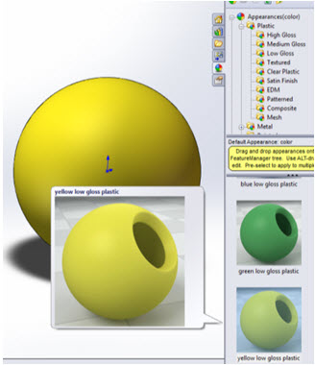
Then I’ll right mouse button on the sphere and choose the “edit yellow low gloss plastic” option from the appearance drop down.
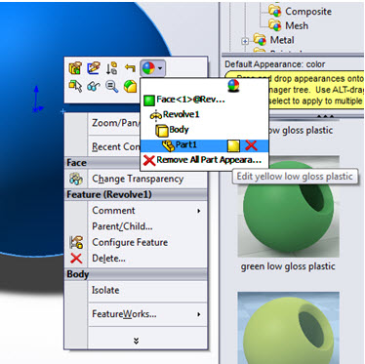
On the Color/Image tab of the appearance editor, I’ll choose the orange color from the color picker area (R 232, G 113, B 8) to change my appearance to orange.
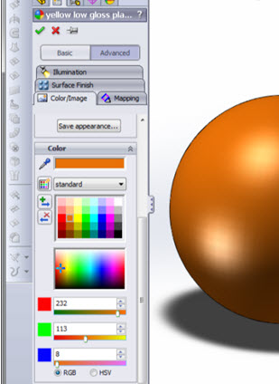
Now that I have defined our appearance with the correct color, I'll save it so it can be re-used. Click the “Save appearance” button in the appearance editor, then choose a location and name to save your appearance. Note: you should save all custom appearances to a location outside of your SolidWorks install folder.
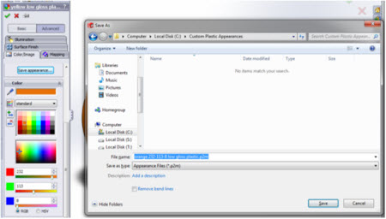
Let’s see how the new appearance looks in the different visualization modes.
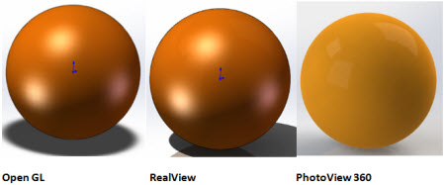
Now I will create another procedural appearance, but this time I’ll adjust some of the settings to make it more complex. I’d like to have an appearance that simulates a plastic weave. I’ll start will the “orange low gloss plastic” appearance I previously created and adjust the settings to add the weave texture.
I’ll need to edit the “orange low gloss plastic” appearance, which I can do by clicking the right mouse button on the sphere and choosing the “edit orange low gloss plastic” option from the appearance drop down. In the appearance editor I’ll switch to the Surface Finish tab and choose the “From file” option. Now I’ll browse to a grayscale weave texture file.
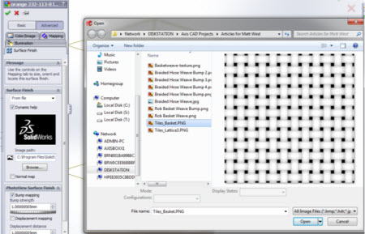
Now that my weave surface finish is applied, I’ll have to adjust the mapping so it displays correctly on my sphere. I switch to the Mapping tab, set the Mapping to “Cylindrical,” and adjust the size until it’s scaled correctly.
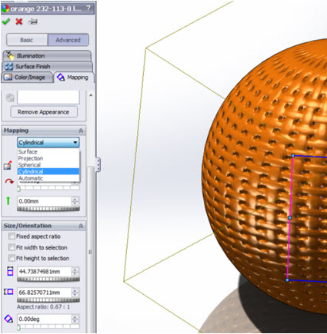

Switching back to the Color/Image tab, I choose the “Save appearance” option and define a location and appearance name.
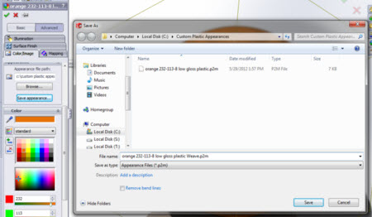
I have now created a second custom procedural appearance. If we have a look in the different visualization modes, we notice RealView and PhotoView 360 have used my surface finish weave image to give my geometry a 3D texture effect. OpenGL only shows a “flat” image because it doesn’t support bump maps, which is what I used to create the weave texture.
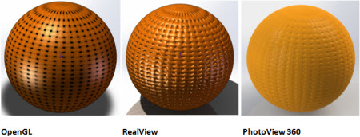
To take this one step further let’s switch my surface finish option from “bump mapping” to “displacement mapping.”
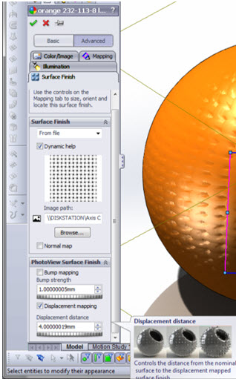
This is how my visualization modes now display the appearance. OpenGL remains the same and PhotoView 360 has a much more realsitic represenation than RealView.
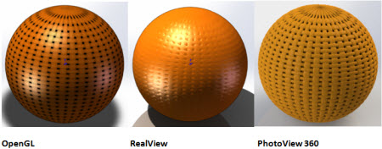

Textural
Textural appearances map an image file around your geometry like wallpaper to create the appearance. Let’s create a weave appearance similar to the procedural weave I previously created, but this time I’ll use a weave image file instead.
Again, to create my custom appearance I’ll start with one of the default appearances found inside of SolidWorks. Since I want to use an image as the base for my appearance, I’ll have to choose a default appearance that uses an image so that option is available to me. I'll apply “burlap” to my geometry by double clicking the appearance in the Task Pane.
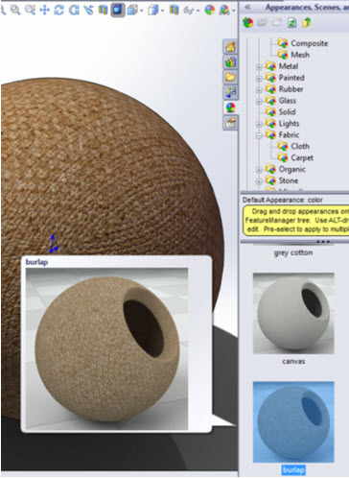
Like the procedural appearance, I’ll now edit the appearance and adjust the settings to define my own custom appearance. Right mouse button on the sphere and choose the “edit burlap” option from the appearance drop down.
On the Color/Image tab in the appearance editor I’ll browse to a new image file and choose an image of a weave pattern.
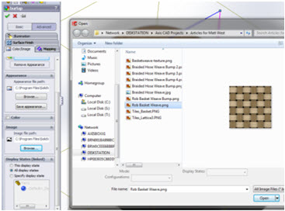
Since I am using an image to create my appearance, it’s important that I map it correctly. Switching over to the Mapping tab, I’ll choose “Cylindrical” as the mapping type and adjust the size to my desired scale.
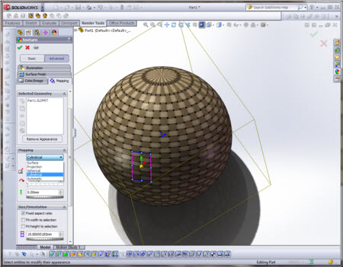
Switching back to the Color/Image tab, I can chose the option to “Save appearance.” I have now created a custom textural appearance.
In my visualization modes the appearance displays like this.
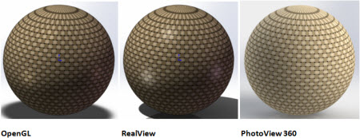
Like the procedural appearance, I can add bump or displacement in the surface finish tab to add to the realism. In this case, my surface finish image will be a gray scale version of the weave image file.
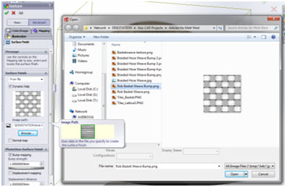
With surface finish added and set to the “bump mapping” setting, my visualization modes display like this.
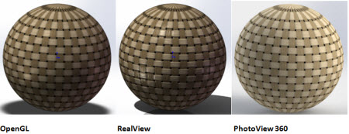
With surface finish added and set to the “displacement mapping” setting, my visualization modes display like this.

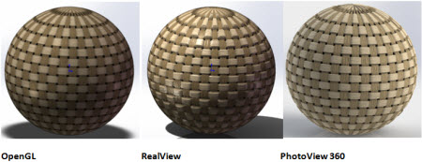
As you can see, creating custom appearances is easy and might even be fun! You can achieve a good level of realism, especially if you’re using PhotoView 360 as your visualization mode. Custom appearances can greatly enhance the visual properties and value of your models.

