Knit Surface
Use the Knit Surface tool to combine two or more faces and surfaces into one.
Note the following about knit surfaces:
- Edges of the surfaces must be adjacent and not overlapping.
- Surfaces do not need to be on the same plane.
- Select the entire surface body, or select one or more adjacent surface bodies.
- Knit surfaces absorb the surface bodies you used to create them.
- Create a solid body when the knit surfaces form a closed volume, or leave as a surface body.
- Select Merge entities to merge faces with the same underlying geometry.
- Select Gap Control to view the gaps or modify the knitting tolerance.
To knit surfaces:
- Click Knit Surface on the Surfaces toolbar, or click Insert, Surface, Knit.  In the PropertyManager, under Selections: | 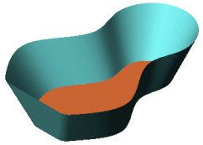  Create adjacent, non-intersecting surfaces
- Select faces and surfaces for Surfaces and Faces to Knit .  - Select Try to form solid to create a solid model from enclosed surfaces.  - Select Merge entities to merge faces with the same underlying geometry. | 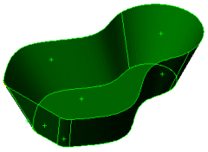  Select the faces to knit
- Select Gap Control to view edge pairs that might introduce gap problems, and to view or edit the knitting tolerance or gap range. | View the Knitting tolerance. Modify it if required.  The gap range depends on the knitting tolerance. Only gaps within the selected gap range are listed. You can modify the gap range if required.
- Click OK .  The result is a single surface listed in the FeatureManager design tree as Surface-Knit<n>.  There is no difference in the appearance of the faces and surfaces after knitting. | 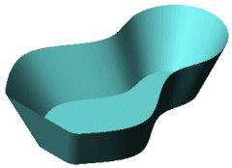
To use the Seed faces option:
To knit surfaces with the Seed faces option, you must use Radiate Surface.
- Create a radiated surface.
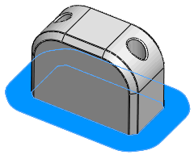
- Click Knit Surface on the Surfaces toolbar, or click Insert, Surface, Knit.
- In the PropertyManager, under Selections:
  - Select the radiated surface for Surfaces and Faces to Knit .
  - Click in Seed faces , then select a face on the model to knit with the radiated surface.
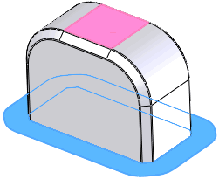
- Click OK .
The seed face and all adjacent faces are knitted to the radiated surface.

