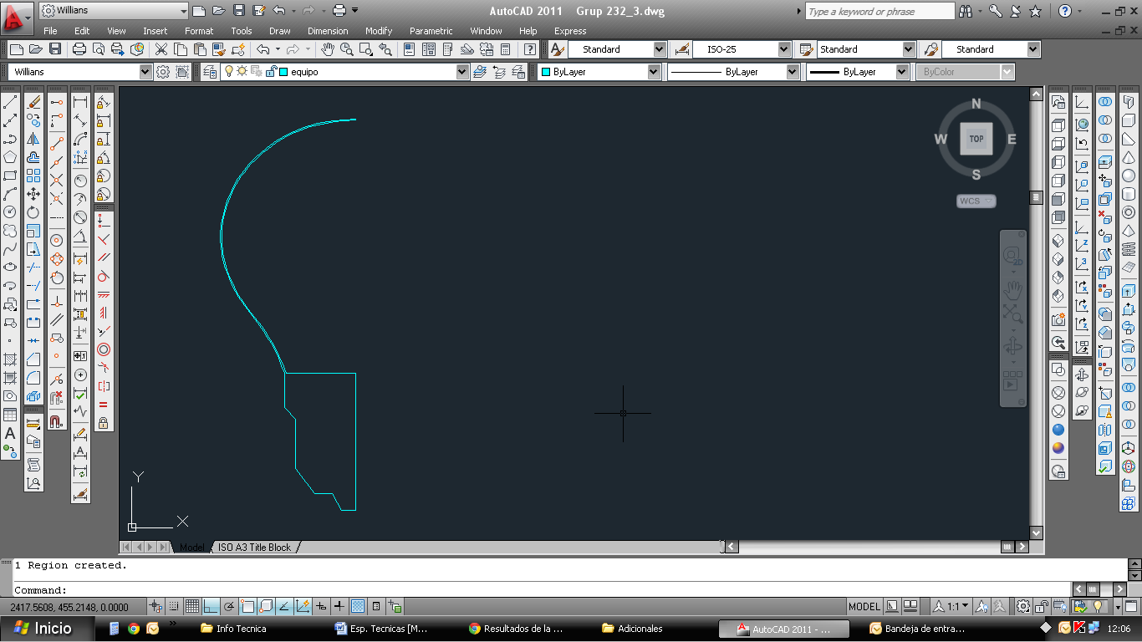

You have Light Bulb  profile (with the thickness of the glass), transforms it into region with thecommand "reg"  
After revolution, according to the central axis. Using command "rev"  
And that's it ...  
  
3D Light Bulb ..

