- Make extruded boss of your desired thickness the corner rounded off. I used 1mm radius.
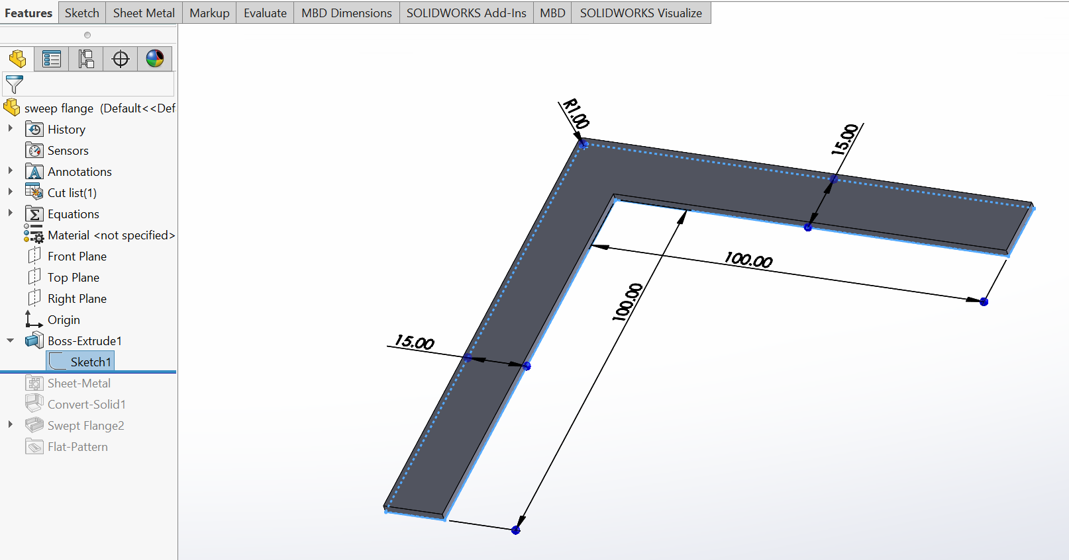
- Use convert to sheet metal on the extrude.
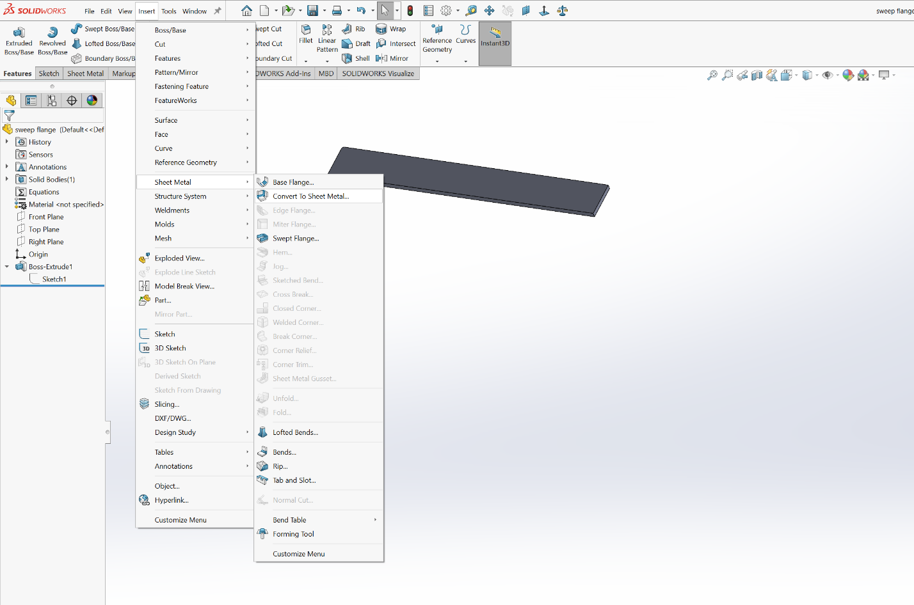

- Select the back face of the boss for sheet metal conversion.
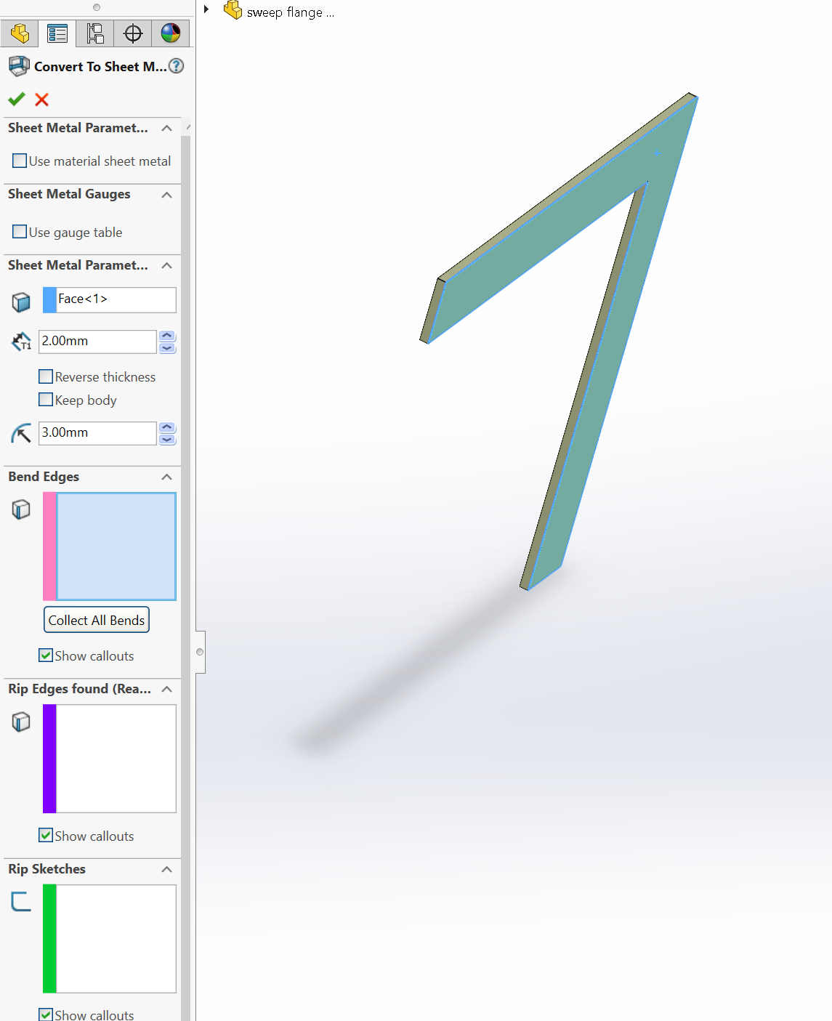
Keep the T1 as the boss thickness
Here select the back face of boss

- Select the face to draw a sketch
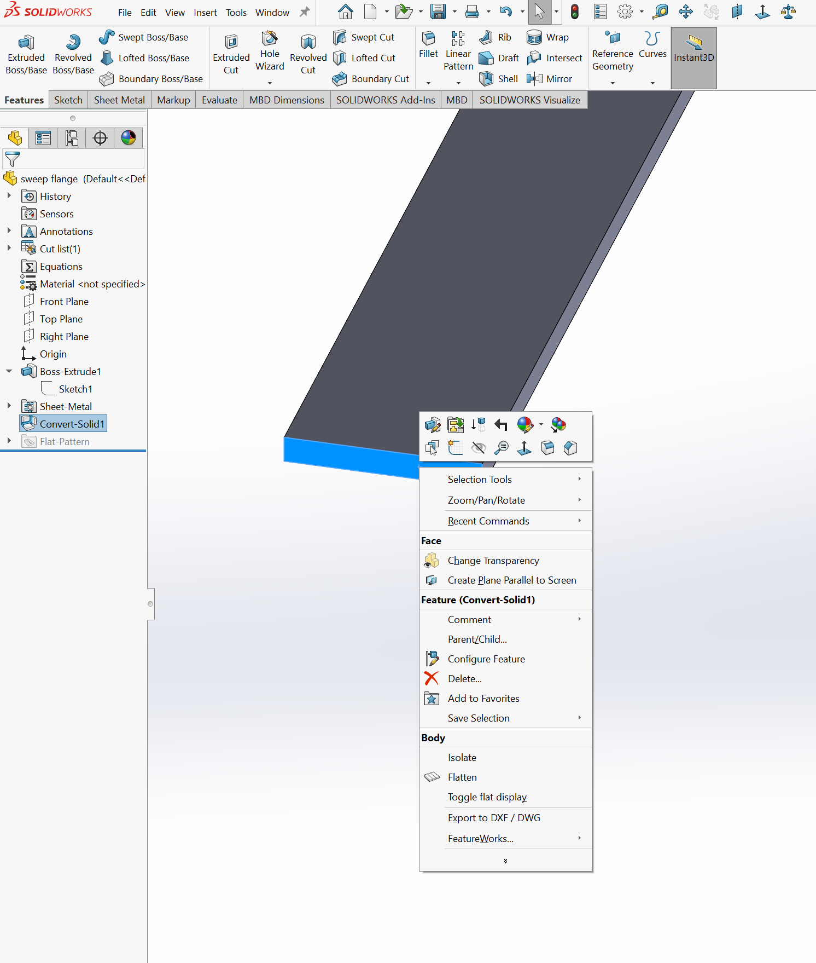

- The sketch as drawn
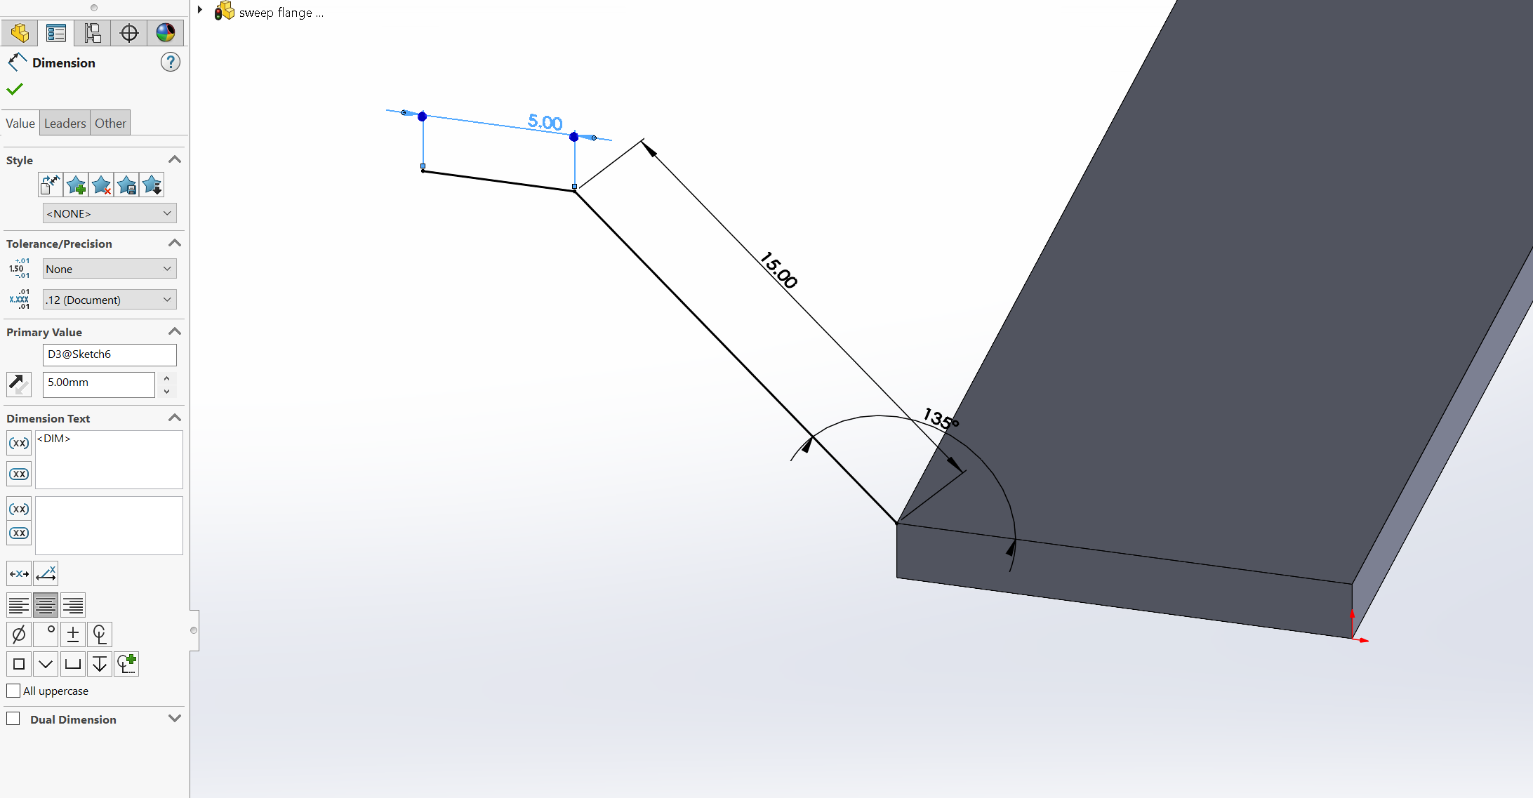

- Select the swept flange. Point to the sketch for profile and edges of boss as path and you will get the following
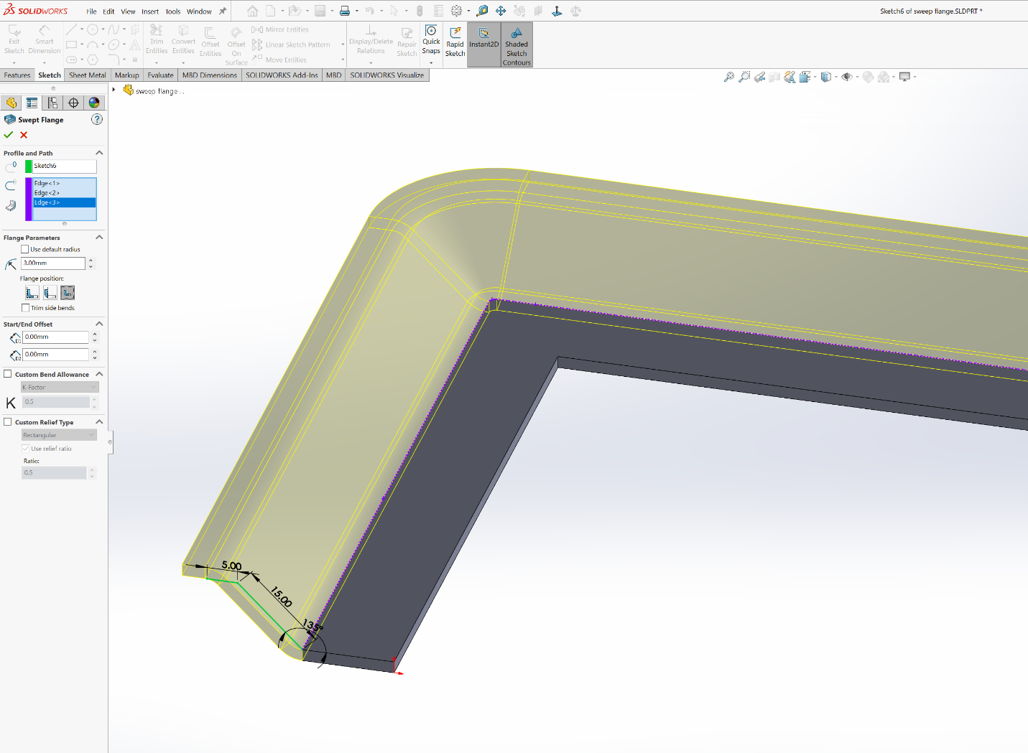
Select this one
- After okeying the process you will get a thing like this
