# Creating metric threads in Autodesk Fusion 360.

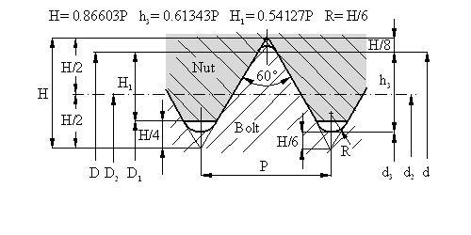

Bolt cilinder diam.=d3-1/3H Nut cilinder diam = D1-H/2

Source: <https://www.robkalmeijer.nl/techniek/montage/metrische_bouten/index.html>

Example M60

|  |  |  |  |  |  |  |  |  |
| --- | --- | --- | --- | --- | --- | --- | --- | --- |
| M 60.00 | 5.50 | 0.794 | 56.428 | 53.252 | 54.046 | 3.374 | 2.977 | 54.50 |
| **Nominal diameter** | **Pitch** | **Enter radius** | **Flank diameter** | **Core diameter** | | **Wire height** | | **Drill diameter** |
| **d = D** | **P** | **R** | **d2=D2** | **d3** | **D1** | **h3** | **H1** | **mm** |

# Extrusion along a winding: Coil

1. CREATE Sketch.  
   In the XY plane, draw a center line vertically upward from the origin slightly longer than the length of the desired thread. Draw a circle diameter H=0,86603P(itch) with the origin   
   x= 0,5(d3-1/3H) en y=0.

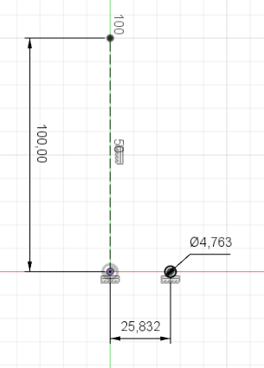

Close the sketch.

1. Activate the function to place windings: CREATE Coil.  
   Choose the profile (the circle), Type: Revolution and P(itch), Diameter: d3-1/3H,   
   Revolution: the desired number of windings, Pitch the required pitch, Section: Triangular, Section position: Outside, Section size: H=0,86603Pitch and operation New Body. OK.

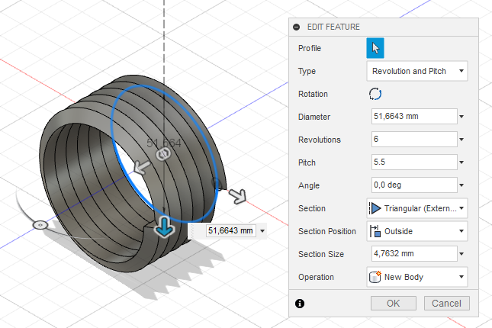

1. Activate the round-off function: MODIFY Fillet.  
   Give the outside of the thread a rounding R=0,86603/6. OK
2. CREATE Sketch.  
   Make a sketch in the XY plane and draw a circle from the origin with diameter d3.   
   Close the sketch.

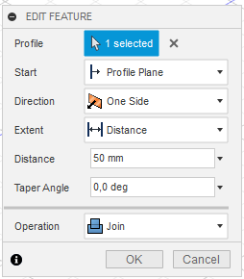

1. CREATE Extrude.   
   Extrude the core of the thread d3 on the desired

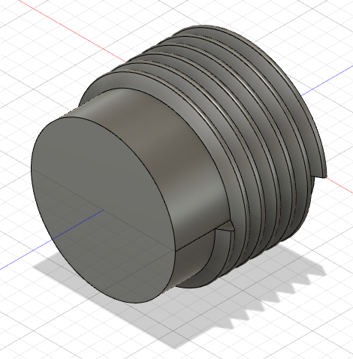length according to the adjacent settings.   
OK.

1. 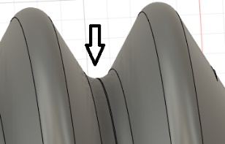Activate the round-off function: MODIFY Fillet.  
   Give the inside of the thread (2x) a rounding 0,95R.

Save the file.

# Bijlage schroefdraad tabel.

|  |  |  |  |  |  |  |  |  |
| --- | --- | --- | --- | --- | --- | --- | --- | --- |
| Metric screw threads ISO 724 (DIN 13 T1) | | | | | | | | |
| **Nominal diameter** | **Pitch** | **Enter radius** | **Flank diameter** | **Core diameter** | | **Wire height** | | **Drill diameter** |
| **d = D** | **P** | **R** | **d2=D2** | **d3** | **D1** | **h3** | **H1** | **mm** |
| M 1.00 | 0.25 | 0.036 | 0.838 | 0.693 | 0.729 | 0.153 | 0.135 | 0.75 |
| M 1.10 | 0.25 | 0.036 | 0.938 | 0.793 | 0.829 | 0.153 | 0.135 | 0.85 |
| M 1.20 | 0.25 | 0.036 | 1.038 | 0.893 | 0.929 | 0.153 | 0.135 | 0.95 |
| M 1.40 | 0.30 | 0.043 | 1.205 | 1.032 | 1.075 | 0.184 | 0.162 | 1.10 |
| M 1.60 | 0.35 | 0.051 | 1.373 | 1.171 | 1.221 | 0.215 | 0.189 | 1.25 |
| M 1.80 | 0.35 | 0.051 | 1.573 | 1.371 | 1.421 | 0.215 | 0.189 | 1.45 |
| M 2.00 | 0.40 | 0.058 | 1.740 | 1.509 | 1.567 | 0.245 | 0.217 | 1.60 |
| M 2.20 | 0.45 | 0.065 | 1.908 | 1.648 | 1.713 | 0.276 | 0.244 | 1.75 |
| M 2.50 | 0.45 | 0.065 | 2.208 | 1.948 | 2.013 | 0.276 | 0.244 | 2.05 |
| M 3.00 | 0.50 | 0.072 | 2.675 | 2.387 | 2.459 | 0.307 | 0.271 | 2.50 |
| M 3.50 | 0.60 | 0.087 | 3.110 | 2.764 | 2.850 | 0.368 | 0.325 | 2.90 |
| M 4.00 | 0.70 | 0.101 | 3.545 | 3.141 | 3.242 | 0.429 | 0.379 | 3.30 |
| M 4.50 | 0.75 | 0.108 | 4.013 | 3.580 | 3.688 | 0.460 | 0.406 | 3.80 |
| M 5.00 | 0.80 | 0.115 | 4.480 | 4.019 | 4.134 | 0.491 | 0.433 | 4.20 |
| M 6.00 | 1.00 | 0.144 | 5.350 | 4.773 | 4.917 | 0.613 | 0.541 | 5.00 |
| M 7.00 | 1.00 | 0.144 | 6.350 | 5.773 | 5.917 | 0.613 | 0.541 | 6.00 |
| M 8.00 | 1.25 | 0.180 | 7.188 | 6.466 | 6.647 | 0.767 | 0.677 | 6.80 |
| M 9.00 | 1.25 | 0.180 | 8.188 | 7.466 | 7.647 | 0.767 | 0.677 | 7.80 |
| M 10.00 | 1.50 | 0.217 | 9.026 | 8.160 | 8.376 | 0.920 | 0.812 | 8.50 |
| M 11.00 | 1.50 | 0.217 | 10.026 | 9.160 | 9.376 | 0.920 | 0.812 | 9.50 |
| M 12.00 | 1.75 | 0.253 | 10.863 | 9.853 | 10.106 | 1.074 | 0.947 | 10.20 |
| M 14.00 | 2.00 | 0.289 | 12.701 | 11.546 | 11.835 | 1.227 | 1.083 | 12.00 |
| M 16.00 | 2.00 | 0.289 | 14.701 | 13.546 | 13.835 | 1.227 | 1.083 | 14.00 |
| M 18.00 | 2.50 | 0.361 | 16.376 | 14.933 | 15.394 | 1.534 | 1.353 | 15.50 |
| M 20.00 | 2.50 | 0.361 | 18.376 | 16.933 | 17.294 | 1.534 | 1.353 | 17.50 |
| **Nominal diameter** | **Pitch** | **Enter radius** | **Flank diameter** | **Core diameter** | | **Wire Height** | | **Drill diameter** |
| **d = D** | **P** | **R** | **d2=D2** | **d3** | **D1** | **h3** | **H1** | **mm** |