Area Law
Several coupling types are available in the Coupling tab:
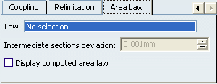
This option allows you to define and control the shape of a multi-sections solid between its sections.
To create a multi-sections solid allowing an area law, the following inputs can be used:
- planar sections (with no tangency conditions)
- a spine (optional)
- a guide curve (either no guide curve, one or two guide curves)
Let's define the law that will be used to create the multi-sections surface. But first, let's open the Generative Shape Design workbench.
In our example, three sketches with closed contours have been created and filled. A spine between these sections have been created:
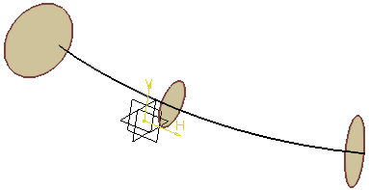

- Click Measure to compute the geodesic length of the spine:
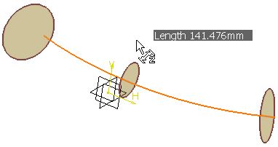
- Click Split to split the spine by the section plane.
- Click Measure again to compute the geodesic length of the resulting curve:
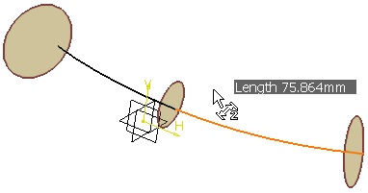
- Using the Sketcher, create a line and a curve corresponding to the previous computed lengths.
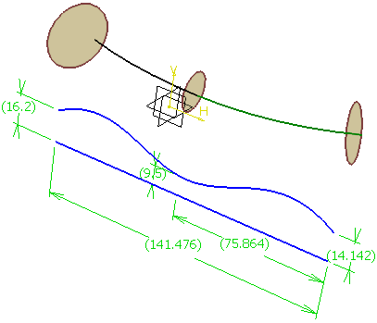
Info: Radius values (16.2, 9.5 and 14.142) are similar to the radius values of the corresponding sections (that is R=√(A/π) where A is the section area).
- Click Extract to create separate elements of the line and curve.
- Click Law to create the law from the previously extracted elements.
- In the Law Definition dialog box, select the Reference line and the Definition curve.
- Click OK to create the law.
- Click Multi-sections Surface .
The Multi-sections Surface Definition dialog box appears.
- Select the sketches as the planar section curves.
- Select the Area law tab.
- In the Law field, specify the length law to be used to control the section area.
Here, select the law we have just created.
The Intermediate sections deviation option only applies to intermediate sections (unlike the Deviation option that applies to the sections extremities) and is homogeneous with the selected law. It specifies the deviation of the length law to be applied to the intermediate sections in order to smooth the resulting shape
- Click OK to create the multi-sections surface.
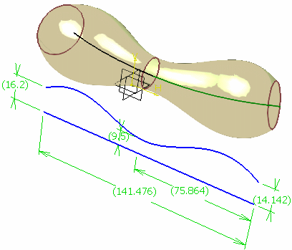
Info: You can select the Display computed area law check box to display in the 3D geometry:
- in red, the area law
- in blue, the sections areas and a flag on each section that displays the deviation between the area law and the sections areas as well as the equivalent radius of each section.
