**Grade breakdown of task**

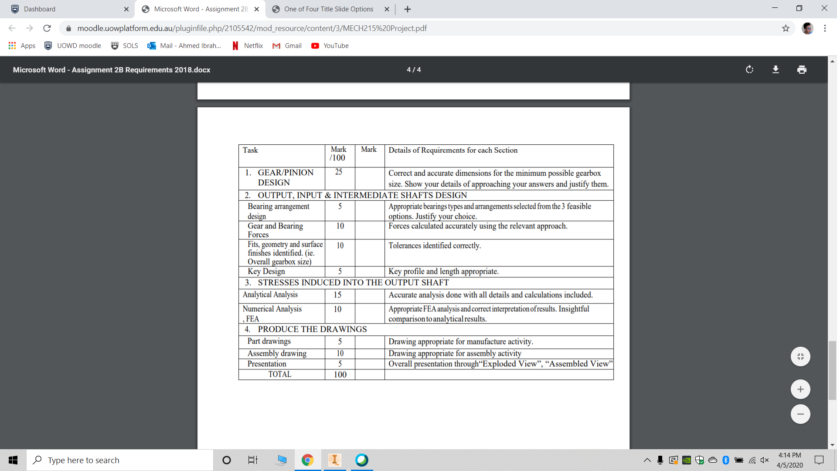***Notes to be fulfilled for obtaining full marks: -***

* **Two-stage** compound reverted **helical** gear **reducer**.
* Power Delivered: **15kW**
* Input Speed: **1440 RPM**
* Speed Reduction: **1:20 (±1%)**
* Gears and bearings: Gears and bearings life should exceed **10,000 hours**.
* Assume the **normal pressure angle** (𝜙𝑛) to be **20 degrees** for all gears.
* Assume the **helix angle** (𝜓) to be **30 degrees** for **all gears**.
* The overall Gearbox **height Y= 20 cm**.
* The overall Gear-box size need to be **minimized**.
* The chosen portions of the gear train (e) are to be as **evenly divided** between the stages as possible.
* It is desirable for the **input shaft** and the **output shaft** of a two-stage compound gear train to **be in-line**.

**Final Inventor drawing should look like this for the gears + Appropriate casing of the dimensions requested of course.**



