Start a sketch on the Top Plane
Sketch and dimension a circle, Figure 1. Click on View and select Dimension Names.
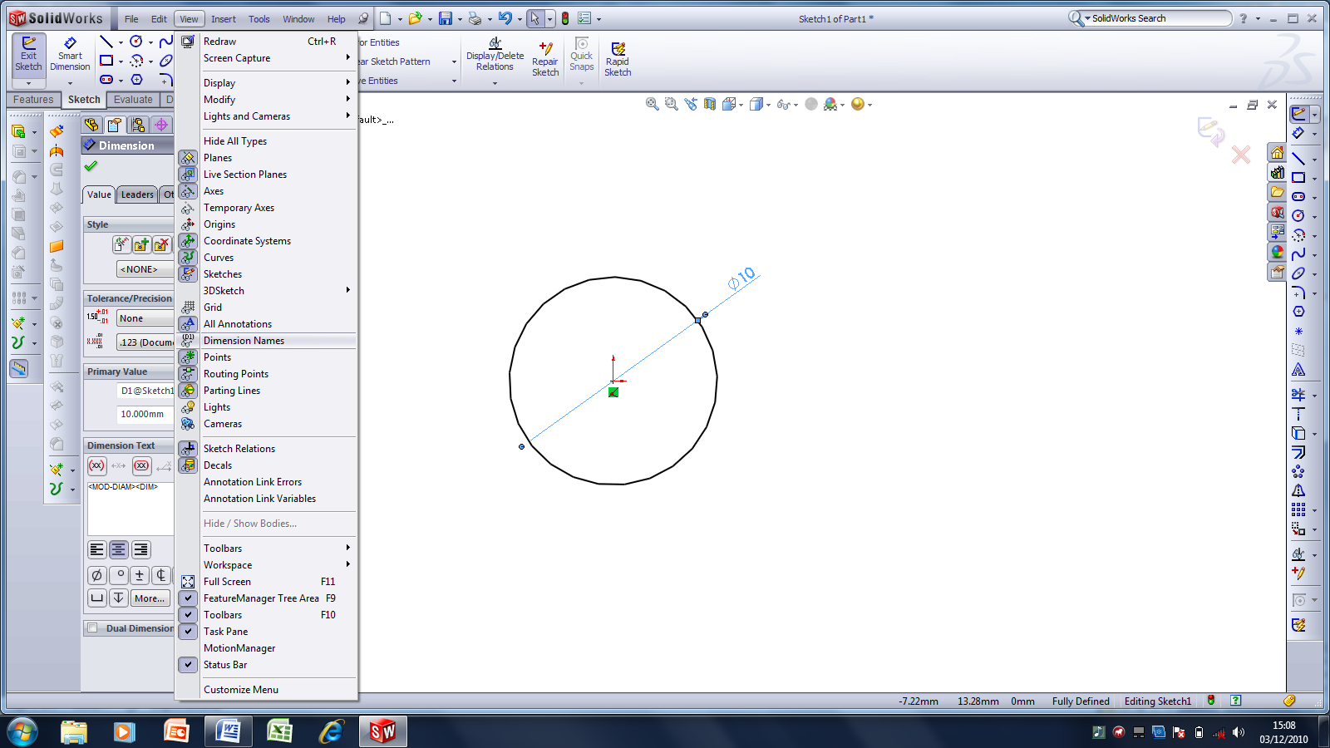
Figure 1
The dimension should now appear as in Figure 2. Click the dimension and when the Dimension Menu appears, type the name Thread Diameter.
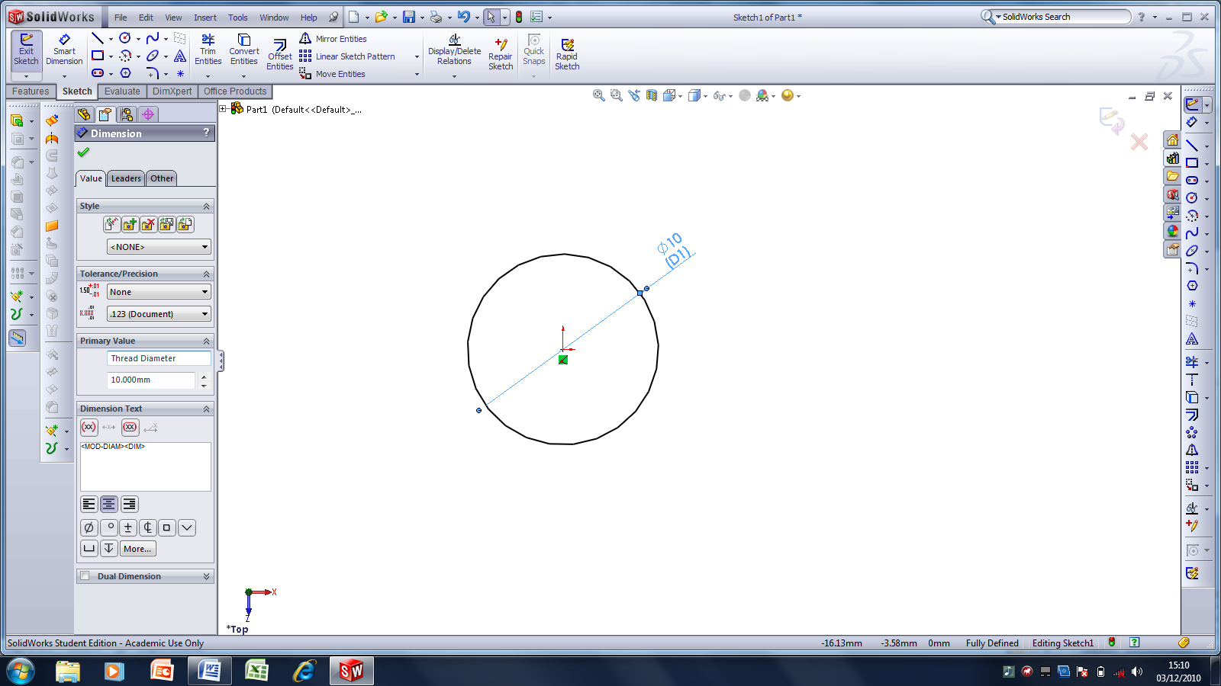
Figure 2
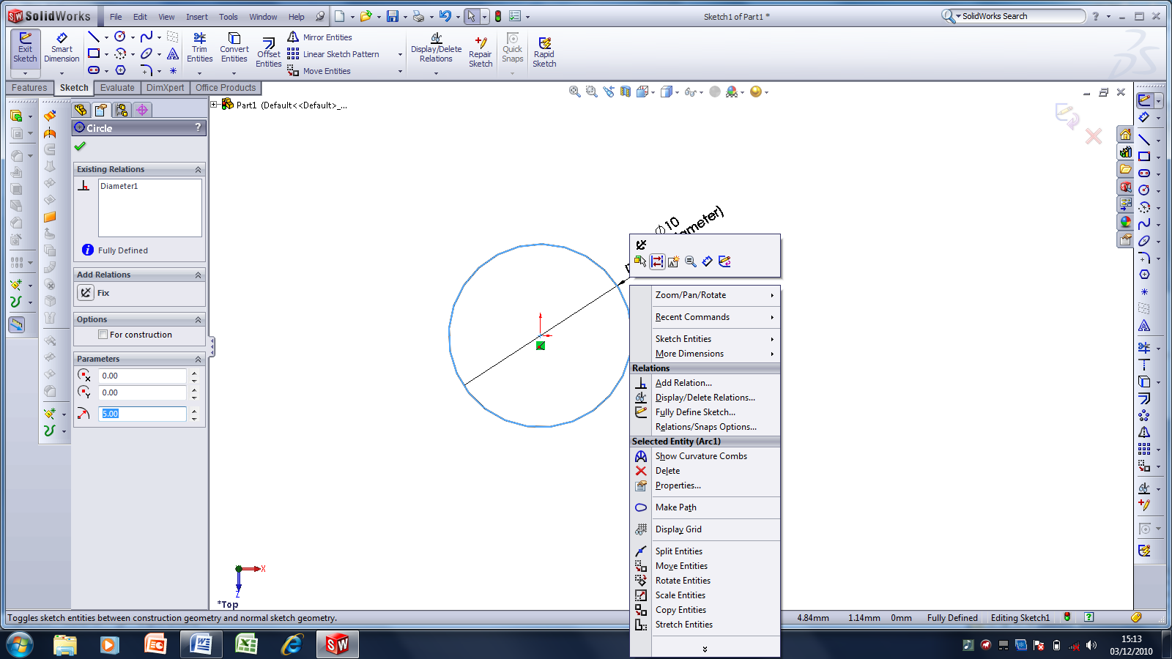
Figure 3
Select the Circle and convert to a Construction Line
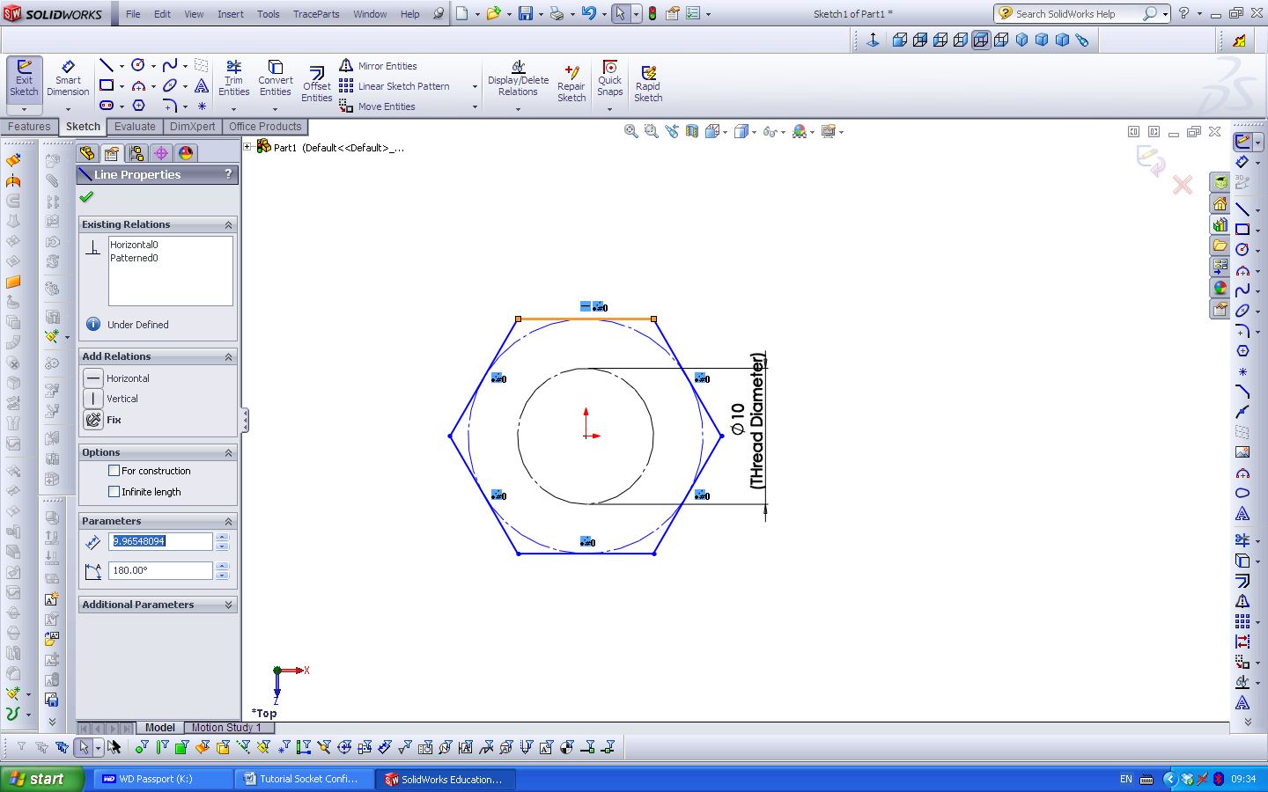
Figure 4
Draw a Hexagon and ensure the Relations of top line is Horizontal.

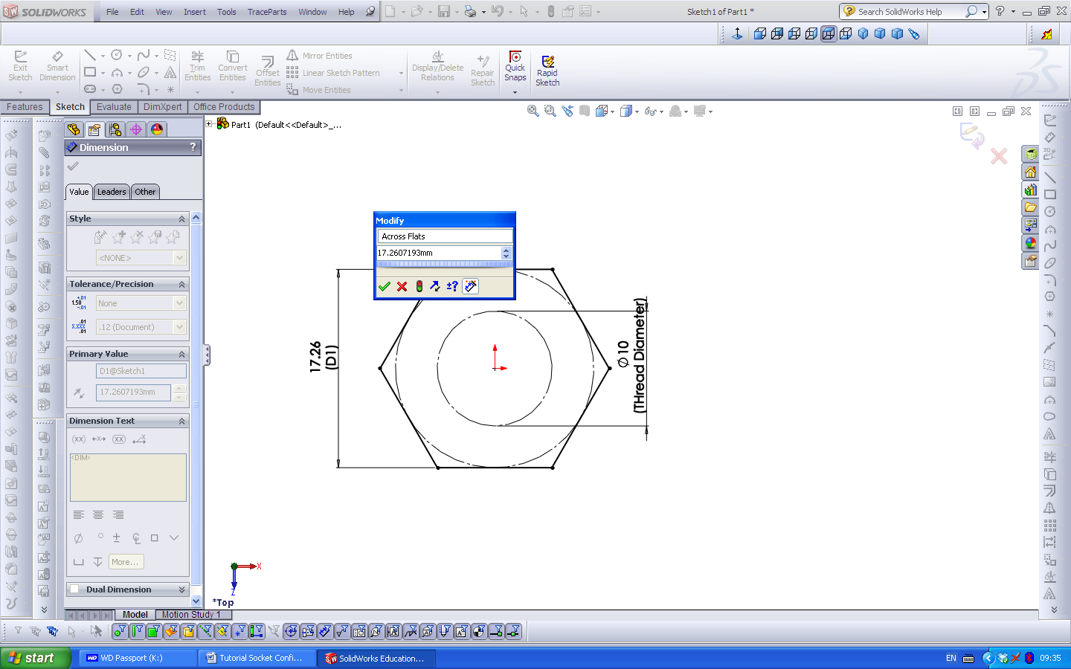
Figure 5
Name the dimension Across Flats
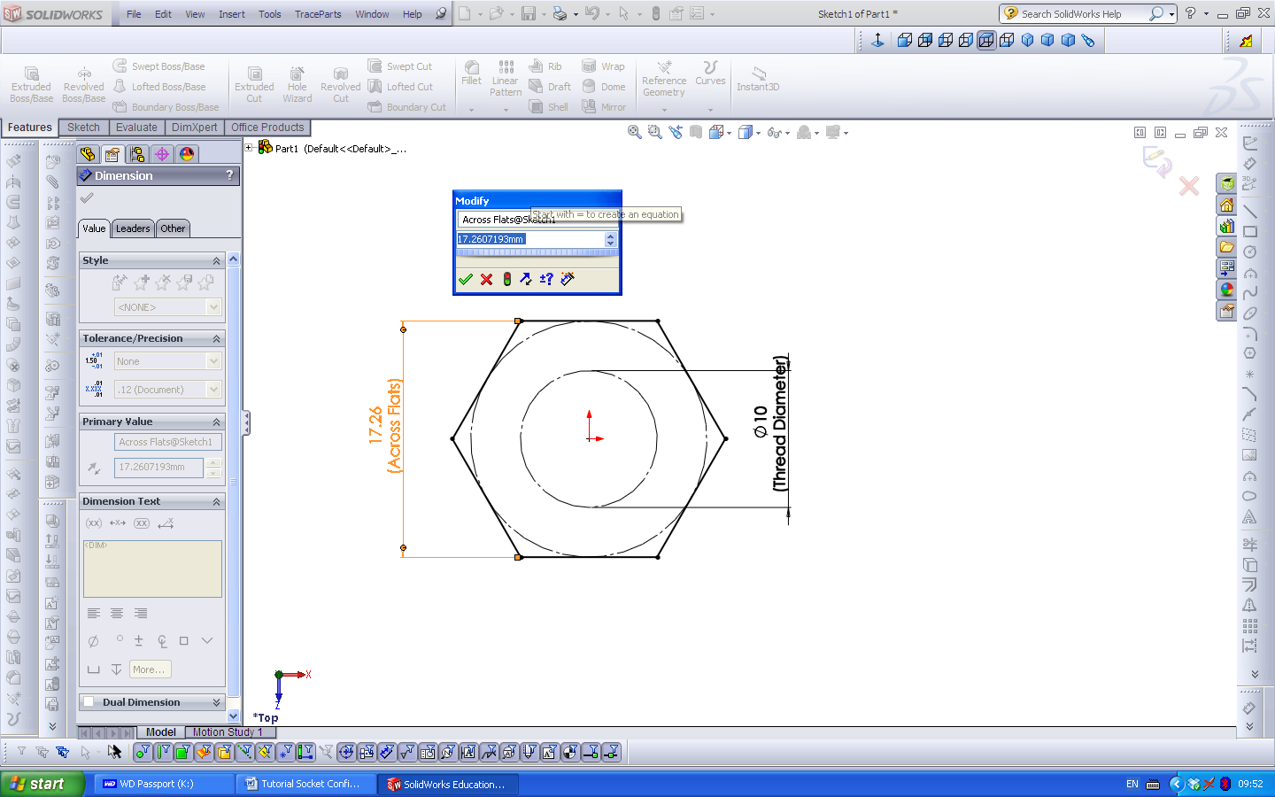
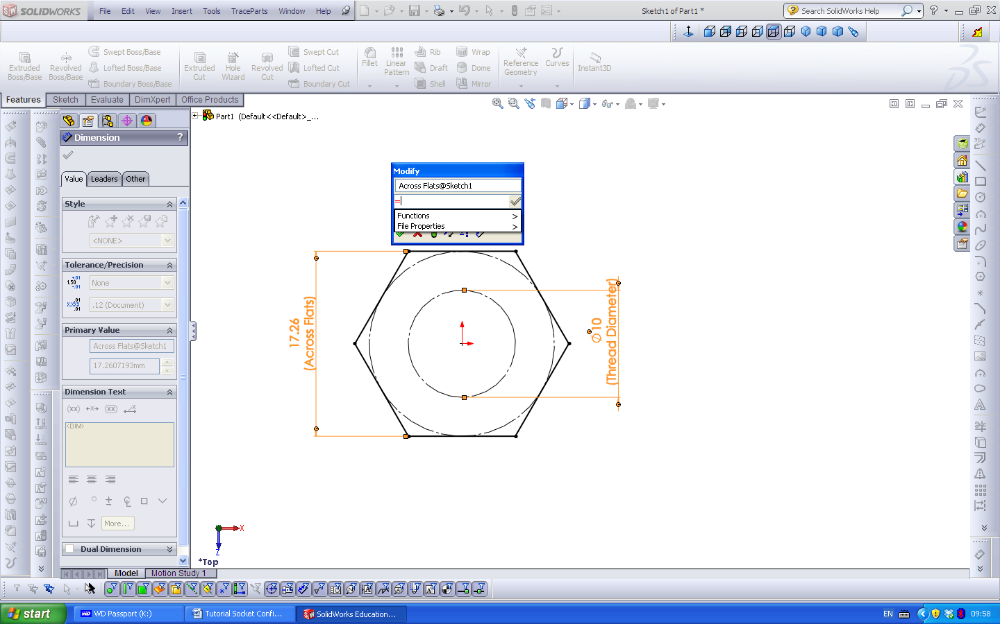
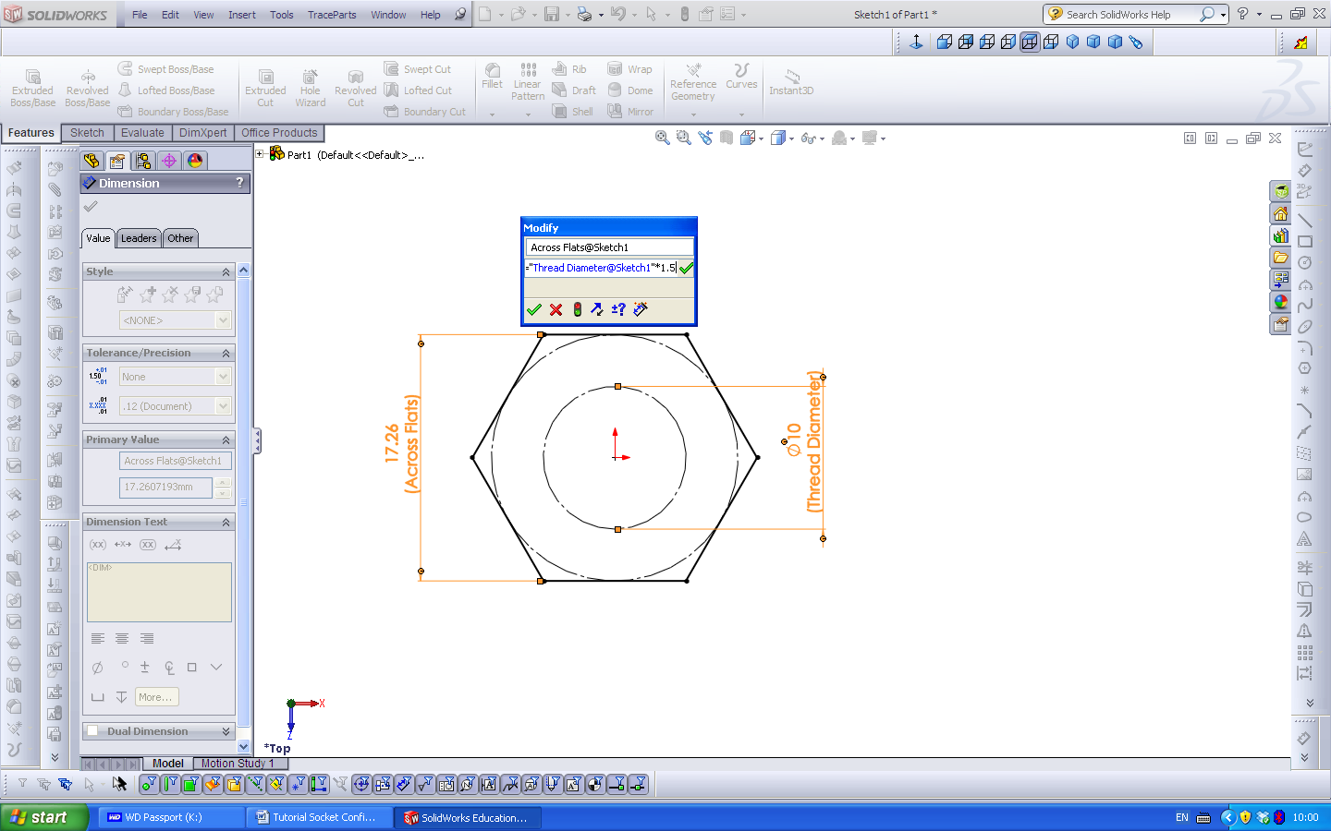

Select the dimension to view the dialogue box, type = as shown, then select the Threaded Diameter dimension and type *1.5 as shown above.
Figure 5
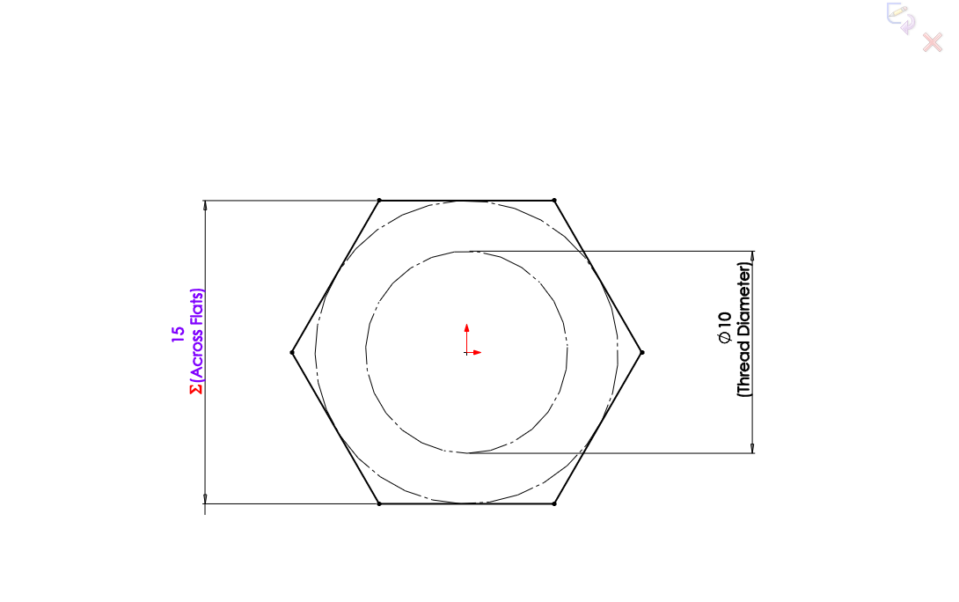
Figure 6
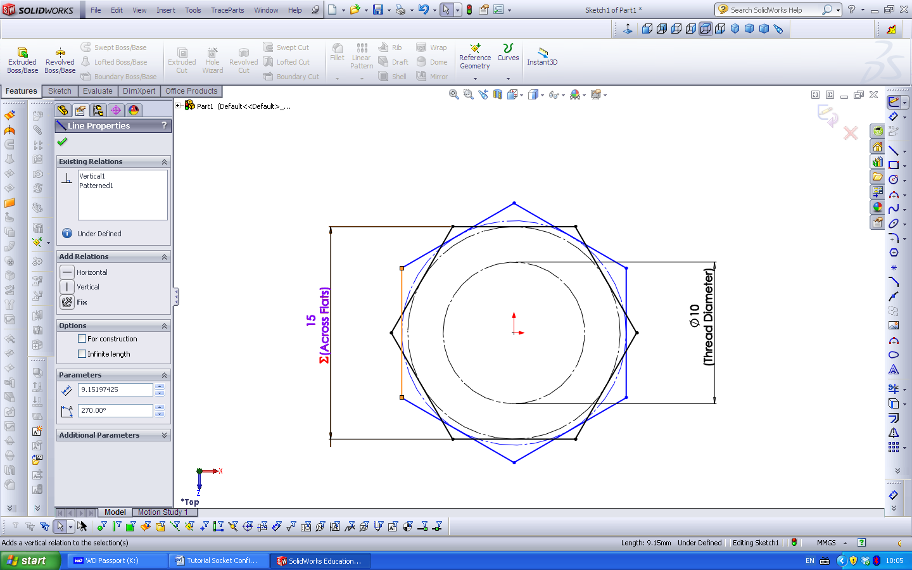
Sketch a second Hexagon and ensure the side has a Vertical Relation
Figure 6
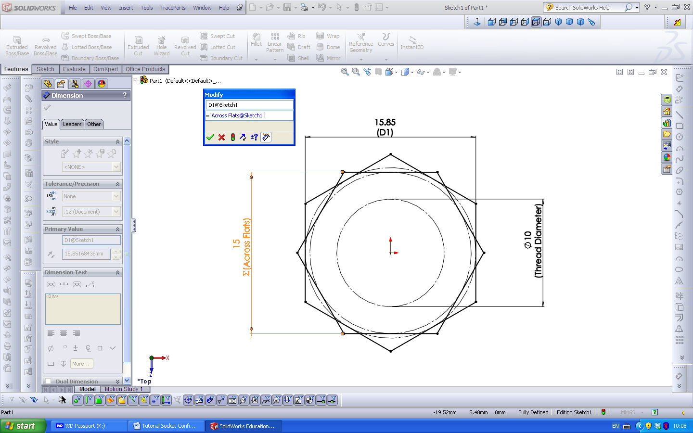
Click on the dimension type = and select the Across Flats dimension.
Figure 7
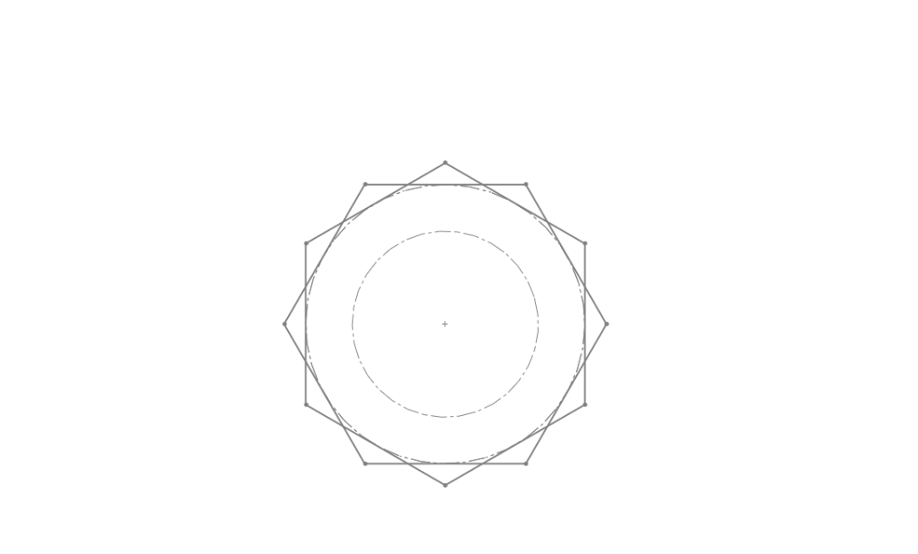
Exit the Skech
Figure 8

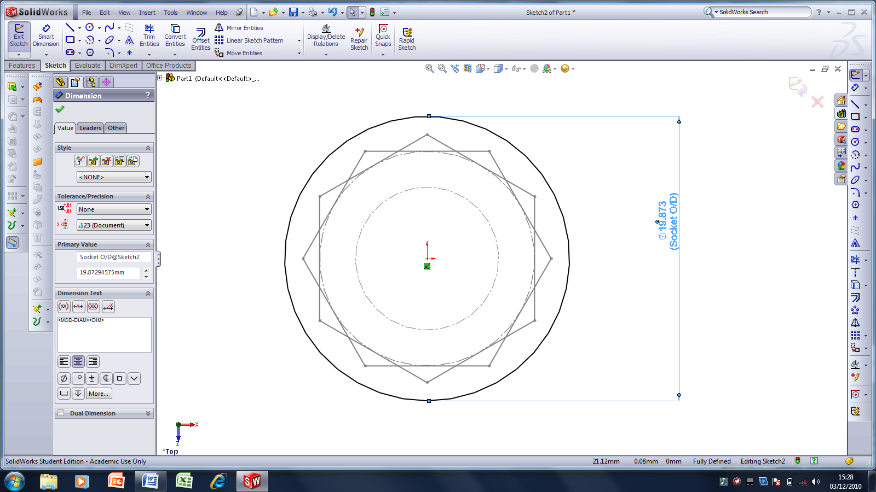
On the Top Plane start and sketch a Circle, add a dimension and name it Socket O/D. The size can be adjusted later for the present ensure it is larger than the Hexagon.
Figure 9
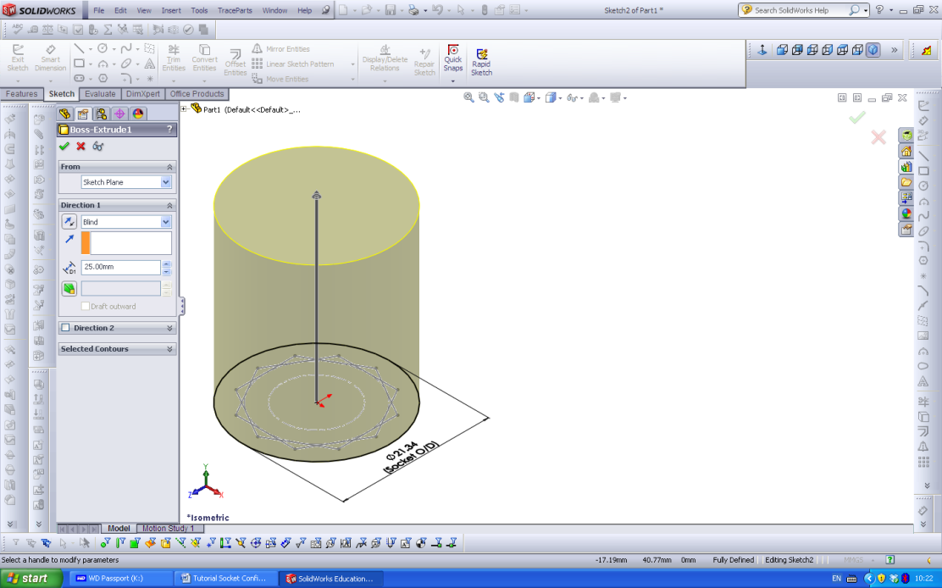
Boss Extrude 25 mm
Figure 10
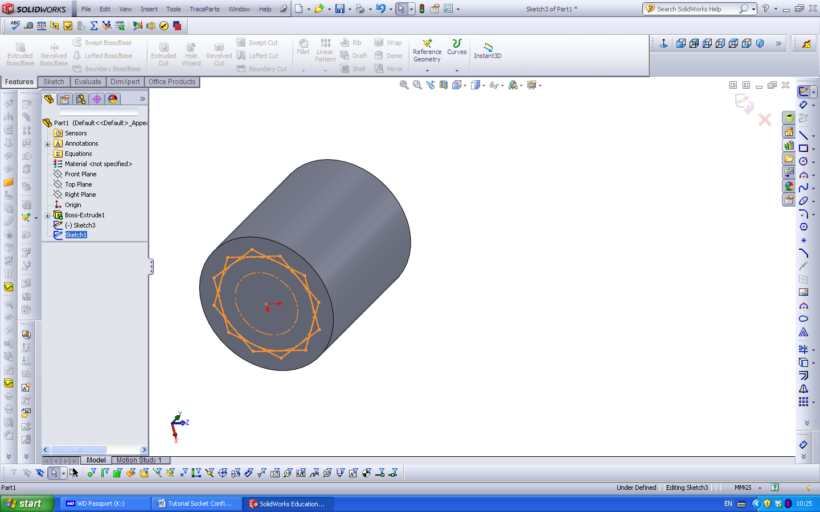
Reposition Sketch1 in the Feature tree, exit the Sketch.
Figure 11
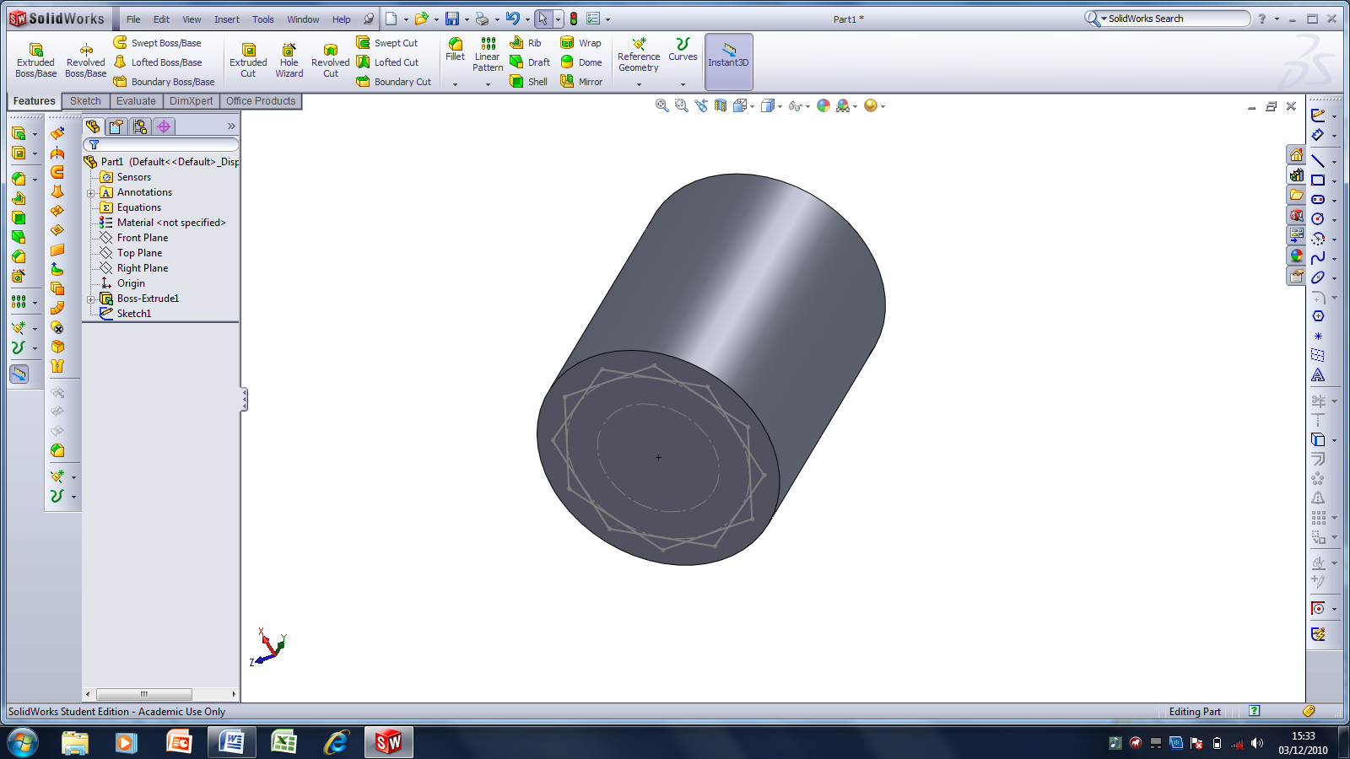
Insert an Extruded Cut
Figure 12
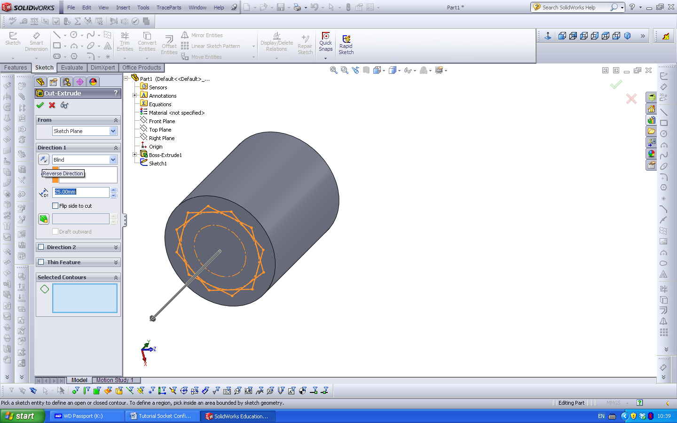
The Extrude arrow may show as above, click the Reverse Direction arrow button.
Figure 13

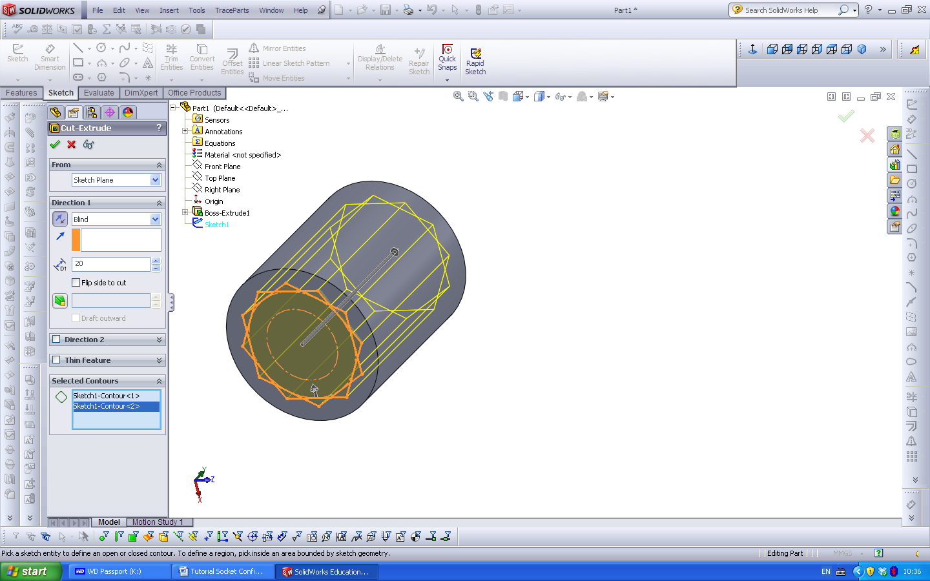
Complete the dialogue as above
Figure 14

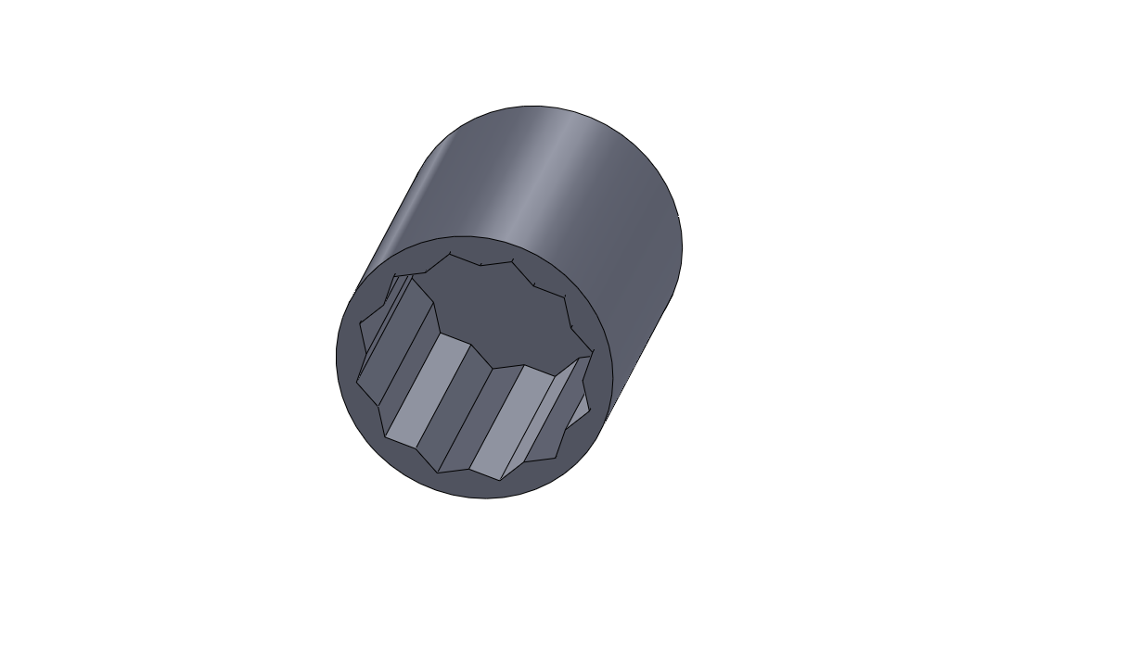
Model
Figure 14
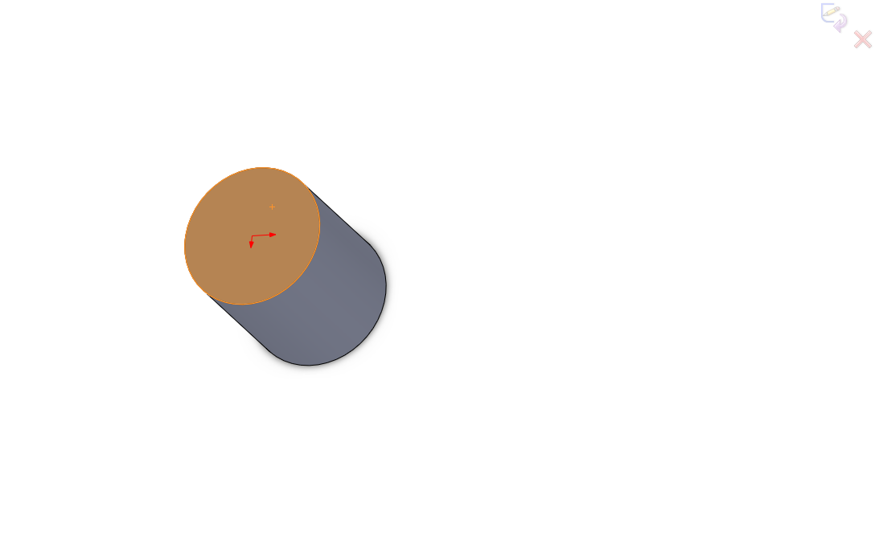
Select the face of the Socket and begin a Sketch
Figure 15
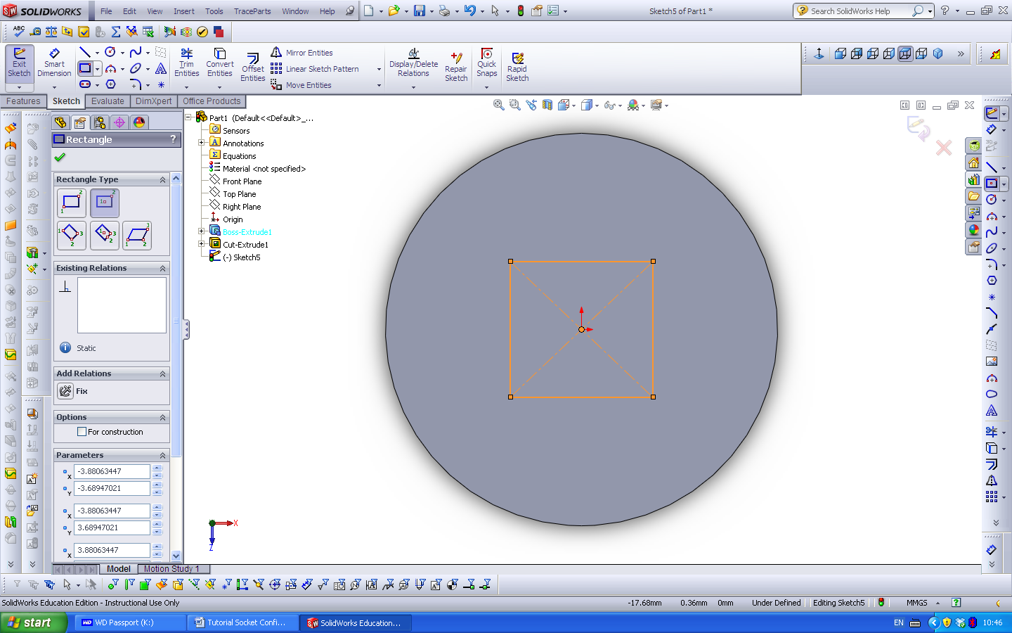
Centre rectangle
Figure 16
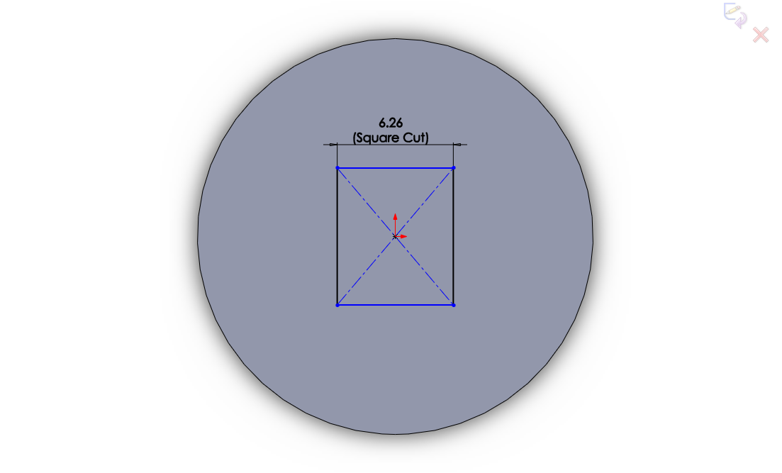
Dimension and name, as shown above
Figure 17
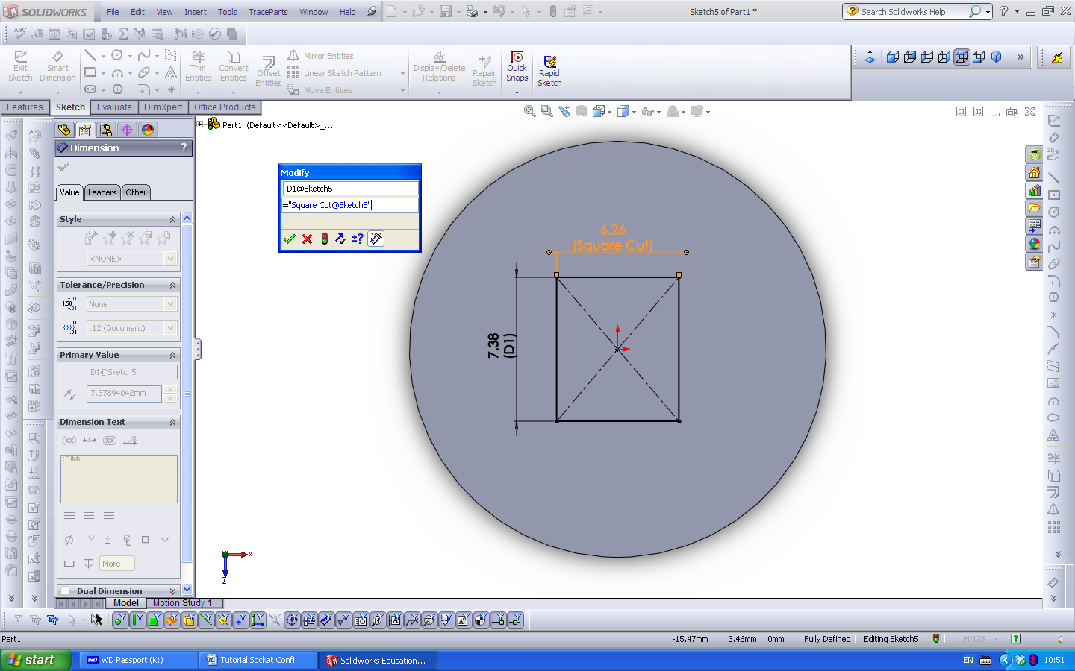
Add the second dimension and add the Equation as shown.
Figure 17
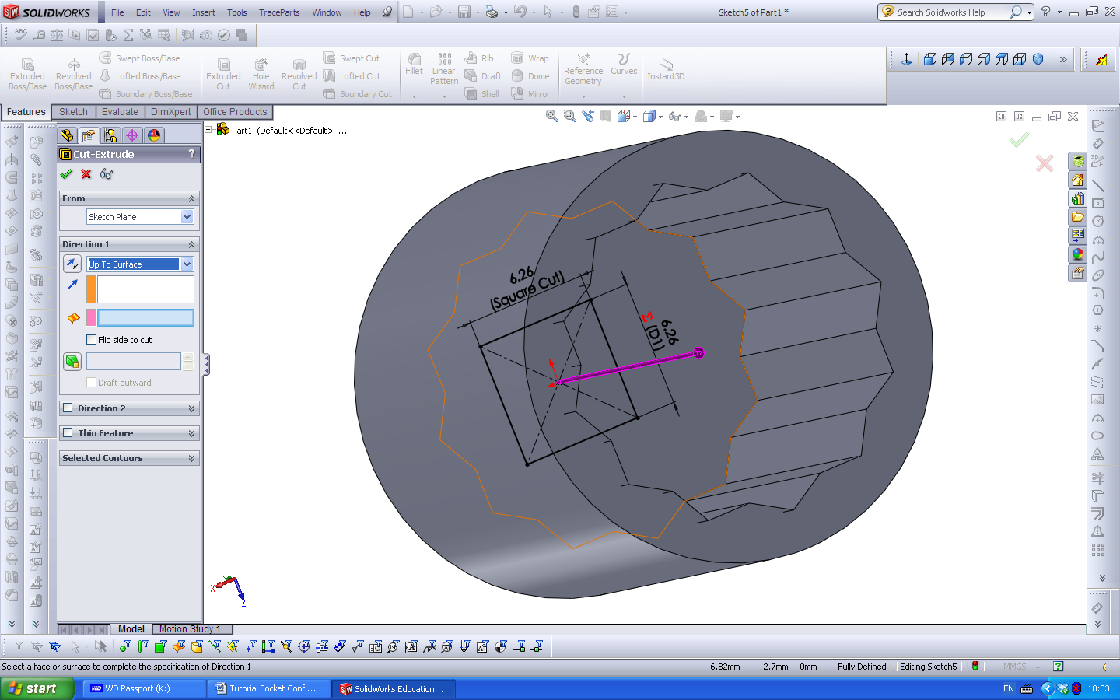
Cut Extrude Up To Surface, pick the inside flat surface of the Socket.
Figure 17
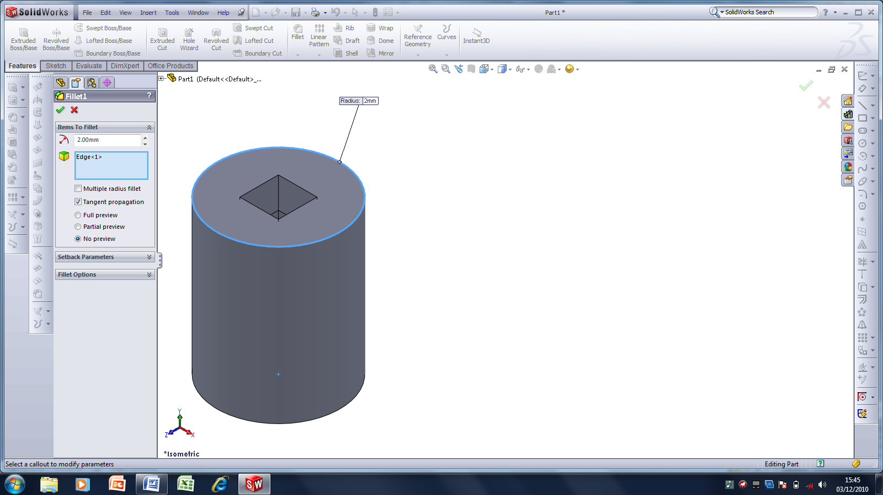
Add a 2mm Fillet Radius to the top.
Figure 18
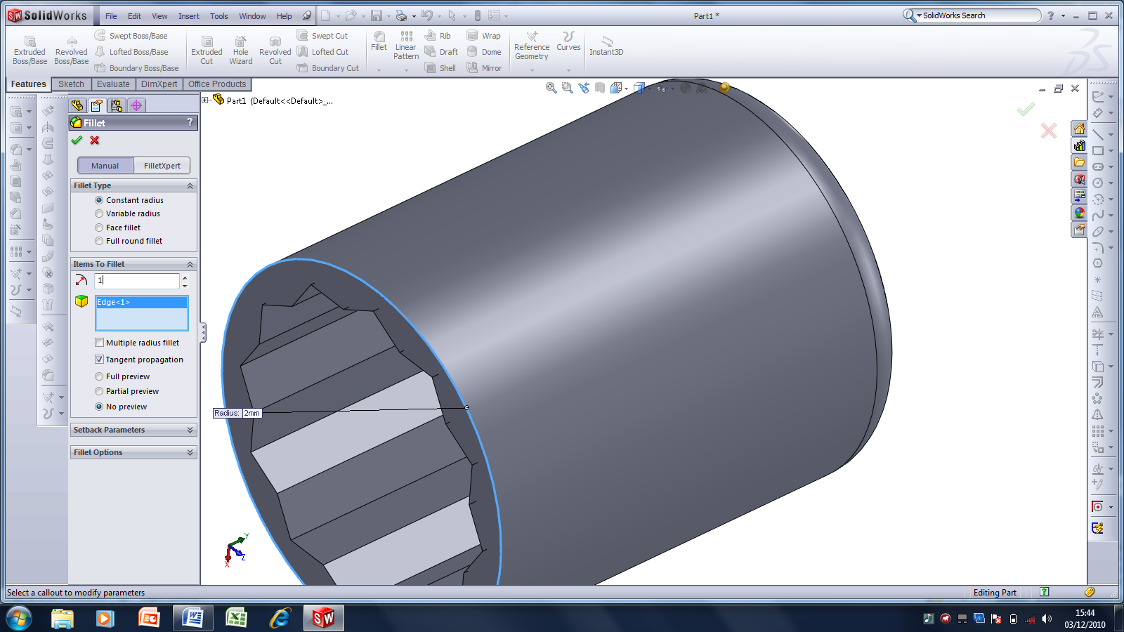
Add a 1mm Fillet Radius to the bottom.
Figure 19
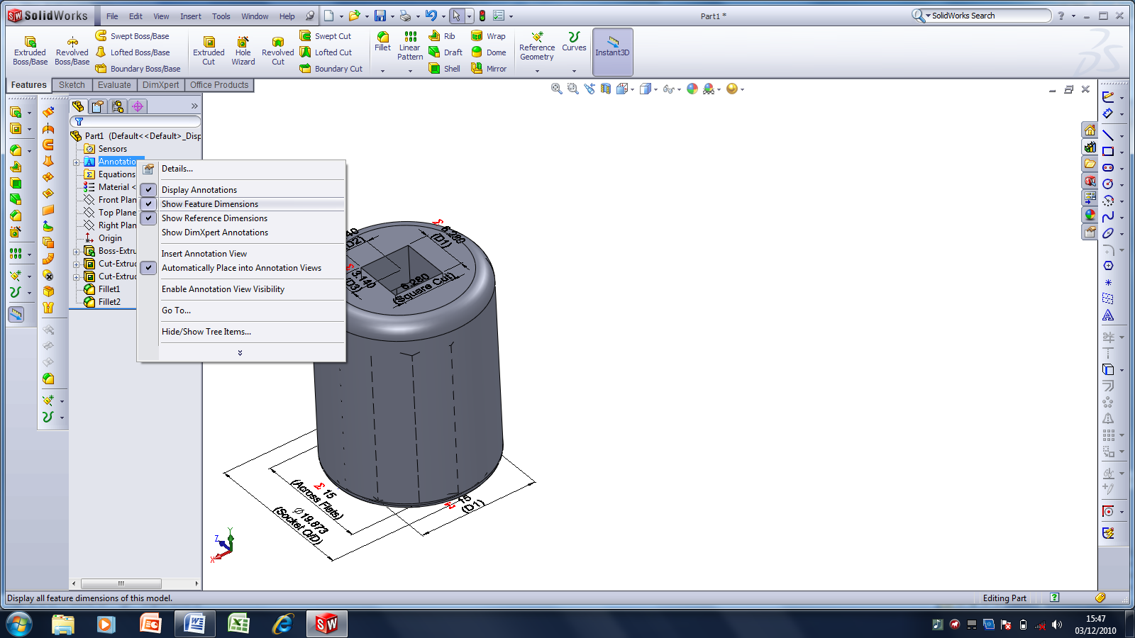
Right click Annotation and click on the items shown above.
Figure 20
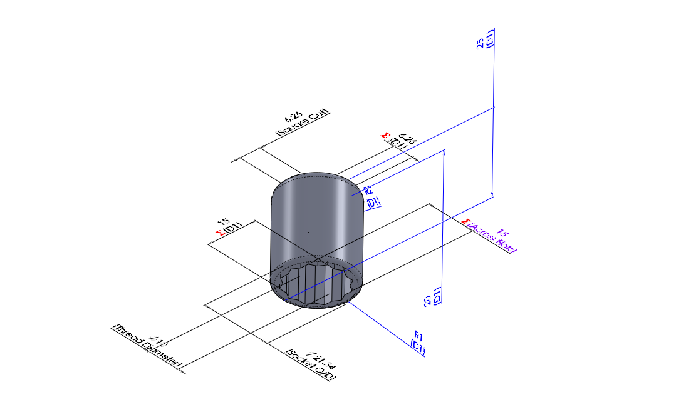
Drag all the dimensions out from the model as shown, it may be necessary to rotate the model to access all of these.
Figure 20

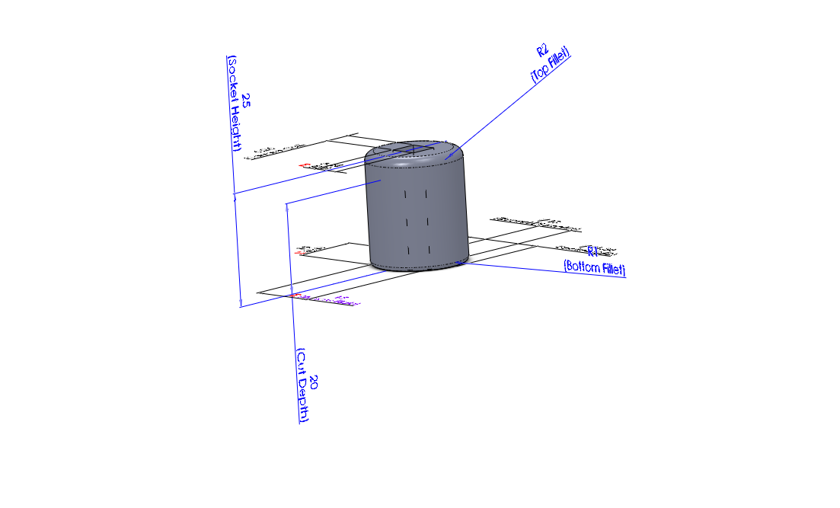
Rename the dimensions as shown, Top Fillet, Bottom Fillet, Socket Height and Cut Depth.
Figure 21
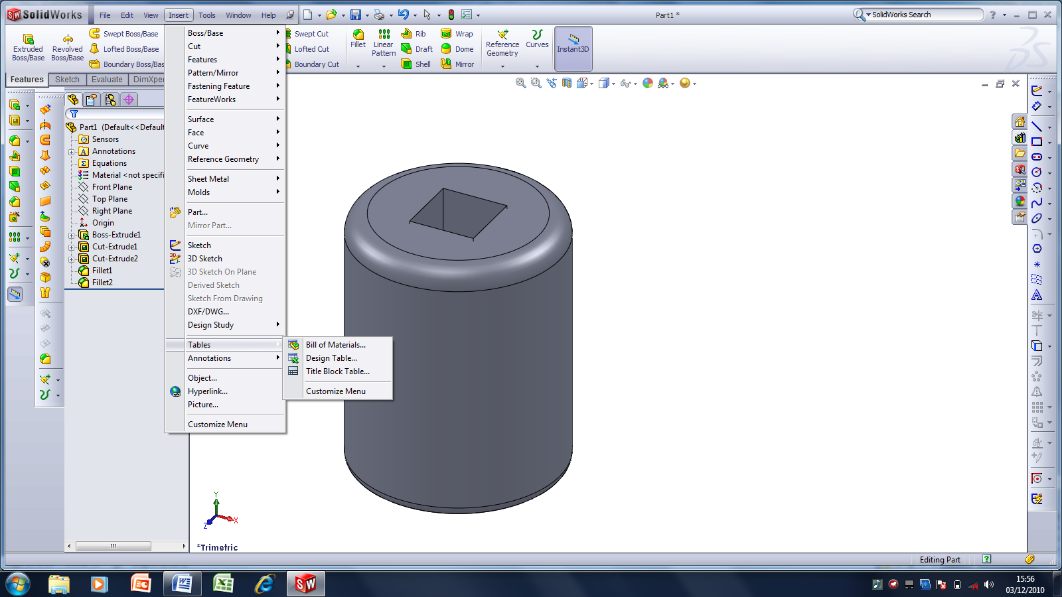
Insert a Design Table
Figure 21

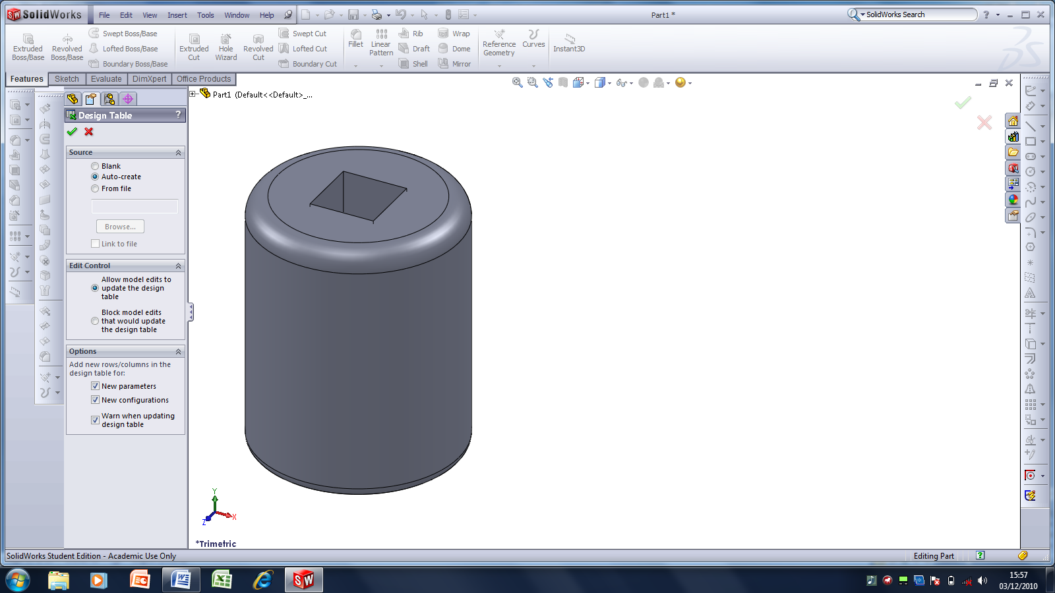
Click Accept
Figure 22
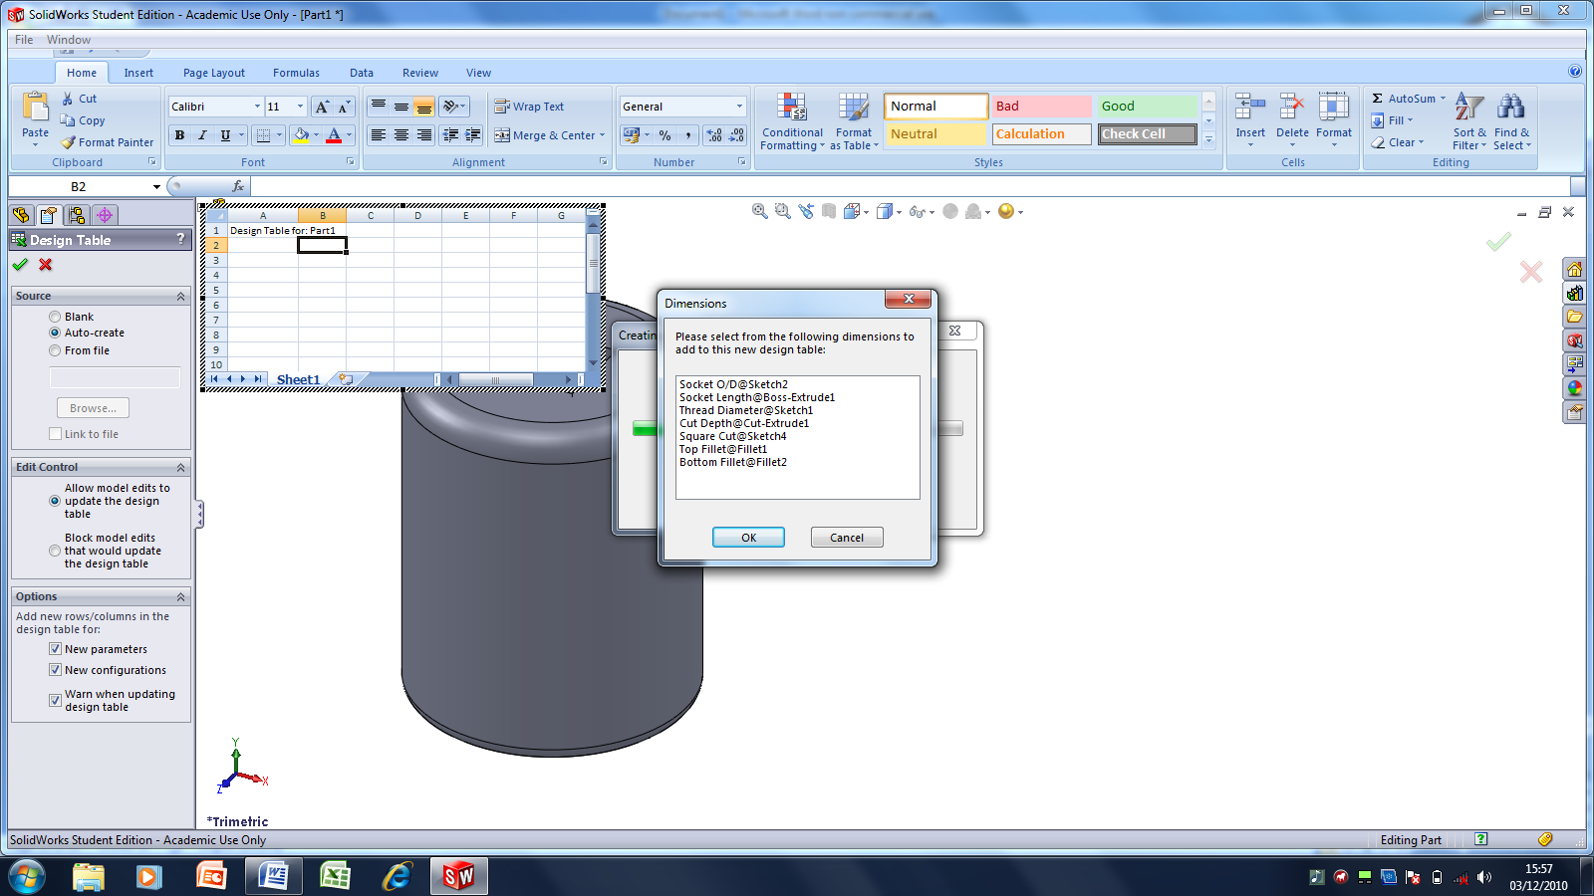
Click OK to the dialogue box as shown above
Figure 22
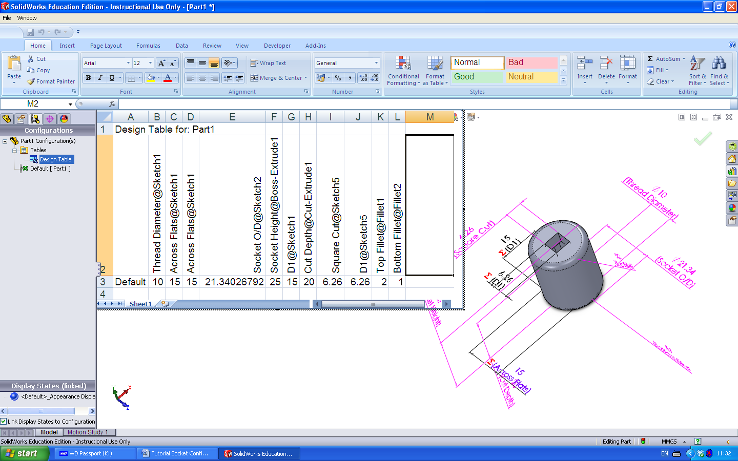
As for a Spreadsheet organise the dimensions as shown above
Figure 23

Dimension with n in front are the result of an Equation and in previous versions of SolidWorks did not appear in the spreadsheet
Figure 24
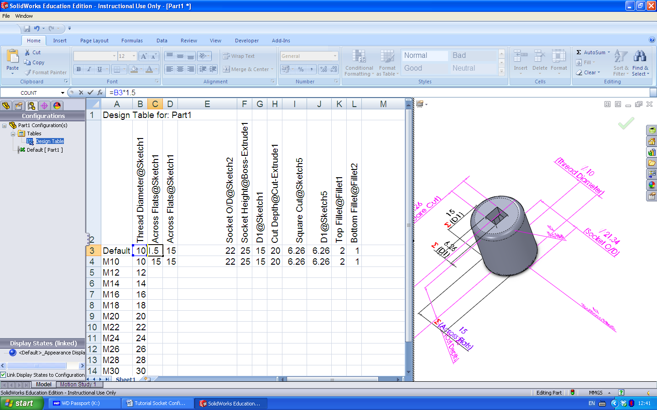
Add the Formula to Cell C3
Figure 25
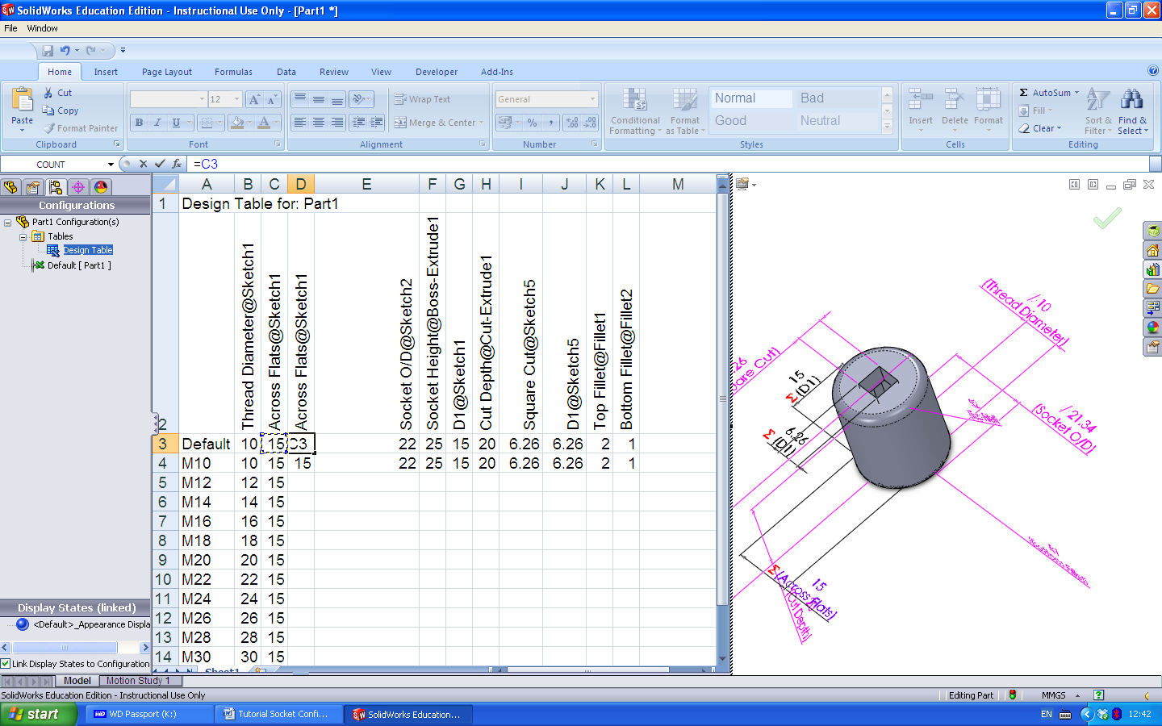
Figure 26 Add Formula to D3
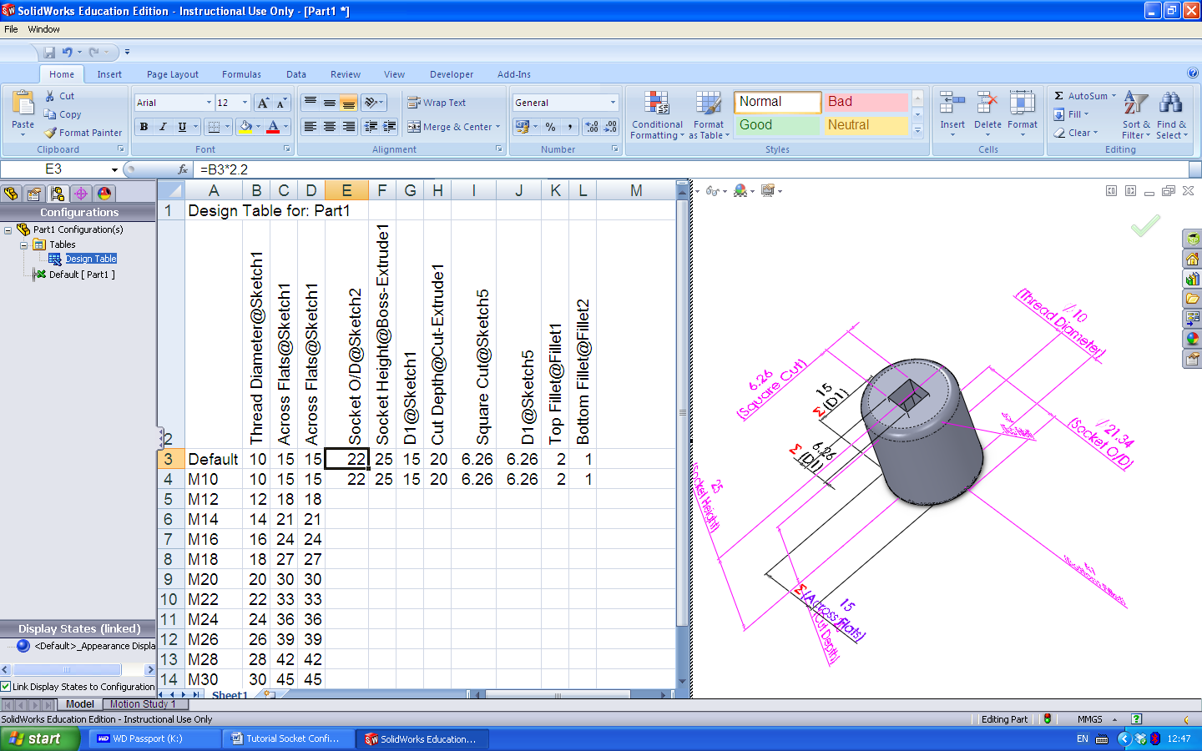
Figure 27 Add Formula to E3
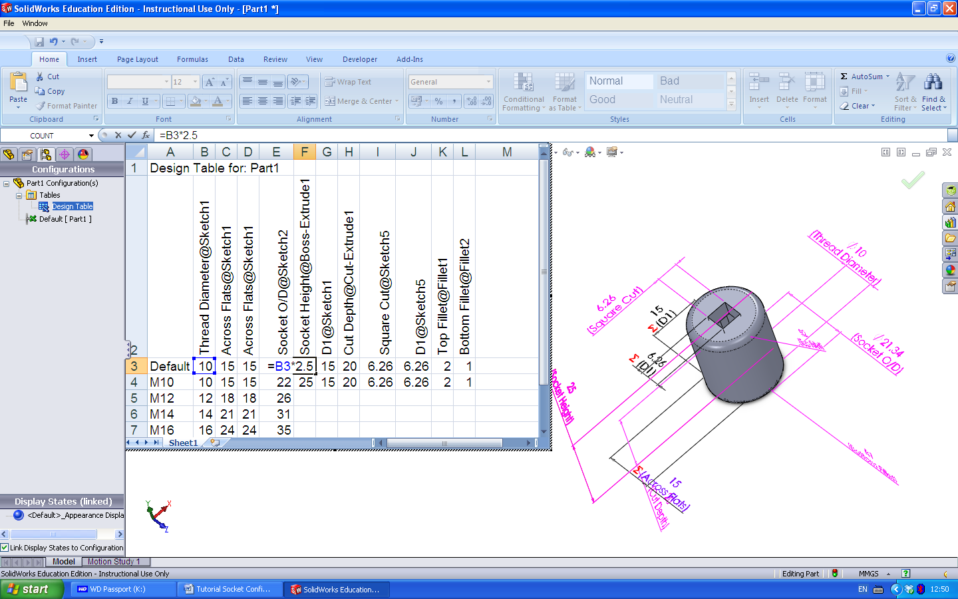
Figure 28 Add Formula to F3
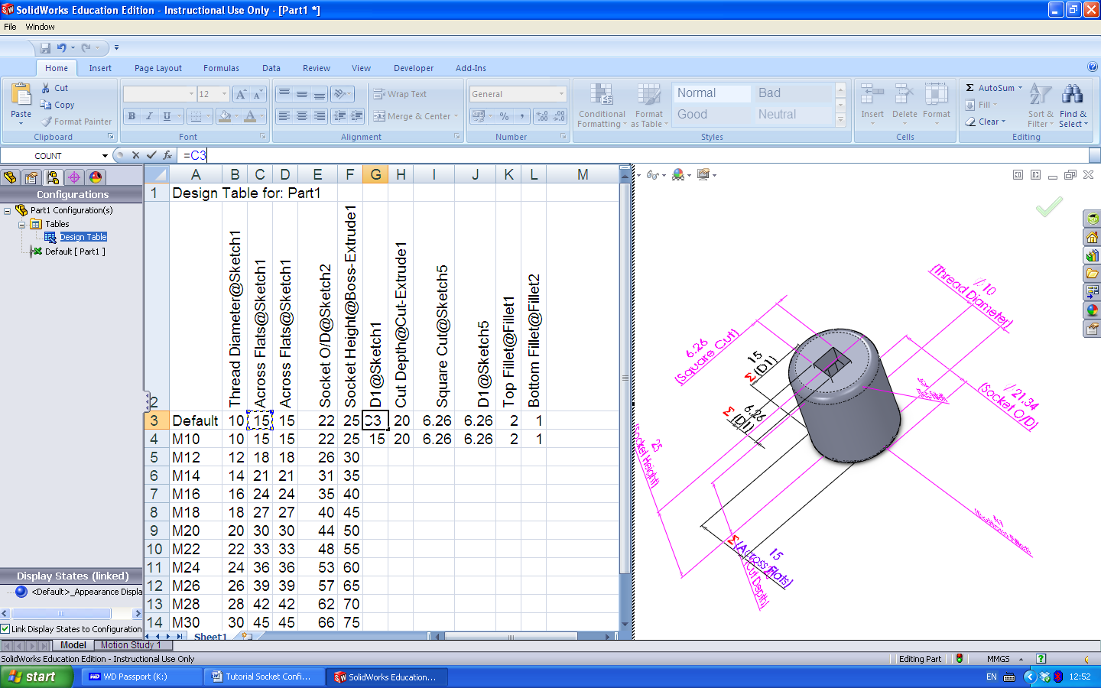
Figure 29 Add Formula to G3

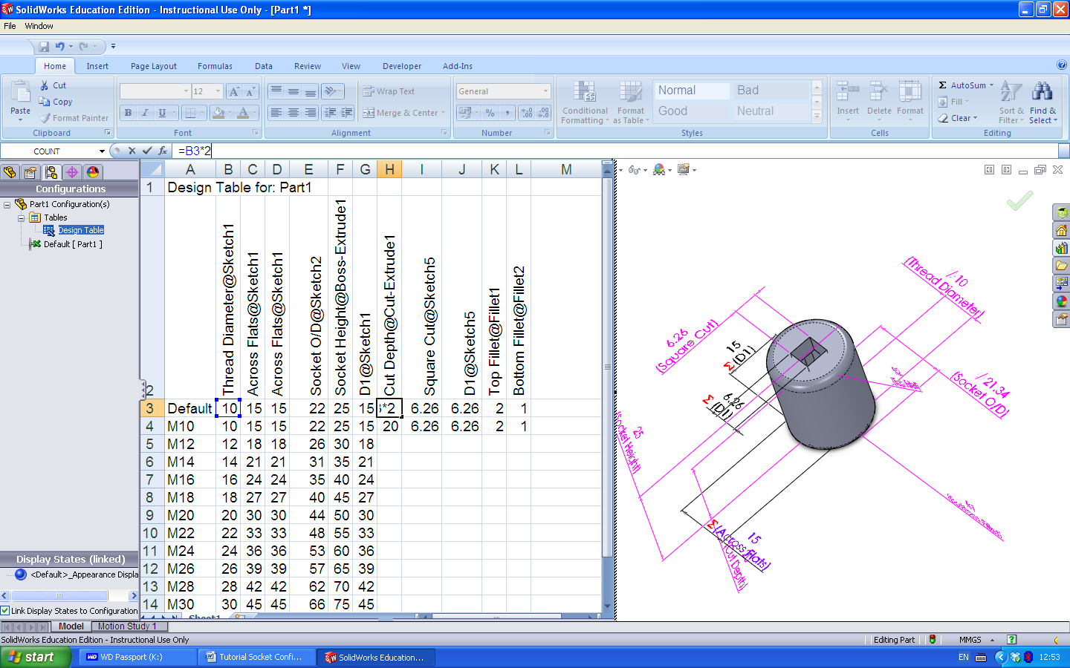
Figure 30 Add Formula to H3

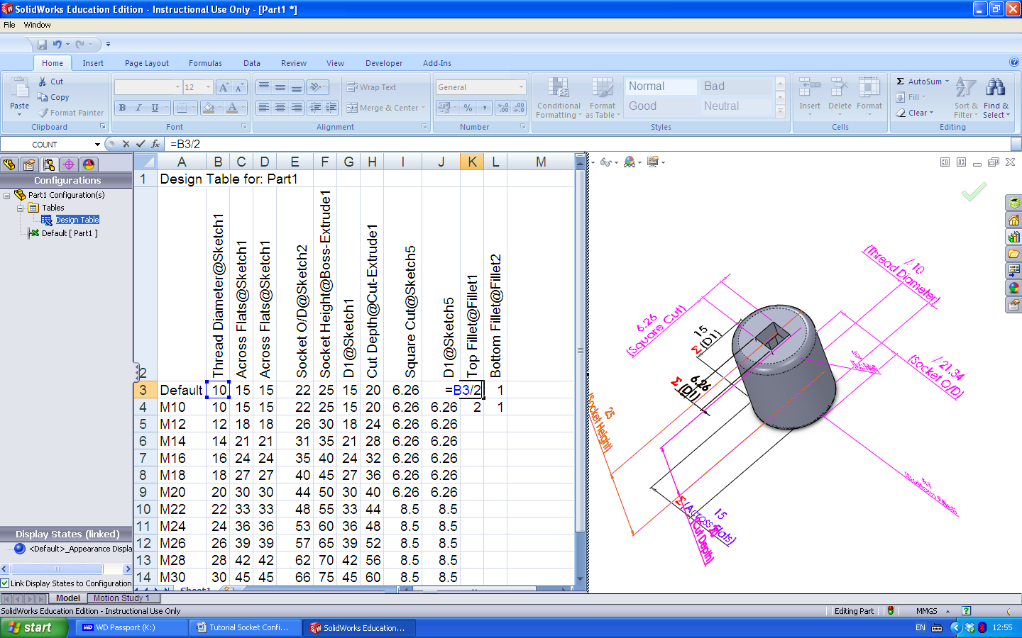
Work out Formulas for I and J and L
Figure 31 Add Formula to K3

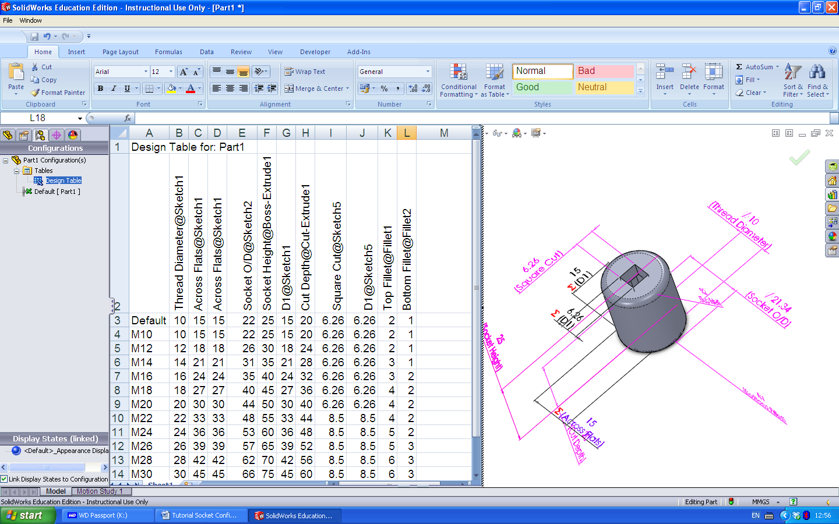
Figure 31
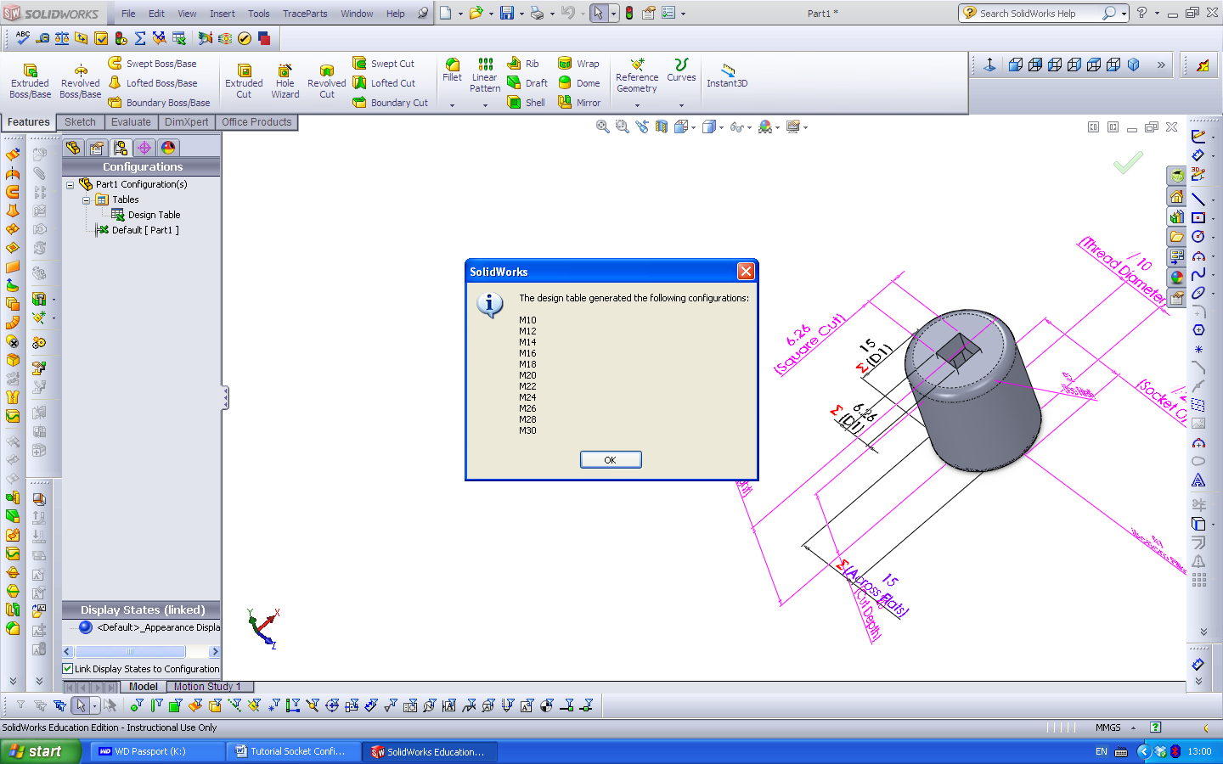
Click to the outside of the spreadsheet to remove it. Click OK to the above.
Figure 31
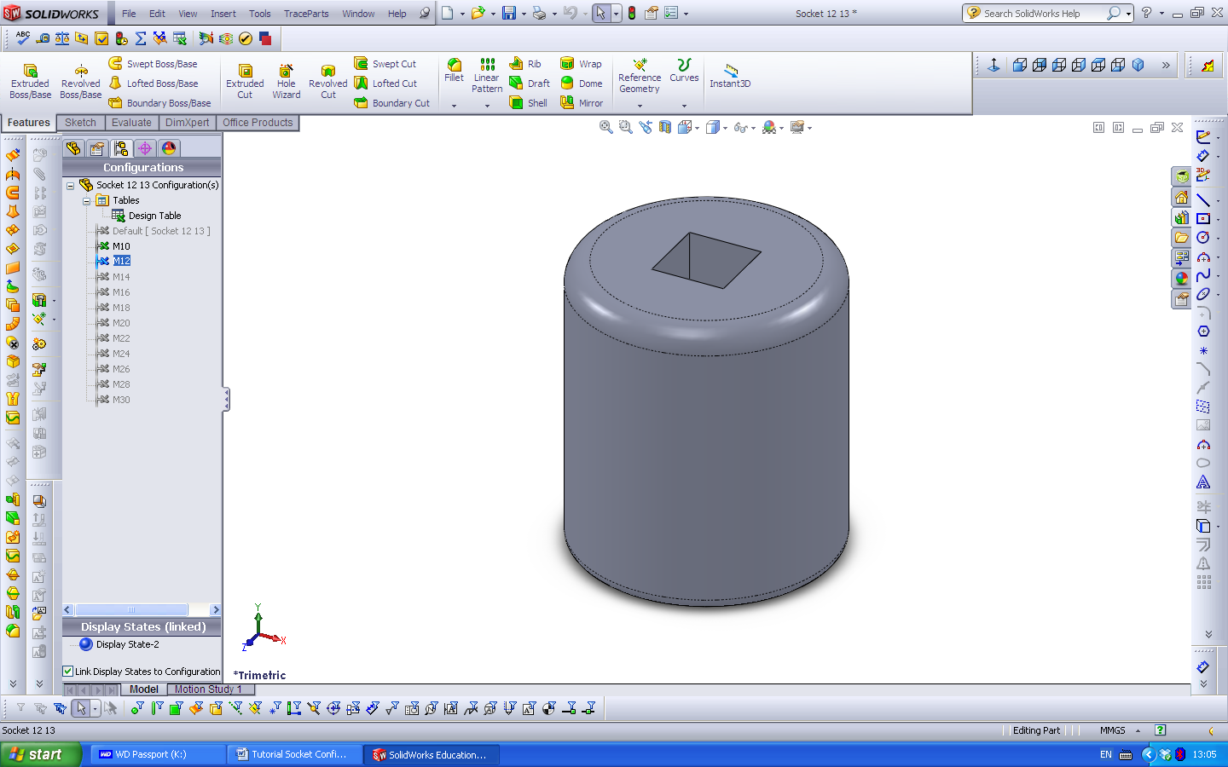

Figure 32
Click on the Configuration name to see the changes.

