[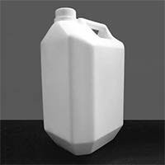](https://www.google.co.ke/imgres?imgurl=https://img2.exportersindia.com/product_images/bc-small/dir_63/1888465/5ltr-jerrycan-572729.jpg&imgrefurl=https://www.exportersindia.com/indian-suppliers/hdpe-jerry-can.htm&docid=RNRb9P-yDzbupM&tbnid=Bbh_x8cV1D1oVM:&vet=1&w=200&h=200&bih=806&biw=1600&ved=0ahUKEwiUvK_h6LTaAhURaVAKHTfcCqUQMwhjKCIwIg&iact=c&ictx=1) [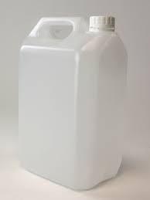](https://www.google.co.ke/url?sa=i&rct=j&q=&esrc=s&source=images&cd=&cad=rja&uact=8&ved=2ahUKEwiu0sb16LTaAhXSblAKHdo7CMcQjRx6BAgAEAU&url=https://www.carterspackaging.com/Shop/Category/Jerry_Cans&psig=AOvVaw1BbCR6BgH0w2DkRZdMNUlk&ust=1523625321142776)