Analysis1

MESH:

Entity | Size
Nodes | 17093
Elements | 57674

ELEMENT TYPE:

Connectivity | Statistics
TE4 | 57674 ( 100.00% )

ELEMENT QUALITY:

Criterion | Good | Poor | Bad | Worst | Average
Stretch | 14675 ( 25.44% ) | 40833 ( 70.80% ) | 2166 ( 3.76% ) | 0.007 | 0.217
Aspect Ratio | 9435 ( 16.36% ) | 20243 ( 35.10% ) | 27996 ( 48.54% ) | 324.500 | 6.950

Materials.1

Material | Steel
Young's modulus | 2e+011N_m2
Poisson's ratio | 0.266
Density | 7860kg_m3
Coefficient of thermal expansion | 1.17e-005_Kdeg
Yield strength | 2.5e+008N_m2

Static Case

Boundary Conditions
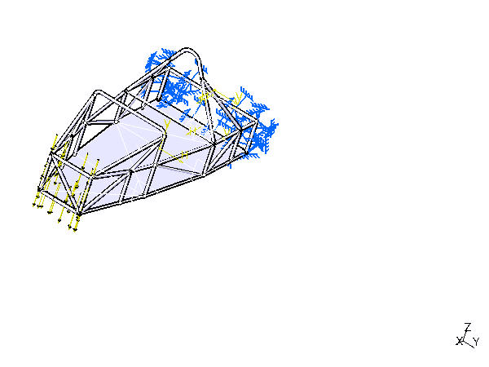
Figure 1

STRUCTURE Computation
Number of nodes | : | 17093
Number of elements | : | 57674
Number of D.O.F. | : | 51279
Number of Contact relations | : | 0
Number of Kinematic relations | : | 0

Linear tetrahedron | : | 57674

RESTRAINT Computation
Name: Restraints.1
Number of S.P.C : 1146

LOAD Computation
Name: Loads.1
Applied load resultant :
Fx | = | -1 | . | 513e-009 | N
Fy | = | 2 | . | 654e-007 | N
Fz | = | -1 | . | 000e+004 | N
Mx | = | -8 | . | 829e+001 | Nxm
My | = | 2 | . | 049e+004 | Nxm
Mz | = | 5 | . | 439e-007 | Nxm

STIFFNESS Computation
Number of lines | : | 51279
Number of coefficients | : | 923583
Number of blocks | : | 2
Maximum number of coefficients per bloc | : | 499978
Total matrix size | : | 10 | . | 77 | Mb

SINGULARITY Computation
Restraint: Restraints.1
Number of local singularities | : | 0
Number of singularities in translation | : | 0
Number of singularities in rotation | : | 0
Generated constraint type | : | MPC

CONSTRAINT Computation
Restraint: Restraints.1
Number of constraints | : | 1146
Number of coefficients | : | 0
Number of factorized constraints | : | 1146
Number of coefficients | : | 0
Number of deferred constraints | : | 0

FACTORIZED Computation
Method | : | SPARSE
Number of factorized degrees | : | 50133
Number of supernodes | : | 2662
Number of overhead indices | : | 179118
Number of coefficients | : | 5333547
Maximum front width | : | 612
Maximum front size | : | 187578
Size of the factorized matrix (Mb) | : | 40 | . | 6917
Number of blocks | : | 6
Number of Mflops for factorization | : | 9 | . | 374e+002
Number of Mflops for solve | : | 2 | . | 158e+001
Minimum relative pivot | : | 2 | . | 739e-005
Minimum and maximum pivot
Value | Dof | Node | x (in) | y (in) | z (in)
2.7612e+006 | Tz | 17087 | 2.0529e+001 | -8.9101e+000 | 2.5025e+001
2.9428e+011 | Tx | 10013 | 2.1285e+001 | -1.6754e+001 | 4.6799e-001
Minimum pivot
Value | Dof | Node | x (in) | y (in) | z (in)
3.7262e+006 | Tz | 17093 | 1.7783e+001 | 1.0867e+001 | 2.1333e+001
4.2227e+006 | Ty | 17087 | 2.0529e+001 | -8.9101e+000 | 2.5025e+001
4.3679e+006 | Tz | 17037 | 8.9856e+000 | 4.8431e+000 | 2.8950e-001
5.2531e+006 | Tz | 7640 | 5.4691e+001 | 1.2797e+001 | 1.8683e+001
5.3073e+006 | Ty | 17034 | 7.7362e+000 | 5.0407e+000 | -3.4968e-017
5.4094e+006 | Ty | 17083 | 6.9047e+000 | 7.0836e+000 | -5.3126e-001
5.9717e+006 | Ty | 17091 | 1.8135e+001 | 1.0590e+001 | 2.1234e+001
6.4019e+006 | Tz | 17089 | 8.1221e+001 | 7.3383e+000 | 1.3047e+001
7.0463e+006 | Tz | 17083 | 6.9047e+000 | 7.0836e+000 | -5.3126e-001
Translational pivot distribution
Value | Percentage
10.E6 --> 10.E7 | 3.3910e-002
10.E7 --> 10.E8 | 3.2115e-001
10.E8 --> 10.E9 | 7.0353e+000
10.E9 --> 10.E10 | 5.7577e+001
10.E10 --> 10.E11 | 3.4397e+001
10.E11 --> 10.E12 | 6.3631e-001

DIRECT METHOD Computation
Name: Static Case Solution.1
Restraint: Restraints.1
Load: Loads.1
Strain Energy : 7.699e+001 J
Equilibrium
Components | Applied  Forces | Reactions | Residual | Relative  Magnitude Error
Fx (N) | -1.5134e-009 | 1.8726e-006 | 1.8711e-006 | 6.1618e-011
Fy (N) | 2.6543e-007 | -2.4502e-006 | -2.1848e-006 | 7.1949e-011
Fz (N) | -1.0000e+004 | 1.0000e+004 | 2.1043e-005 | 6.9300e-010
Mx (Nxm) | -8.8293e+001 | 8.8293e+001 | 1.5465e-006 | 2.4682e-011
My (Nxm) | 2.0487e+004 | -2.0487e+004 | -3.4488e-005 | 5.5041e-010
Mz (Nxm) | 5.4393e-007 | -3.4417e-006 | -2.8978e-006 | 4.6246e-011

Static Case Solution.1 - Deformed mesh.2
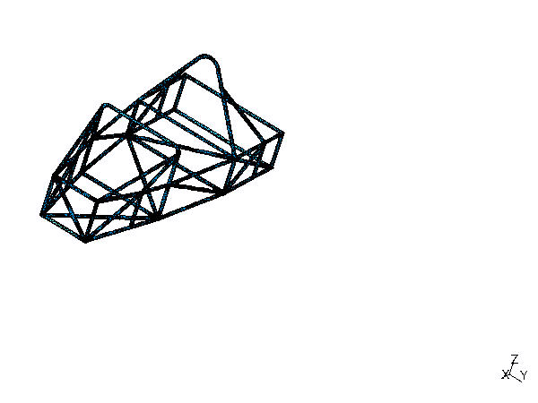
Figure 2
On deformed mesh ---- On boundary ---- Over all the model

Static Case Solution.1 - Von Mises stress (nodal values).2
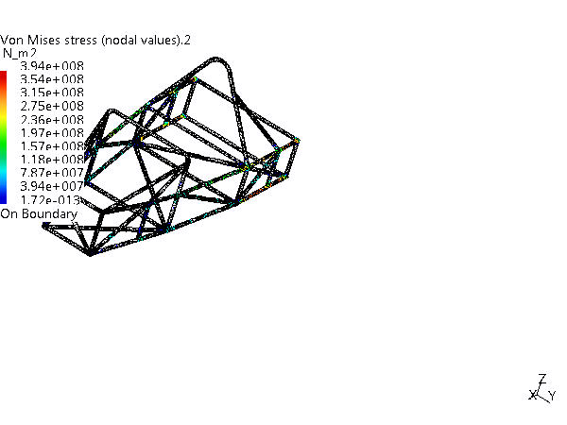
Figure 3
3D elements: : Components: : All
On deformed mesh ---- On boundary ---- Over all the model

Global Sensors

Sensor Name | Sensor Value
Energy | 76.987J
Global Error Rate (%) | 31.805156708

